**Smart Dealer & Distributor CRM – Manufacturing Supply Chain Management System**

**Industry:** Manufacturing

**Target Users:** Sales Managers, Dealers, Distributors, and Customer Support Teams

**Problem Statement**

A manufacturing company distributes its products through multiple dealers and distributors across different regions. Currently, all dealer onboarding, order requests, stock updates, and complaint resolutions are handled via emails, phone calls, and spreadsheets.

This leads to:

* Delayed order processing and delivery.
* No visibility into real-time inventory or dealer performance.
* Miscommunication between sales teams and distributors.
* Lack of centralized data for decision-making.

To solve this, the company wants to implement a **Salesforce CRM solution** to streamline dealer management, automate order tracking, and provide real-time insights into supply chain performance.

**Project Overview**

The system will provide a centralized platform for managing dealers and distributors, automating order lifecycle (from placement to delivery), and enabling real-time communication.

It will:

* Simplify dealer onboarding and profiling.
* Automate distributor order capture and stock allocation.
* Track complaints and service requests with automated assignment.
* Generate dashboards for regional sales, dealer performance, and pending orders.

This will reduce delays, improve communication, and enhance dealer satisfaction.

**Objectives**

* Automate **order management** and reduce manual errors.
* Provide a **single view of dealer/distributor data**.
* Enable **faster issue resolution** through automated case management.
* Improve **supply chain visibility** with dashboards and reports.
* Strengthen **dealer relationships** with timely updates and personalized engagement.

**Use Cases**

1. **Dealer Onboarding**
   * Register new dealers with company profile, location, and sales region.
   * Assign appropriate sales managers automatically.
2. **Order Management**
   * Allow dealers to place orders via a self-service portal.
   * Track status (Pending, Approved, Dispatched, Delivered).
3. **Inventory Tracking**
   * Maintain real-time product stock availability.
   * Alert managers when inventory is low.
4. **Complaint & Service Requests**
   * Dealers log complaints (damaged goods, delayed delivery).
   * Automatically assign cases to the right department.
5. **Reporting & Dashboards**
   * Regional sales performance.
   * Top-performing dealers/distributors.
   * Pending orders and complaint resolution times.

**PHASES**

**Phase 1: Problem Understanding & Industry Analysis**

* Gather requirements from manufacturing managers, dealers, and distributors.
* Identify key challenges: order delays, inventory tracking, dealer complaints.
* Map the current manual process (emails, calls, spreadsheets).
* Analyze manufacturing industry best practices and explore existing CRM solutions.

**Phase 2: Org Setup & Configuration**

**2.1: Salesforce Editions**

* Using **Developer Edition Org** for setup and testing.
* Full Salesforce license reserved for **Sales Head**.
* **Salesforce Platform licenses** used for Regional Managers, Dealers, and Support Agents.

**2.2: Company Profile Setup**

**Navigation**: Setup → Company Information

* **Company Name** → Smart Dealer & Distributor CRM – Manufacturing
* **Address** → Hyderabad, India
* **Phone** → +91 9876543210
* **Primary Contact Email** → [support@smartcrm.com](mailto:support@smartcrm.com)
* **Default Locale** → English (India)
* **Currency** → INR – Indian Rupee
* **Time Zone** → (GMT +5:30) Asia/Kolkata

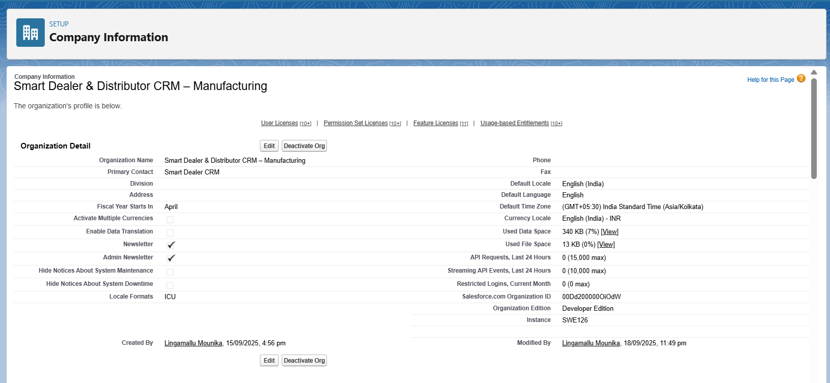

**2.3: Business Hours & Holidays**

Business hours and holidays were defined to ensure proper service-level agreements (SLAs) and realistic scheduling:

1. Business Hours:
   * Days: Monday to Saturday
   * Timings: 9:00 AM – 6:00 PM
2. Holidays Added:
   * Republic Day (26th January)
   * Independence Day (15th August)
   * Diwali (Festival, annual date varies)

This configuration allows Salesforce to automatically consider holidays and working hours in workflows, escalations, and support processes.

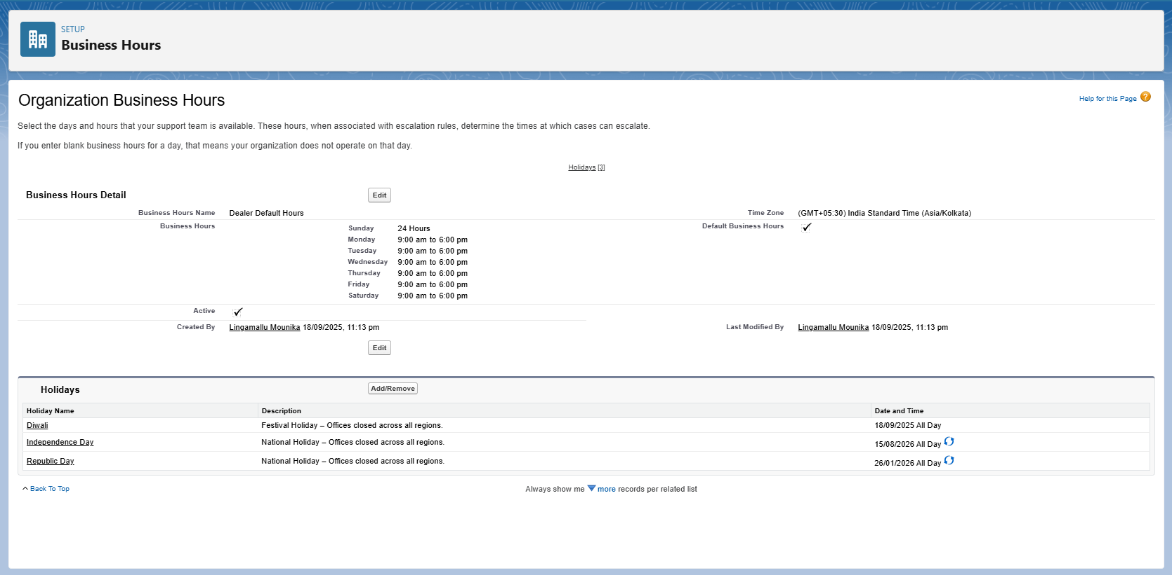

**2.4 Fiscal Year Settings**

To reflect Indian manufacturing practices, the fiscal year was set as:

* **Custom Fiscal Year**: April – March

This is particularly important for financial forecasting, sales reporting, and annual planning in the context of the manufacturing sector.

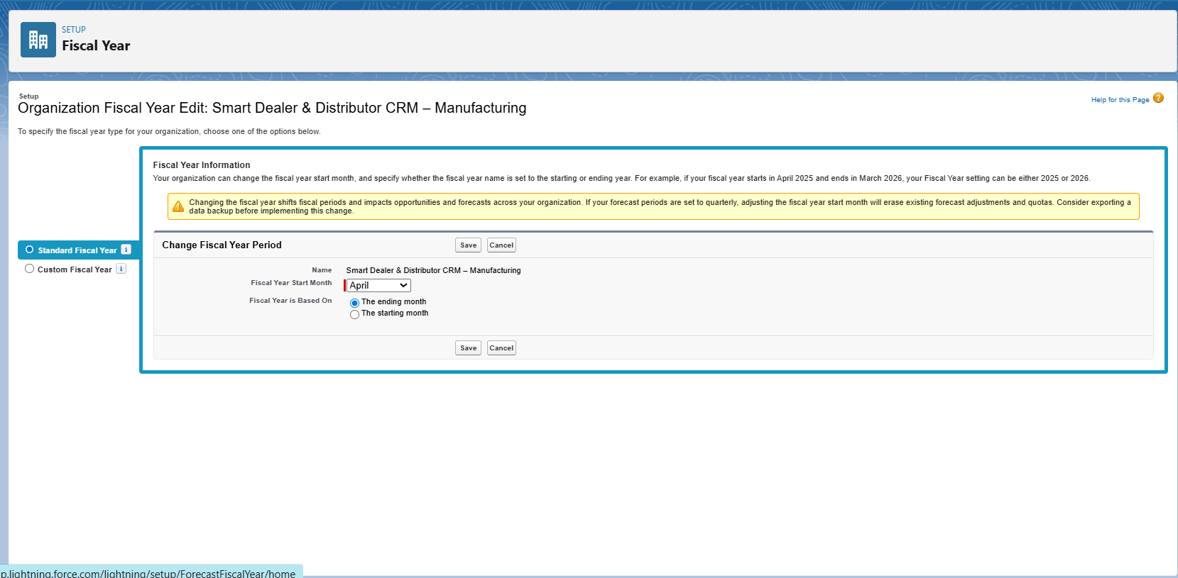

**2.5 User Setup & Licenses**

Create the required users for Smart Dealer & Distributor CRM with correct licenses, profiles, and roles.

**2.5.1 Check Available Licenses**

1. Go to **Setup → Company Information**.
2. Scroll to **User Licenses**.
3. Note:
   * Only **1 Salesforce license** available → reserved for Sales Head.
   * Multiple **Salesforce Platform licenses** available → used for other users.

**2.5.2 Clone Standard Platform Profile**

1. Go to **Setup → Profiles**.
2. Open **Standard Platform User**.
3. Click **Clone**.
4. Create new profiles:
   * Sales Manager Profile (Platform)
   * Dealer Manager Profile (Platform)
   * Support Profile (Platform)
5. Save each profile.

**2.5.3 Configure Profile Permissions**

* **Sales Manager Profile (Platform)** → CRUD on Dealers, Distributors, Orders; Read on Complaints, Inventory.
* **Dealer Manager Profile (Platform)** → CRUD on own Account & Orders; Read-only on Distributors, Inventory.
* **Support Profile (Platform)** → Read/Edit on Cases & Complaints; Read-only on other objects.

**2.5.4 Create Users**

1. Go to **Setup → Users → New User**.
2. Enter required details: *First Name, Last Name, Email, Username, Alias*.
3. Assign license and profile:
   * **Sales Head** → Salesforce license with *Sales Manager Profile (Salesforce)*
   * **Regional Sales Manager** → Salesforce Platform license with *Sales Manager Profile (Platform)*
   * **Dealer Manager** → Salesforce Platform license with *Dealer Manager Profile (Platform)*
   * **Support Agent** → Salesforce Platform license with *Support Profile (Platform)*
4. Choose the appropriate **Role**.
5. Click **Save** to create the user.
6. **Sales Head**

* **License:** Salesforce
* **Profile:** Sales Manager Profile (Salesforce)
* **Role:** Sales Head

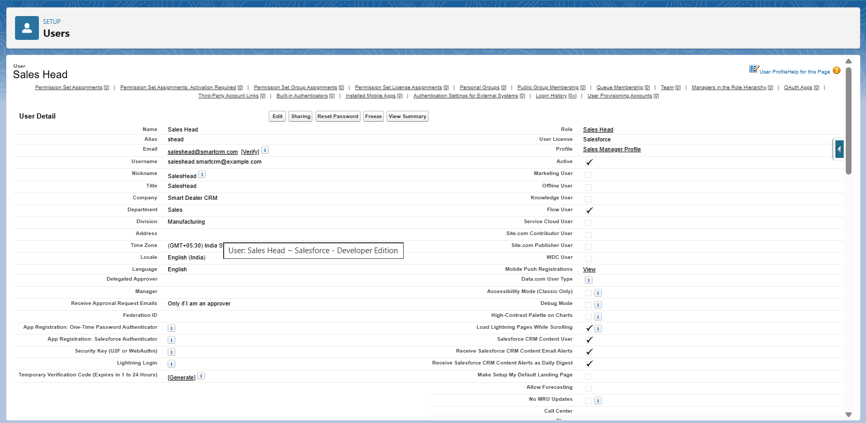

1. **Regional Sales Manager**

* **License:** Salesforce Platform
* **Profile:** Sales Manager Profile (Platform)
* **Role:** Regional Sales Manage

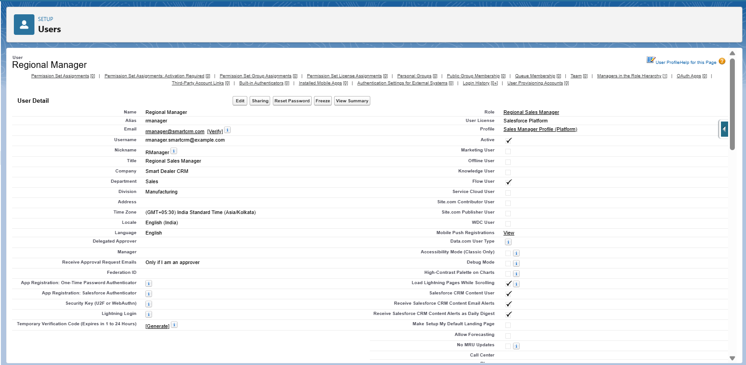

1. **Dealer Manager**

* **License:** Salesforce Platform
* **Profile:** Dealer Manager Profile (Platform)
* **Role:** Dealer Manager

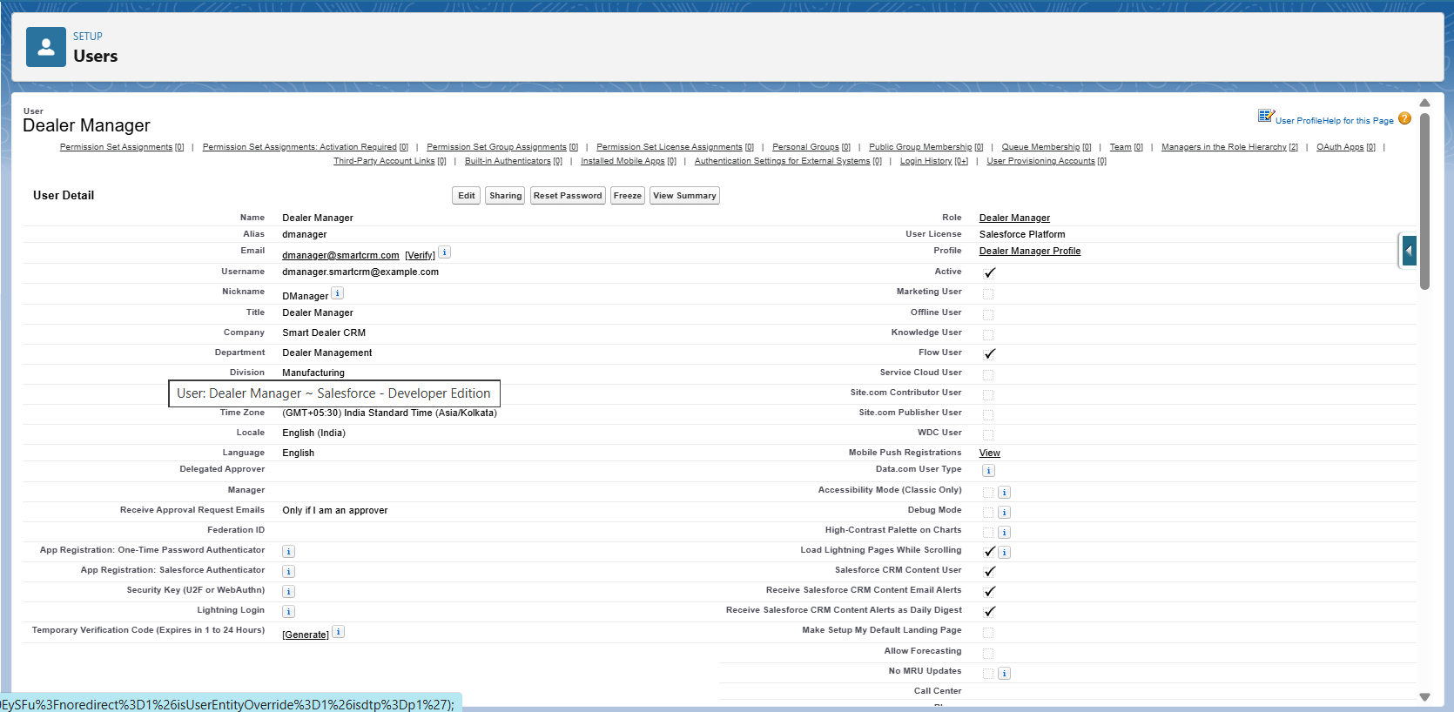

1. **Support Agent**
   * **License:** Salesforce Platform
   * **Profile:** Support Profile (Platform)
   * **Role:** Support Agent

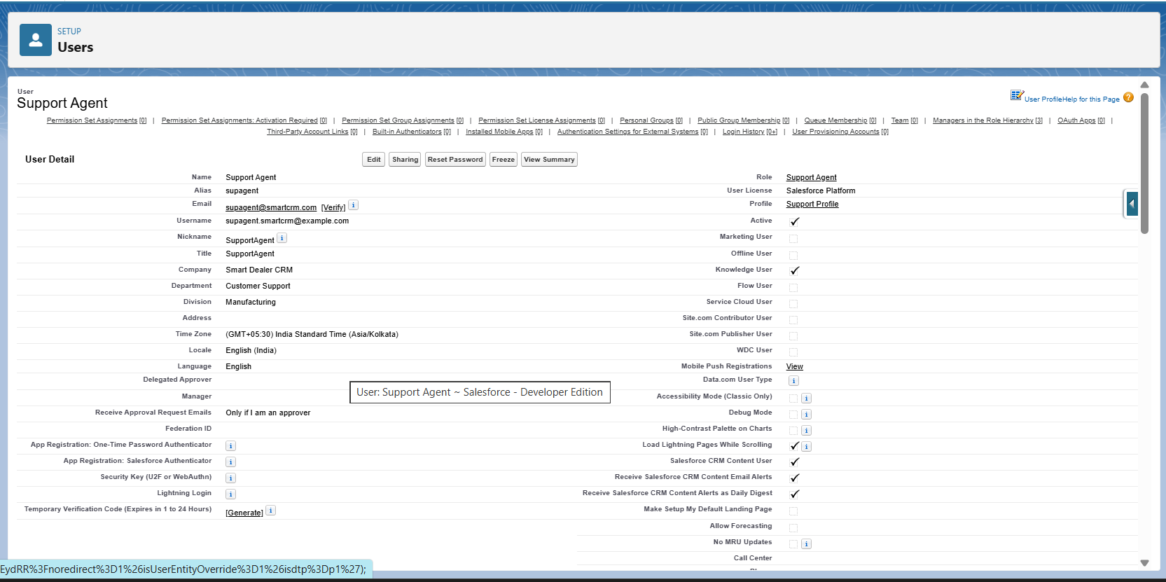

**2.6 Profiles**

Profiles were created and customized to control access for different types of users in the Smart Dealer CRM. Since Salesforce licenses were limited, new **Platform-based profiles** were cloned from the *Standard Platform User* profile.

**2.6.1 Sales Manager Profile (Salesforce)**

To lead and manage a sales team to achieve revenue targets and drive business growth.

* + Used by: **Sales Head**
  + Full access to all dealer and distributor records
  + Can create, edit, and delete Orders, Accounts, and Reports
  + Complete reporting and dashboard access

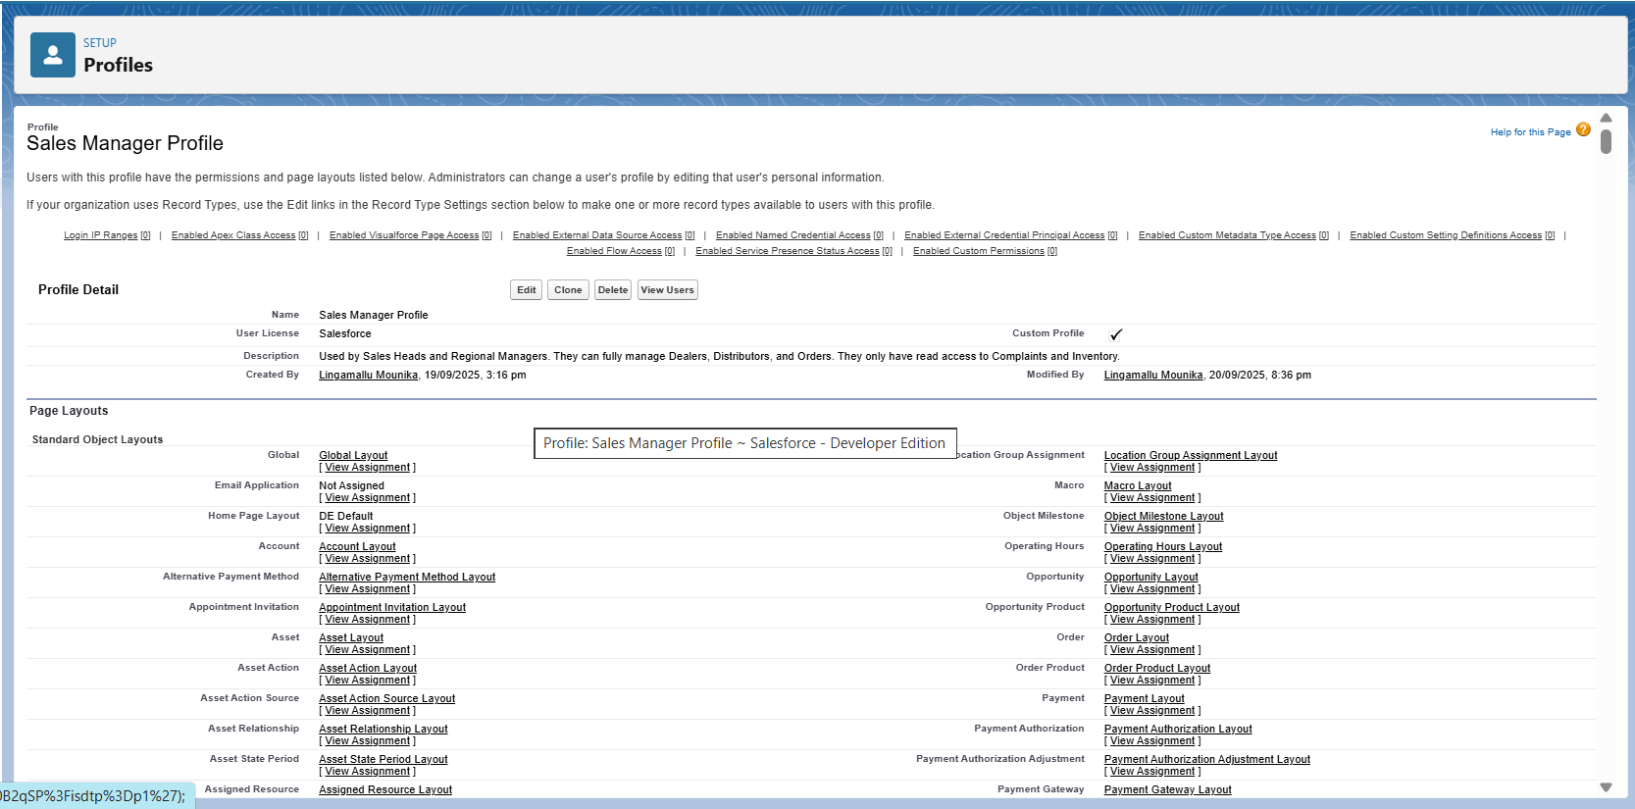

**2.6.2 Sales Manager Profile (Platform)**

To check sales operations within a specific geographic region, leading a team to achieve sales targets and expand customer relationships.

* + Used by: Regional Sales Managers
  + CRUD access on Dealers, Distributors, and Orders
  + Read-only on Complaints and Inventory
  + Limited reporting access

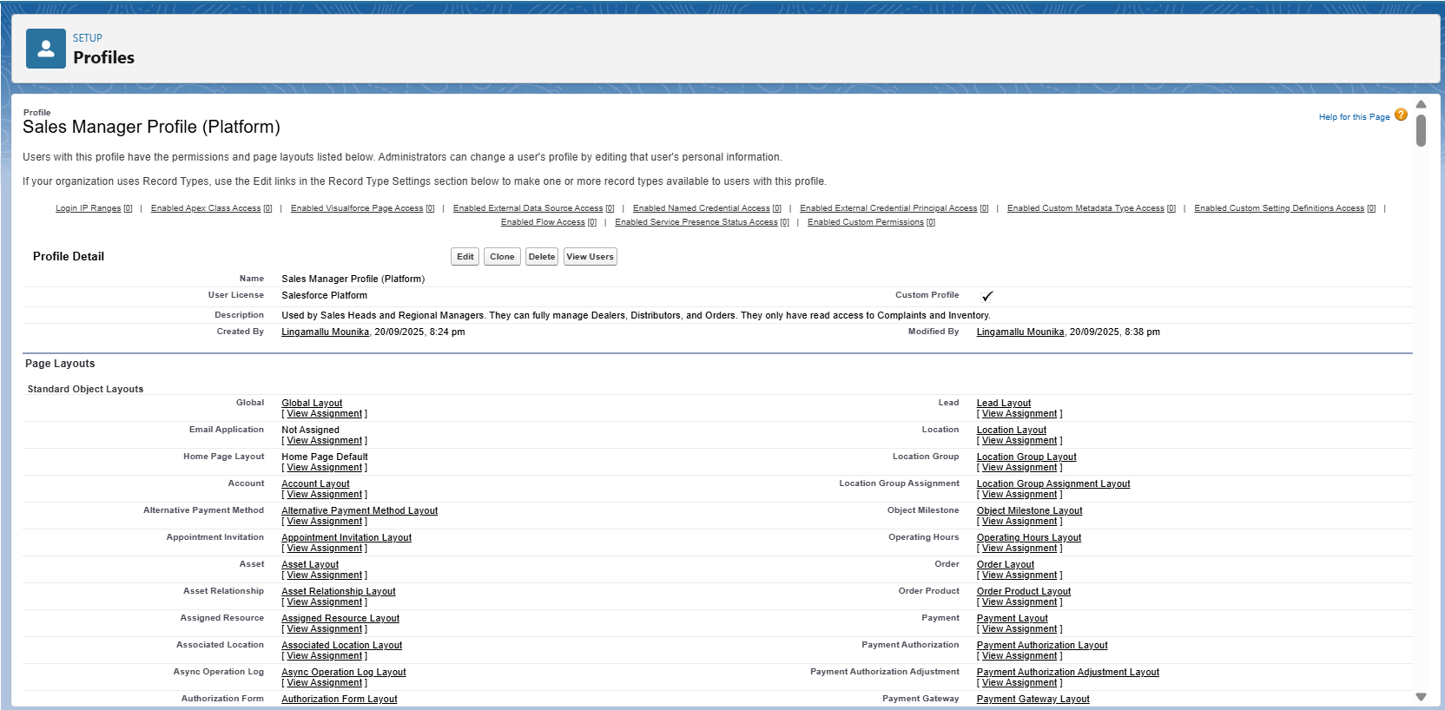

**2.6.3 Dealer Manager Profile (Platform)**

To manage and support a network of dealers or distributors, driving sales growth and ensuring strong partnerships.

* + Used by: Dealer Managers (external users)
  + CRUD access on their own Account and Orders
  + Read-only access to Distributors and Inventory
  + Restricted to community/portal access

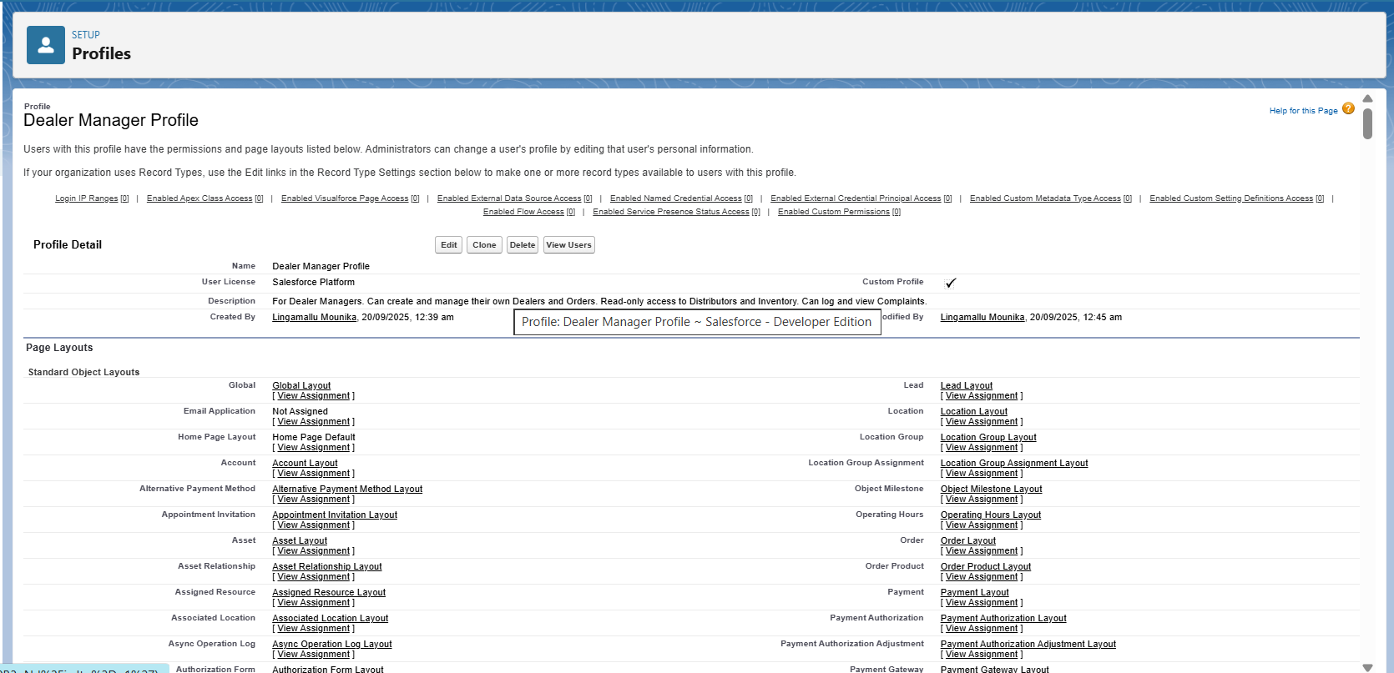

**2.6.4 Support Profile (Platform)**

A Support Agent's primary role is to provide assistance and resolve issues for customers, ensuring a positive experience and building brand loyalty.

* Used by: Support Agents
  + Read/Edit on Complaints and Cases
  + Read-only on Accounts and Orders
  + Service-focused access only



**2.7 Roles**

Roles were defined to create a **hierarchy** for record visibility and reporting. Data rolls up through this structure, ensuring managers can see subordinate records.

* **Sales Head**
  + Top role in the hierarchy
  + Can view all records across the organization
* **Regional Sales Manager**
  + Reports to the Sales Head
  + Can access only the records of dealers in their assigned region
* **Dealer Manager**
  + Sits under the Regional Sales Manager
  + Can access and manage only their own Account and related Orders
* **Support Agent**
  + Created as a parallel role (not under Sales Head)
  + Can access Complaints and Cases across dealers for service management

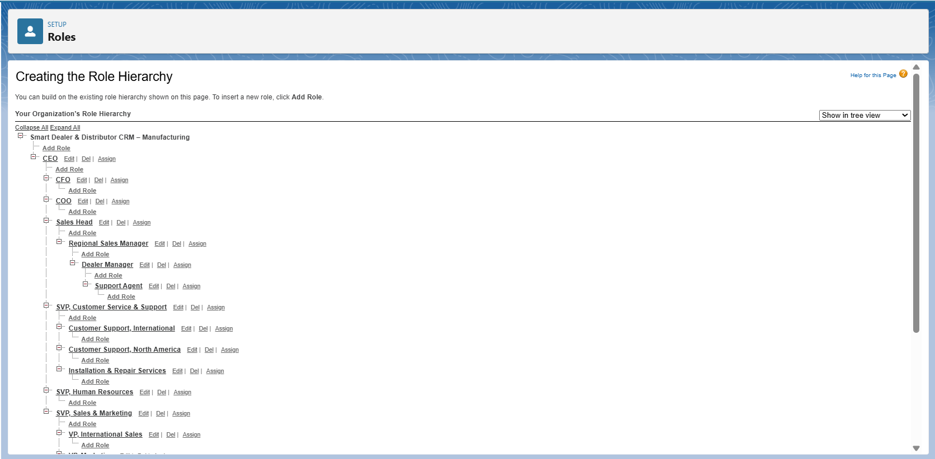

**Step-by-Step: Create Dealer Community User**

**Step 1: Enable Communities (Experience Cloud)**

1. Go to **Setup ⚙️ → Quick Find → Digital Experiences → Settings**.
2. Check **Enable Digital Experiences** (sometimes called “Communities”).
3. Save.  
   This turns on the feature that allows you to create portals for dealers.

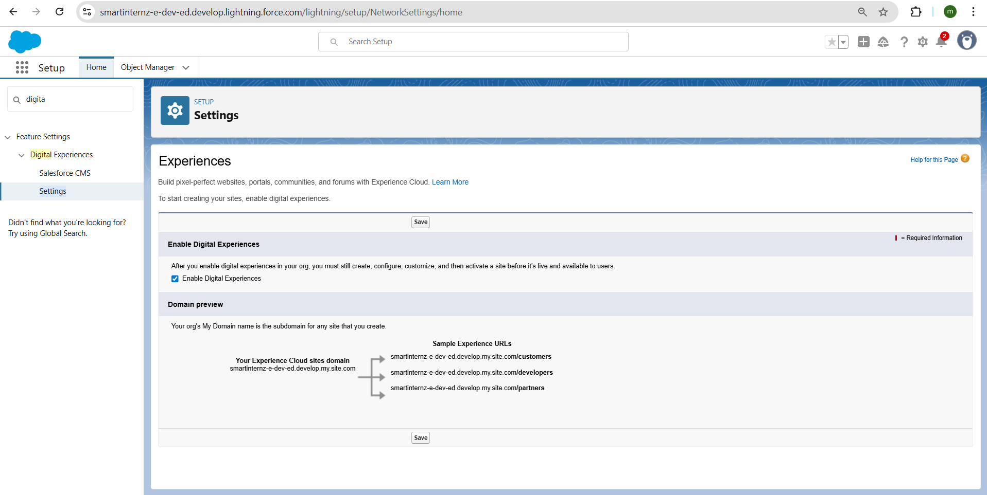

**1. Created Dealer Partner Portal**

* Creating a new portal, specifically a "Dealer Partner Portal."
* **Setup Steps:**
  + **Name Entry:** Users are prompted to "Enter a Name" for the portal.

Example: "Dealer Partner Portal".

* + **URL Generation:** A corresponding URL is automatically generated based on the name as:

smartinternz-e-deved.develop.my.site.com/dealerpartnerportal.

* + **Creation Action:** A "Create" button finalizes the process.

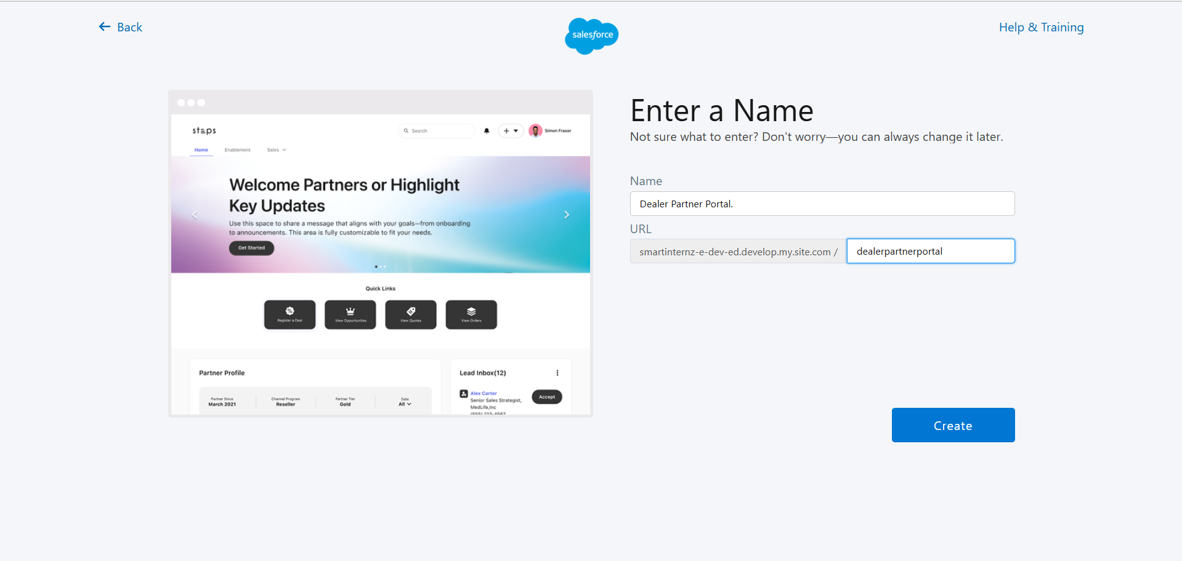

**2. Assigned Profiles to the Portal (Site Members)**

* In the **Administration → Members** section of the portal:
* **System Administrator** profile was added → allows internal admins/developers to log in and test the portal.
* **Dealer Community Profile** (built on Partner Community license) was added → this will be assigned to dealer users for controlled access.

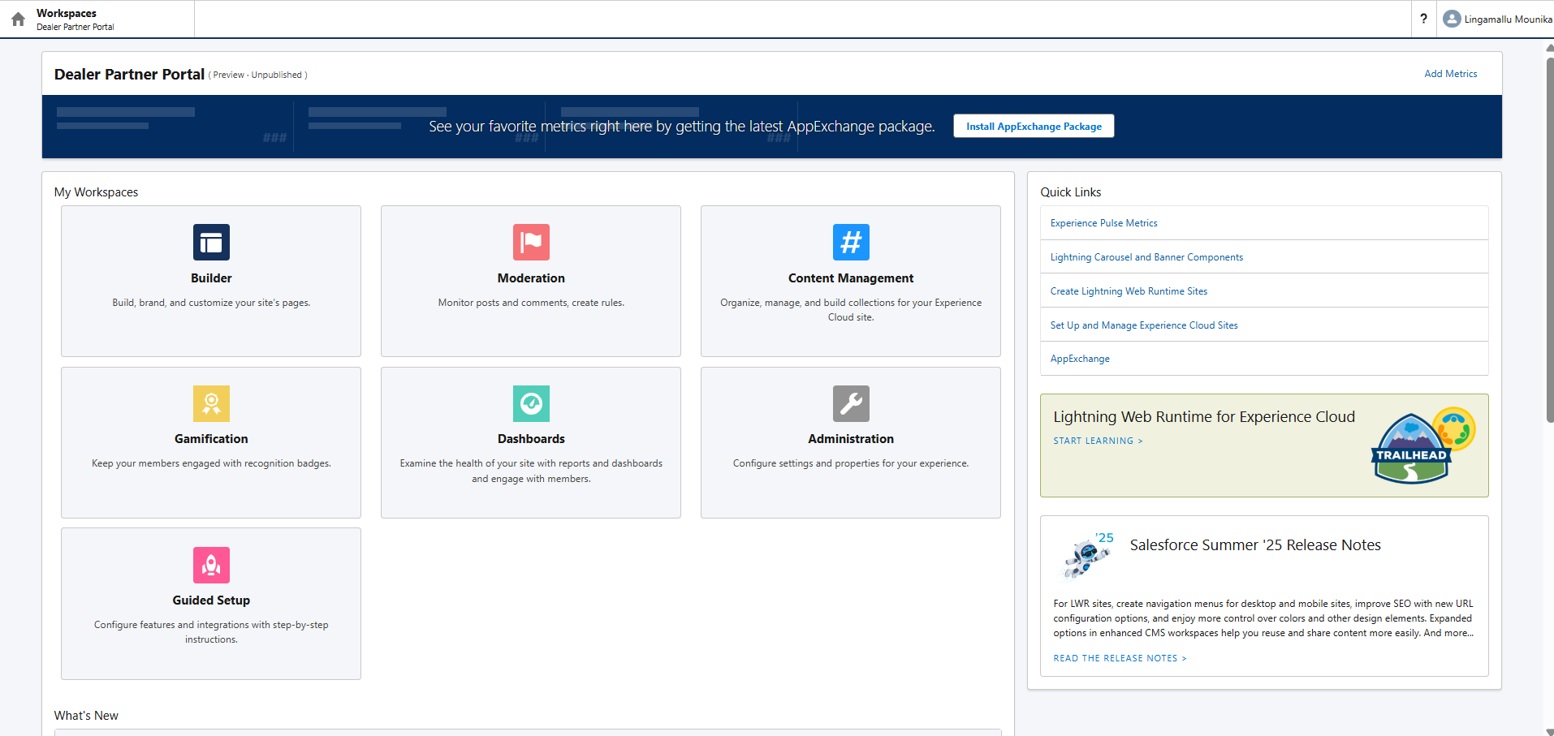

* 1. **Permission Sets**

**2.8.1 Order Export Access**

**Purpose:** Allow Sales Managers to export order reports without changing their profile.

**Configuration Steps:**

1. Go to **Setup → Permission Sets → New**.
2. Create new permission set:
   * **Label:** Order Export Access
   * **API Name:** auto-fills → Order_Export_Access
   * Click **Save**.
3. Open the permission set → **Object Settings → Orders → Edit**.
4. Under **Object Permissions**, enable:
   * Read
   * View All Records (to see all Orders, not just own).
5. Save.

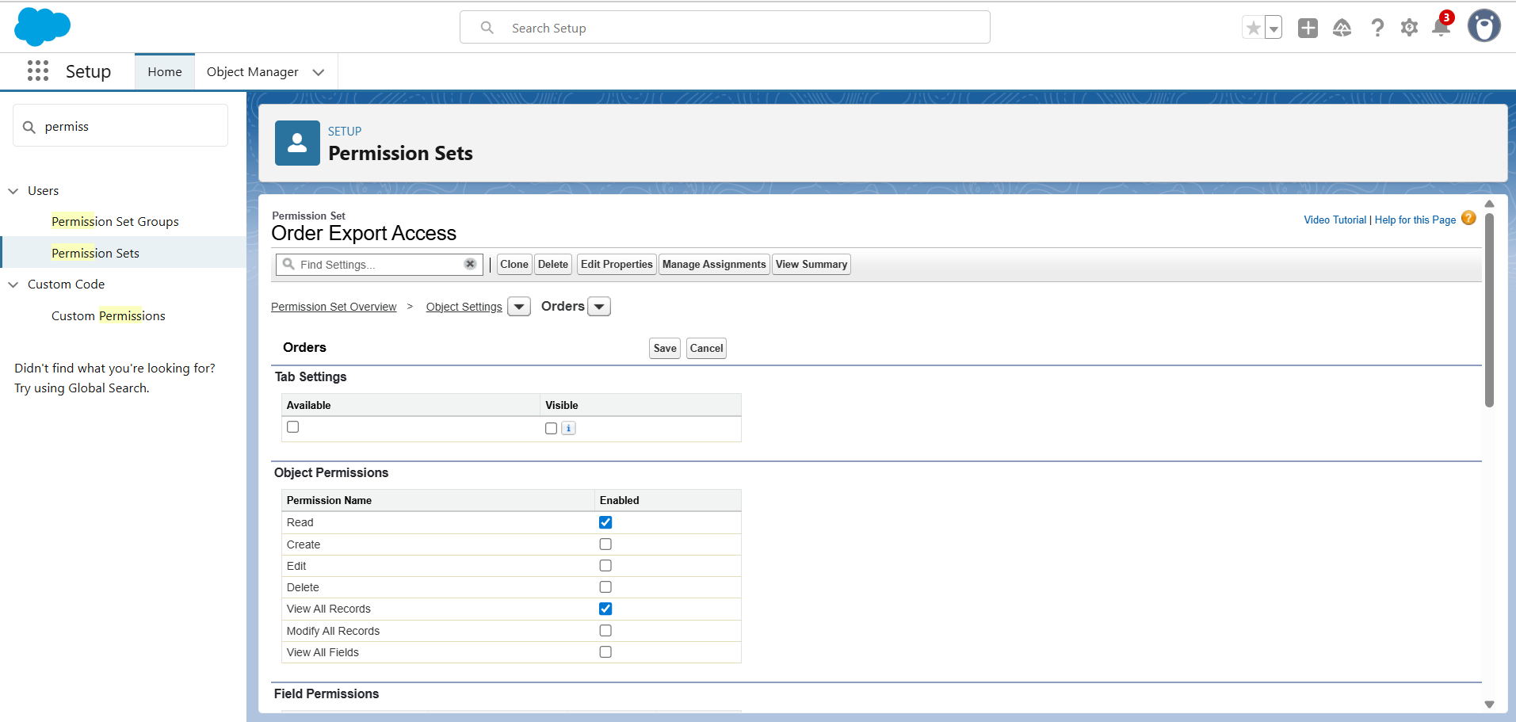

**Assign Users:**

* Manage Assignments → Add Assignments → select **Sales Head** and **Regional Sales Manager**.
* Save.

**Result:** Sales Managers can **read and export Orders** via reports.

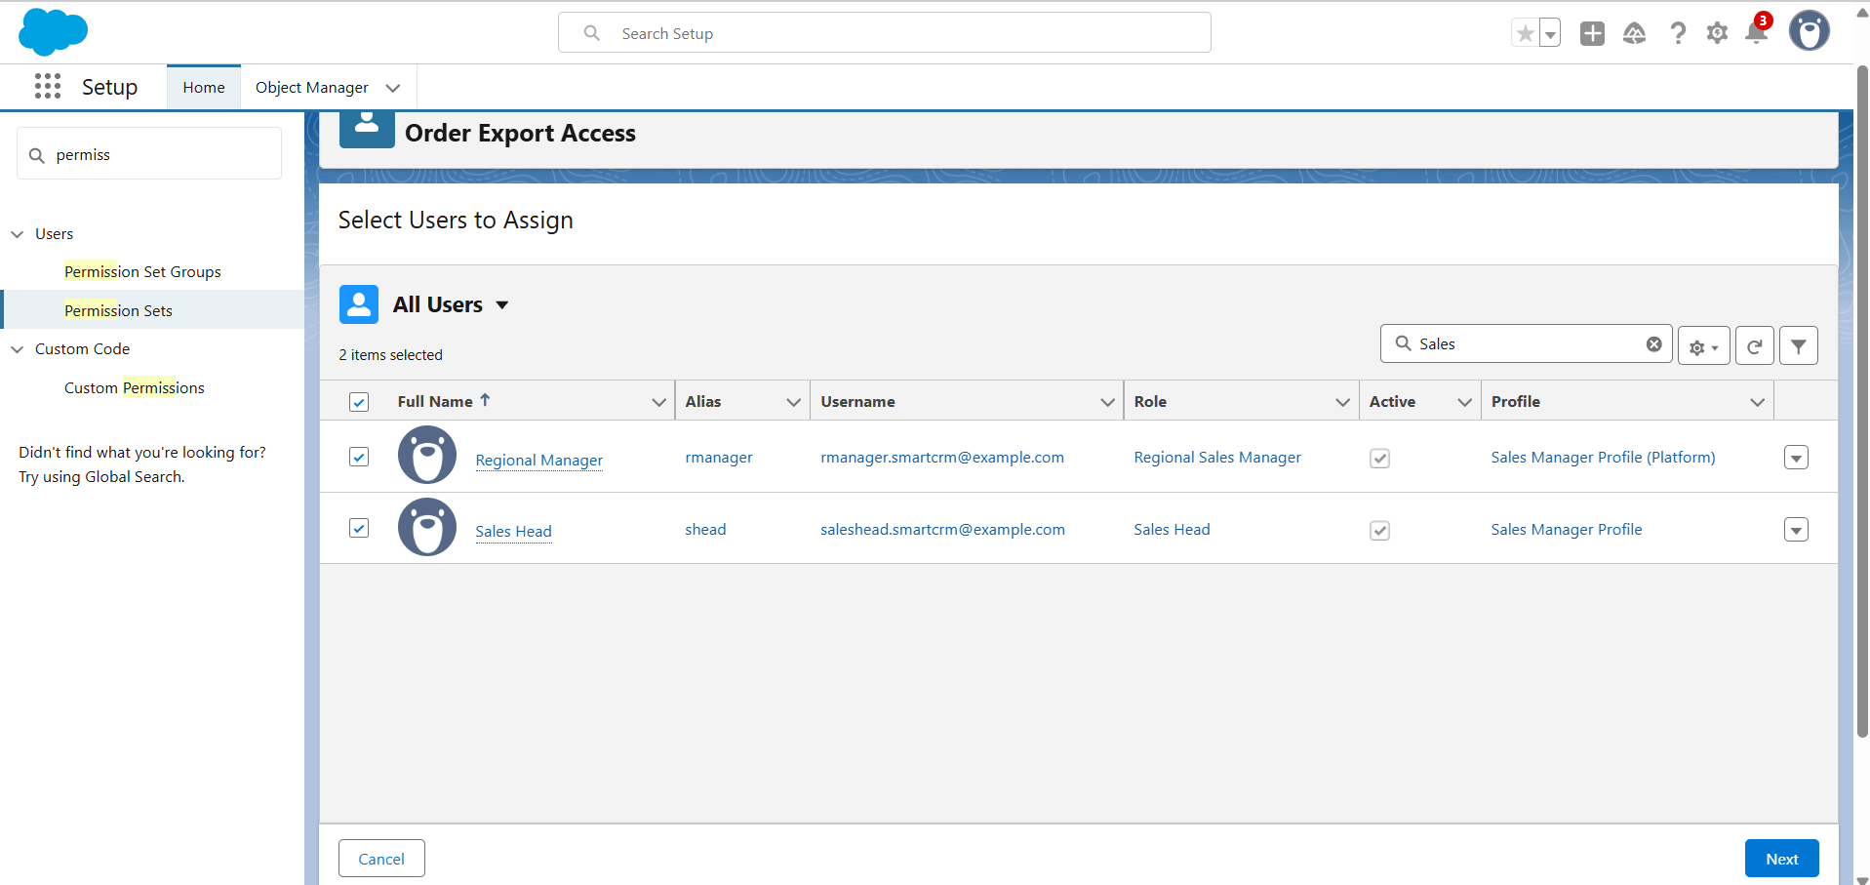

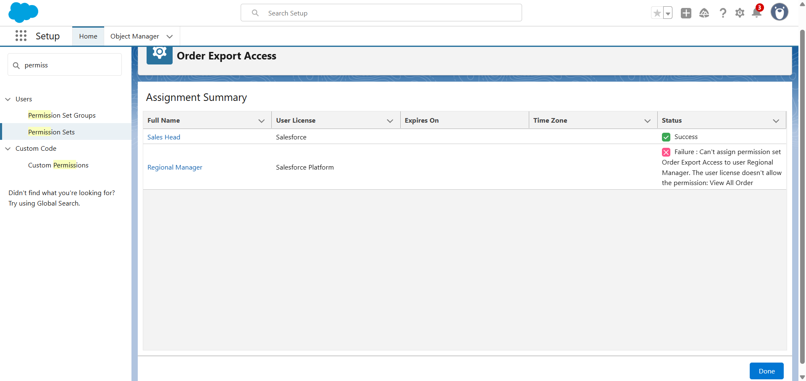

**2.8.2 Complaint Management Access**

**Purpose:** Allow Support Agents to view and update complaints across all regions.

**Configuration Steps:**

1. Go to **Setup → Permission Sets → New**.
2. Create new permission set:
   * **Label:** Complaint Management Access
   * **API Name:** auto-fills → Complaint_Management_Access
3. Click **Save**.
4. Open the permission set → **Object Settings → Complaints → Edit**.
5. Under **Object Permissions**, enable:
   * Read
   * Edit
   * View All Records (to update across regions).
6. Save.
7. **Assign Users:**
   * Manage Assignments → Add Assignments → select **Support Agent**.
   * Save.

**Result:** Support Agents can **read and edit complaints** across regions.

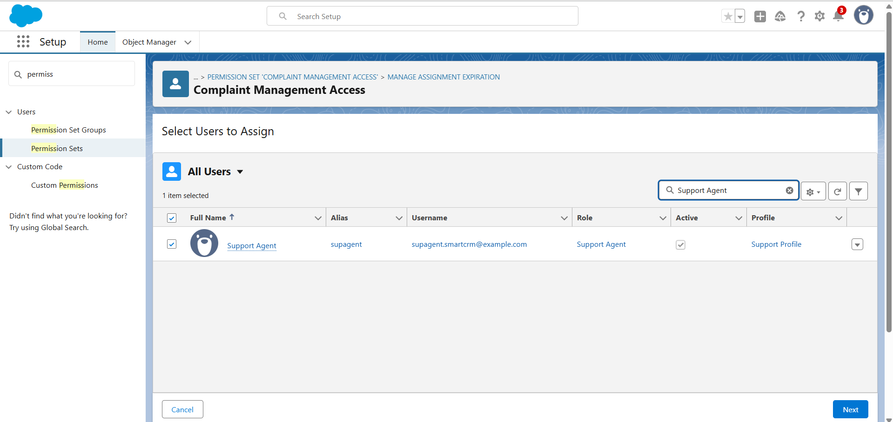

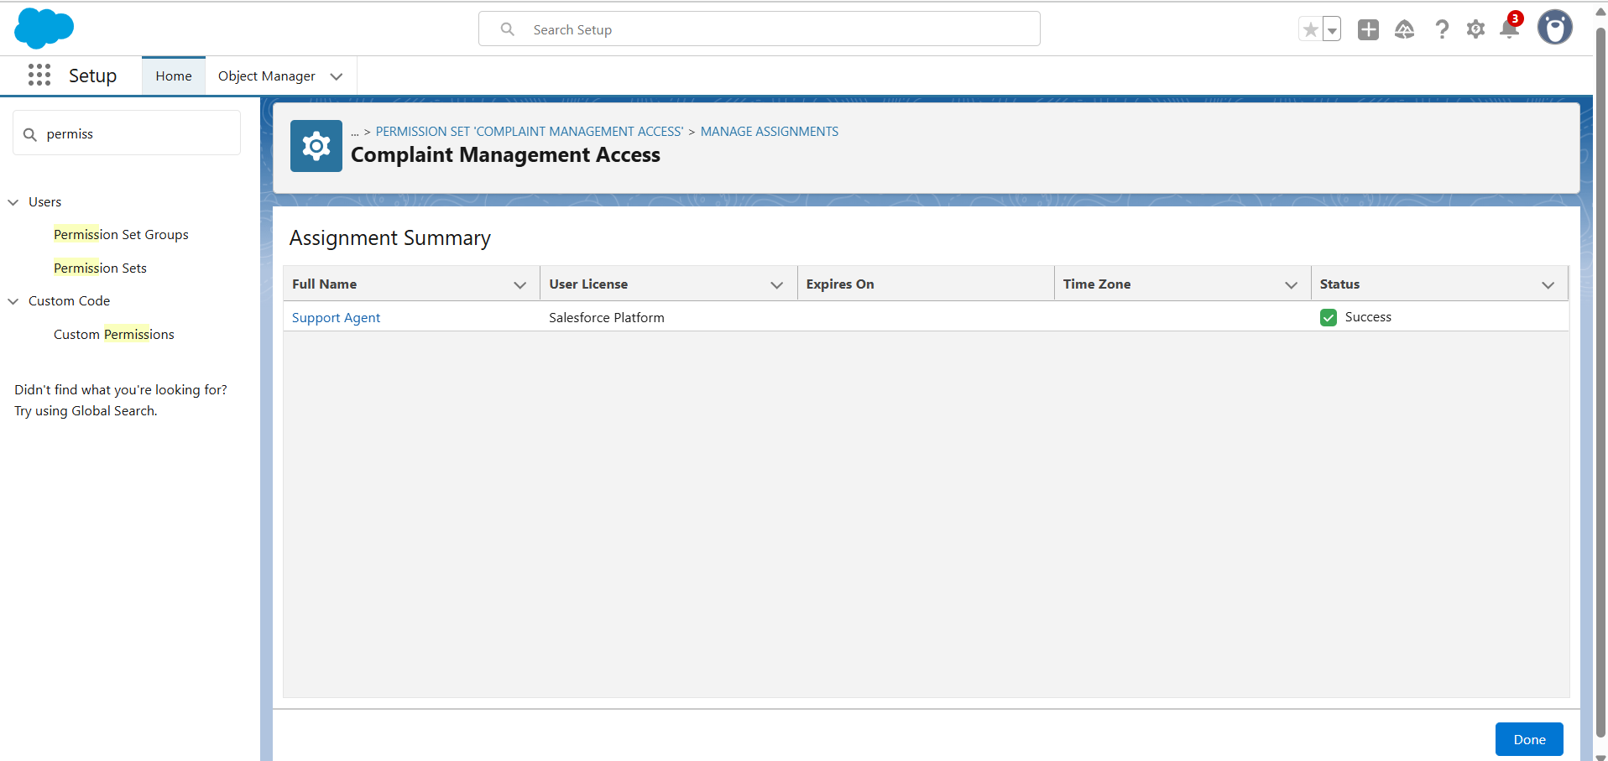

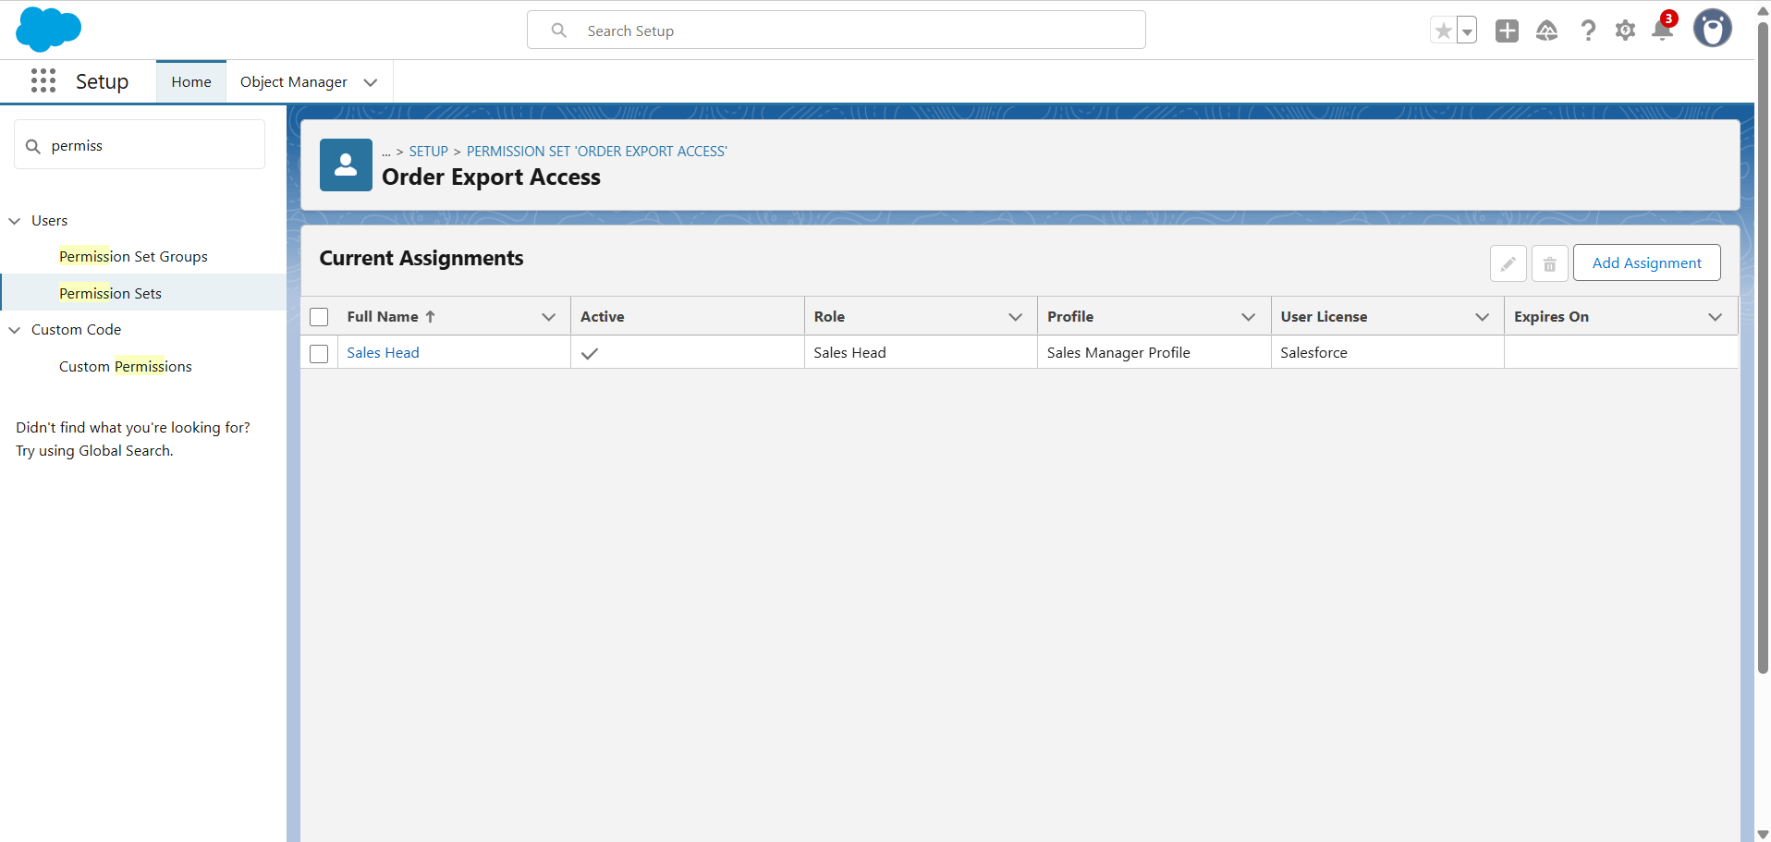

**2.9 OWD**

To manage data visibility and regulate operations across different roles.

* Access is controlled using **Private, Read Only, and Read/Write** levels.
* Users can perform only what their role permits, while sensitive business information remains protected.

**2.9.1 Organization-Wide Defaults (OWD)**

**Purpose:** Set baseline access to all records.

**Implementation Steps:**

1. Go to Setup → Security → Sharing Settings.
2. Configure defaults:
3. **Accounts** → Private

* Giving visibility only to record owners and their managers through the role hierarchy.
* This ensures confidentiality of account details.

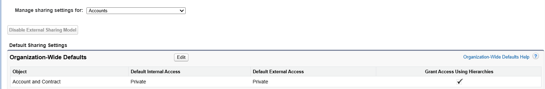

1. **Contacts** → Private

* Contacts **inherit access from their parent Account**, maintaining consistency and proper control over related records.

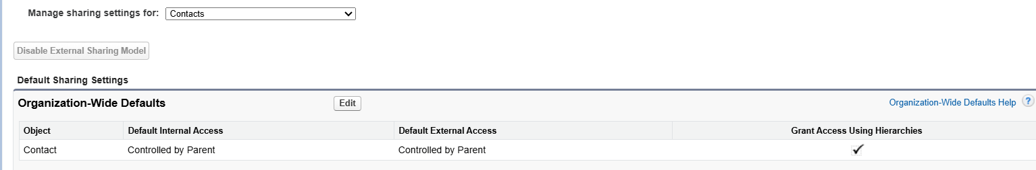

1. **Orders** → Private

* It is **Private**, dealers can work only with their own orders, while managers have the ability to view and update orders within their region.

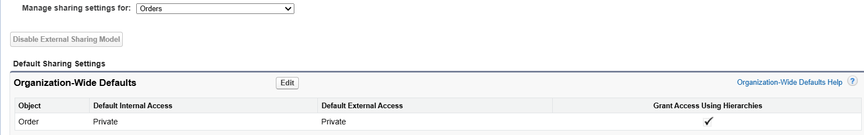

1. **Inventory** → Read Only (for dealers)

* Access is set to **Read Only** for dealers, allowing them to check stock availability, while managers are authorized to update records.

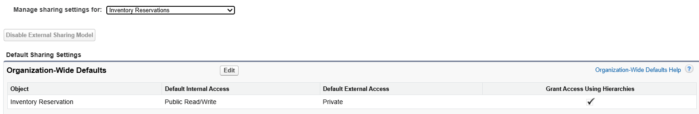

1. **Complaints** → Private

* It is **Private**, where only the assigned Support Agents and Managers can update and resolve complaints.
* Other users have no visibility into these records.

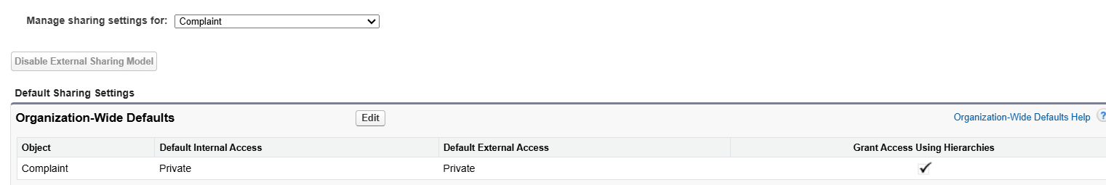

1. Save.

**Result:** Users can only see records they own unless sharing rules grant access. This ensures data security.

**2.10 Sharing rules**

**2.10.1 Region Field Creation (Dealer Object)**

* 1. Navigated to Dealer → Fields & Relationships → New
  2. Selected Picklist field type
  3. Field Label: Region
* Picklist Values: North, South, East, West
* Restrict picklist values enabled to prevent invalid entries

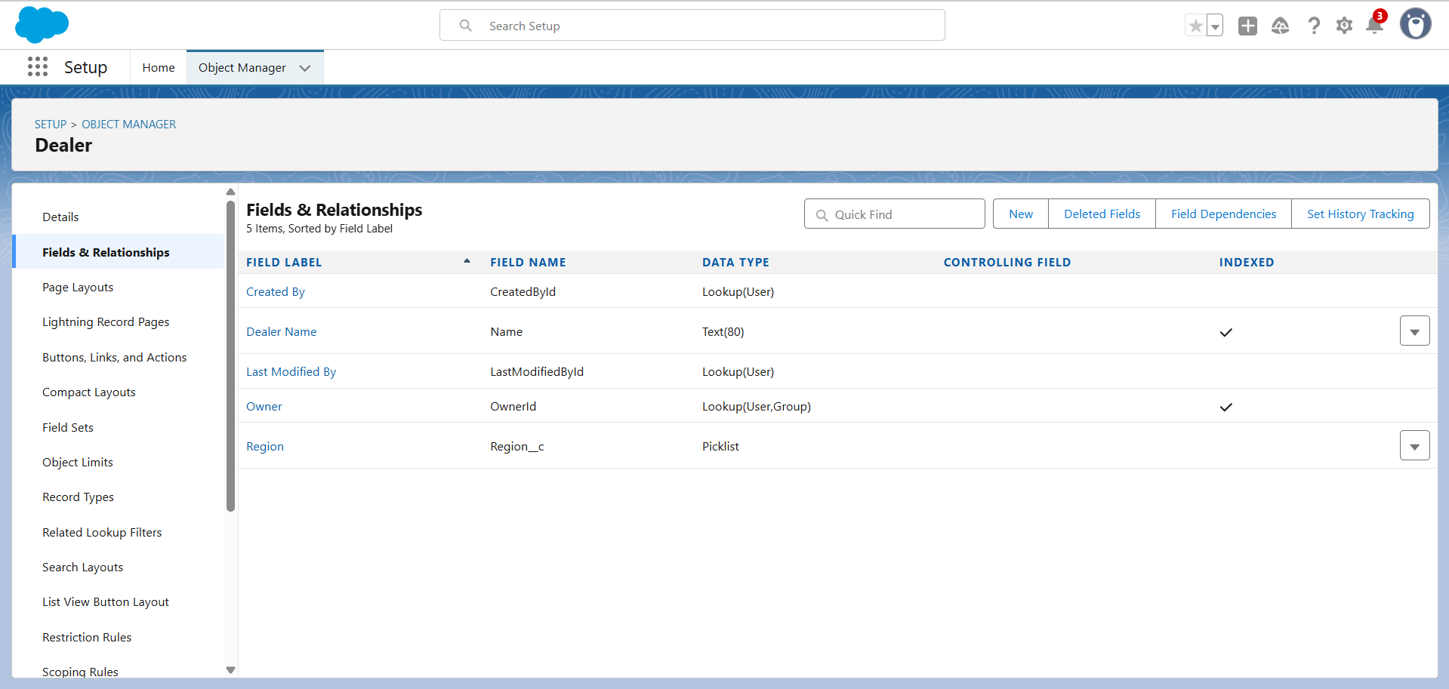

**2.10.2 Field-Level Security Configuration**

1. **Tick “Visible” for the profiles that should see the Region field:**
   * Custom: Sales Profile
   * Dealer Manager Profile
   * Custom: Support Profile
   * Customer Community Login User (Dealer Portal users)
   * Parent Portal Login User
2. **Also tick “Read-Only” for the ones who should only view but not edit:**

* Support Profile – Visible and Read-Only
* Customer Community Login User – Visible and Read-Only

1. **After that, click Next and Save.**
   * 1. **Next Steps**

* Add sample Region values to existing Dealer records (e.g., Dealer A to South, Dealer B to North).
* Configure Sharing Rules: Dealer.Region = Assigned Region.
* Repeat similar Region field creation for Distributor and Order objects to maintain consistency.
* Use Region in dashboards and reports for region-wise performance tracking.

**Dealer Sharing Rule**

1. **Created Region Field**

* Added a custom **Picklist field** Region on the Dealer object with values: North, South, East, West.
* Updated sample Dealer records with the correct region values.

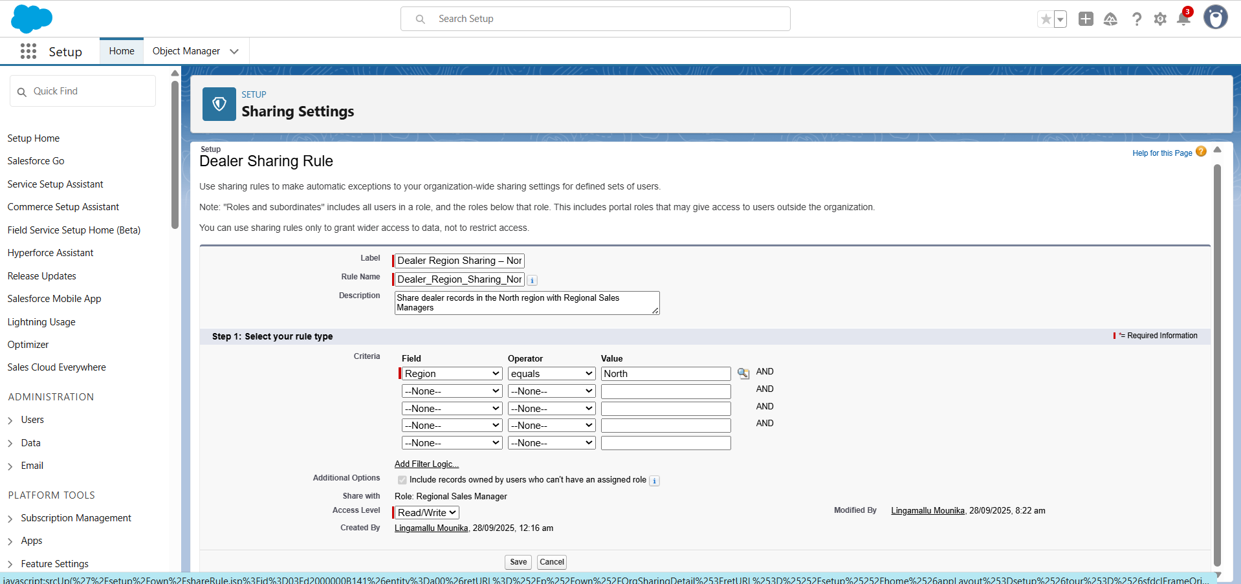

1. **Configured Dealer Sharing Rule**
   * **Label**: Dealer Region Sharing
   * **Rule Name**: Dealer_Region_Sharing
   * **Description**: Share dealer records based on region with Regional Sales Managers
   * **Rule Type**: Based on criteria
   * **Criteria**: Region = South
   * **Shared With**: Role to Regional Sales Manager
   * **Access Level**: Read/Write

**Result**: All Dealer records where **Region = South** are now shared with **Regional Sales Managers**.

1. **Custom Field Setup**

* Created custom picklist field **Region** on Dealer object with values: North, South, East, West.
* Updated existing Dealer records with correct Region values.

**Sharing Rules Configured**

* **Rule Type**: Criteria-Based
* **Criteria**: Dealer.Region = North / South / East / West
* **Shared With**: Role as Regional Sales Manager (corresponding region)
* **Access Level**: Read/Write

**Result**

* Dealer records are automatically shared to Regional Sales Managers based on their assigned region.
* Regional Managers can view and update only dealer records in their own territory.

**d) Dealer Sharing Rule**

**1. Created Region Field**

* Added a **custom Picklist field** Region on the **Dealer** object with values:
  + North
  + South
  + East
  + West
* Updated sample Dealer records with the correct **Region values**.

**2. Configured Dealer Sharing Rules**

**Rule 1: Dealer Region Sharing – North**

* **Label**: Dealer Region Sharing – North
* **Rule Name**: Dealer_Region_Sharing_North
* **Description**: Share dealer records in the North region with Regional Sales Managers
* **Rule Type**: Criteria-Based
* **Criteria**: Dealer.Region = North
* **Shared With**: Role → Regional Sales Manager (North)
* **Access Level**: Read/Write

**Rule 2: Dealer Region Sharing – South**

* **Label**: Dealer Region Sharing – South
* **Rule Name**: Dealer_Region_Sharing_South
* **Description**: Share dealer records in the South region with Regional Sales Managers
* **Rule Type**: Criteria-Based
* **Criteria**: Dealer.Region = South
* **Shared With**: Role → Regional Sales Manager (South)
* **Access Level**: Read/Write

**Rule 3: Dealer Region Sharing – East**

* **Label**: Dealer Region Sharing – East
* **Rule Name**: Dealer_Region_Sharing_East
* **Description**: Share dealer records in the East region with Regional Sales Managers
* **Rule Type**: Criteria-Based
* **Criteria**: Dealer.Region = East
* **Shared With**: Role → Regional Sales Manager (East)
* **Access Level**: Read/Write

**Rule 4: Dealer Region Sharing – West**

* **Label**: Dealer Region Sharing – West
* **Rule Name**: Dealer_Region_Sharing_West
* **Description**: Share dealer records in the West region with Regional Sales Managers
* **Rule Type**: Criteria-Based
* **Criteria**: Dealer.Region = West
* **Shared With**: Role → Regional Sales Manager (West)
* **Access Level**: Read/Write

**3. Result**

* **North Regional Managers** can view and update North dealer records.
* **South Regional Managers** can view and update South dealer records.
* **East Regional Managers** can view and update East dealer records.
* **West Regional Managers** can view and update West dealer records.

Top of Form

Bottom of Form

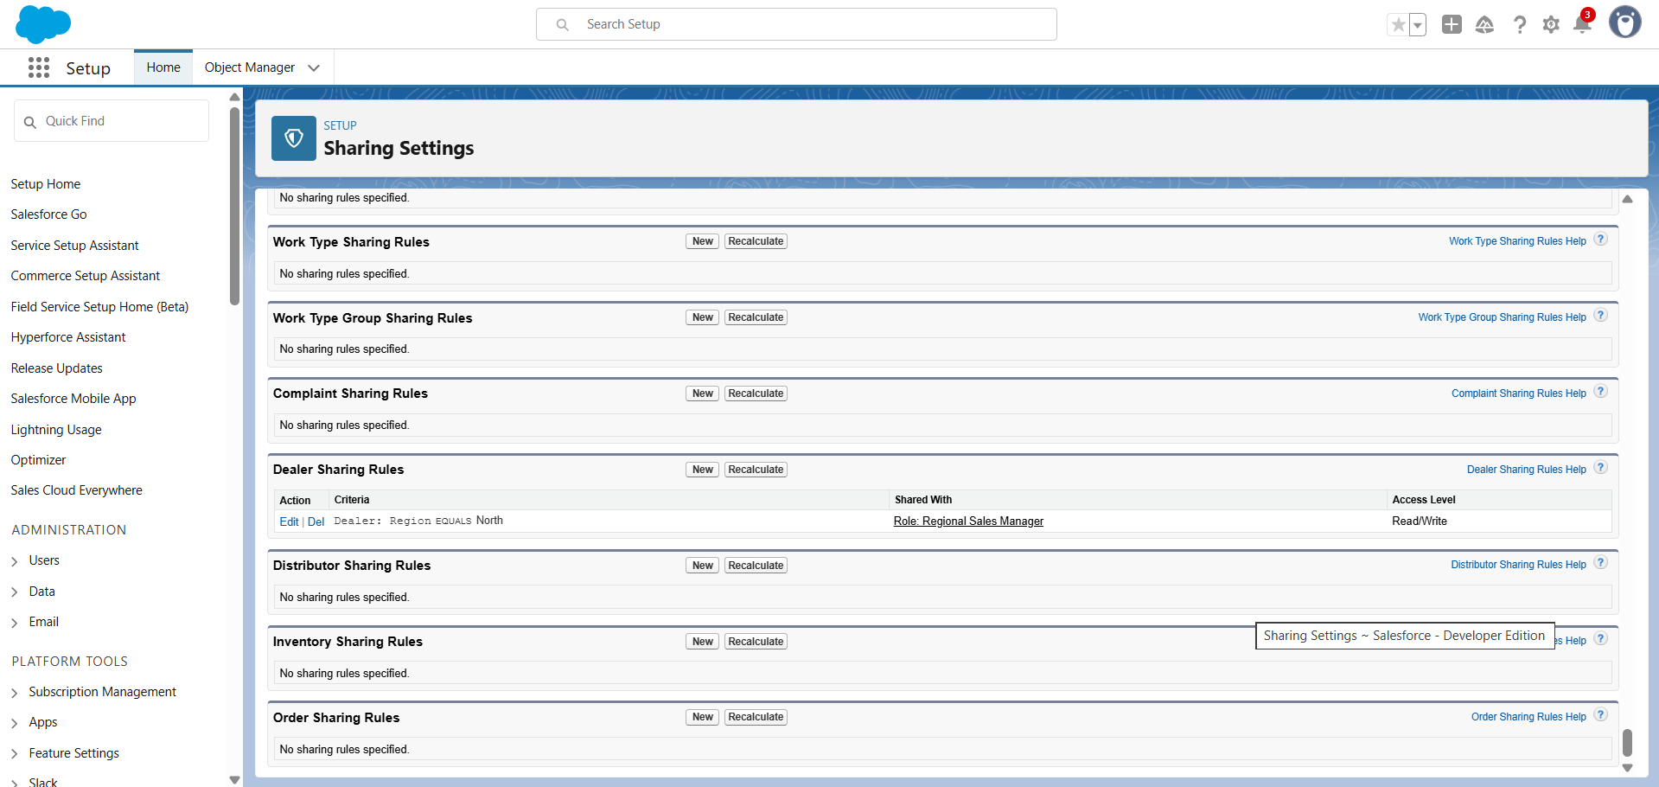

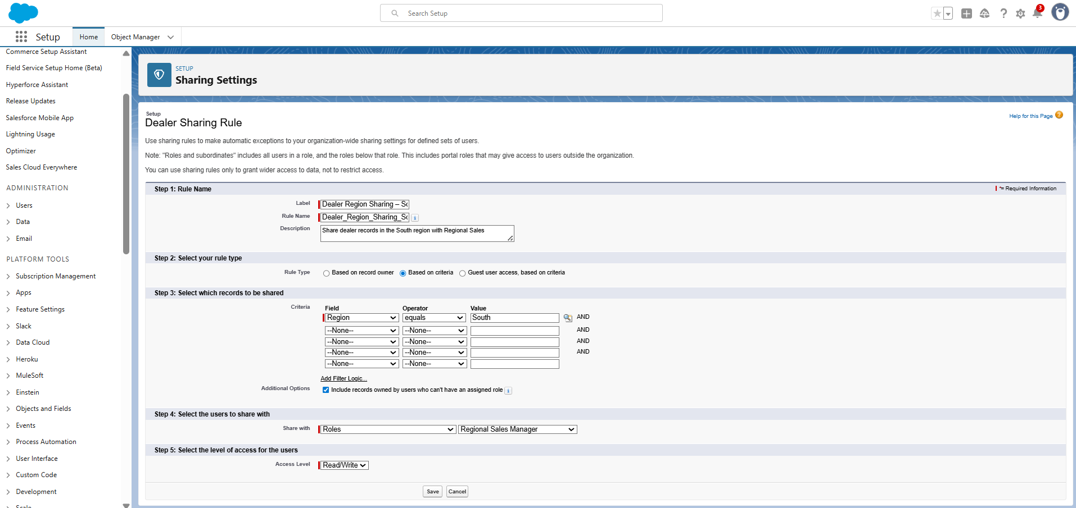

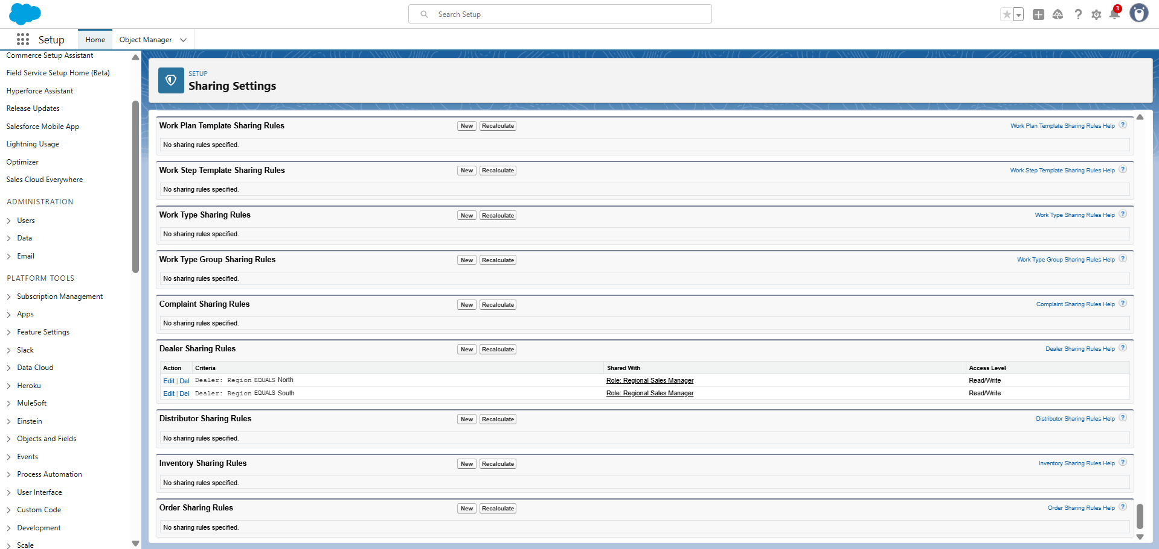

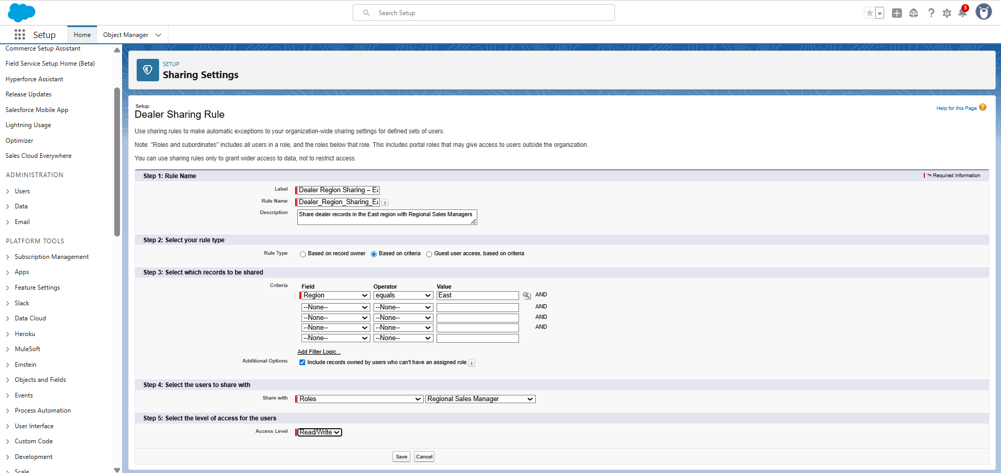

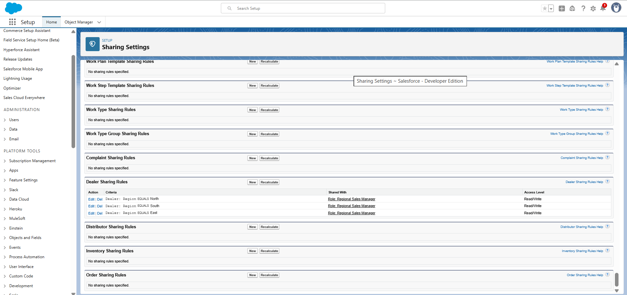

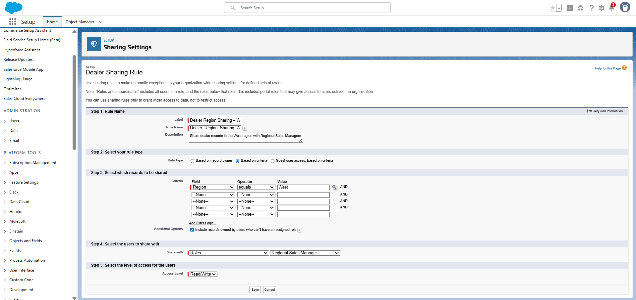

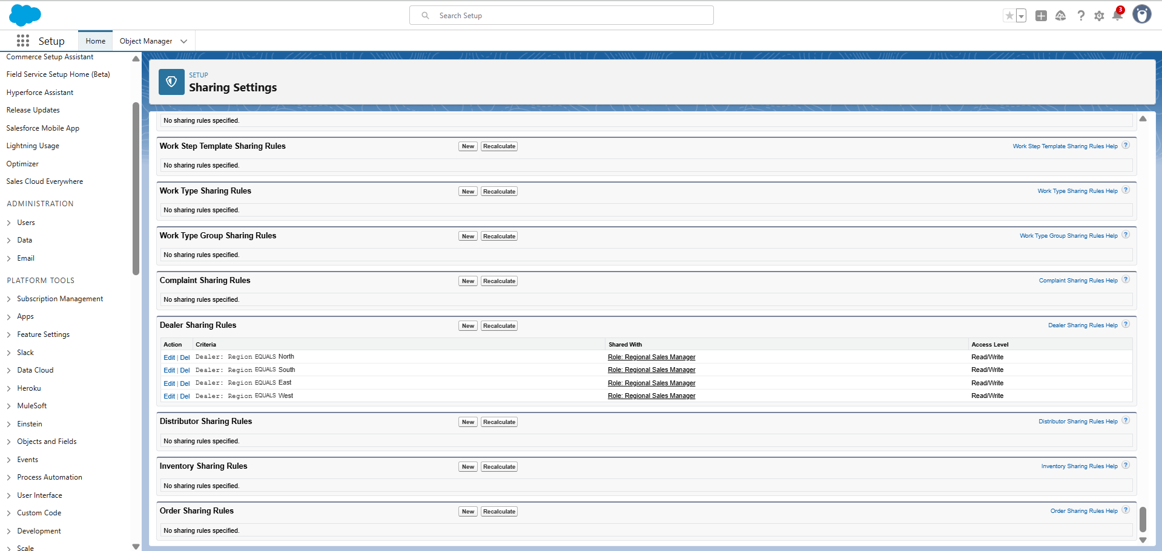

**Order Sharing Rules**

**Step 1: Rule Name**

* **Label:** Order Region Sharing – North
* **Rule Name:** Order_Region_Sharing_North
* **Description:** Shares all orders in the North region with Regional Sales Manager (North).

**Step 2: Select Rule Type**

* **Rule Type:** Based on Criteria

**Step 3: Select Records to be Shared**

* **Criteria:**
  + **Field:** Region
  + **Operator:** Equals
  + **Value:** North

**Step 4: Select Users to Share With**

* **Share With:** Role → Regional Sales Manager (North)

**Step 5: Select Access Level**

* **Access Level:** Read/Write

**Result:** Orders where Region = North are automatically shared with the **Regional Sales Manager (North)** role.

the same steps for South, East, and West, only changing the **Value** (Region = South/East/West) and the **Role** (Regional Sales Manager – South/East/West).

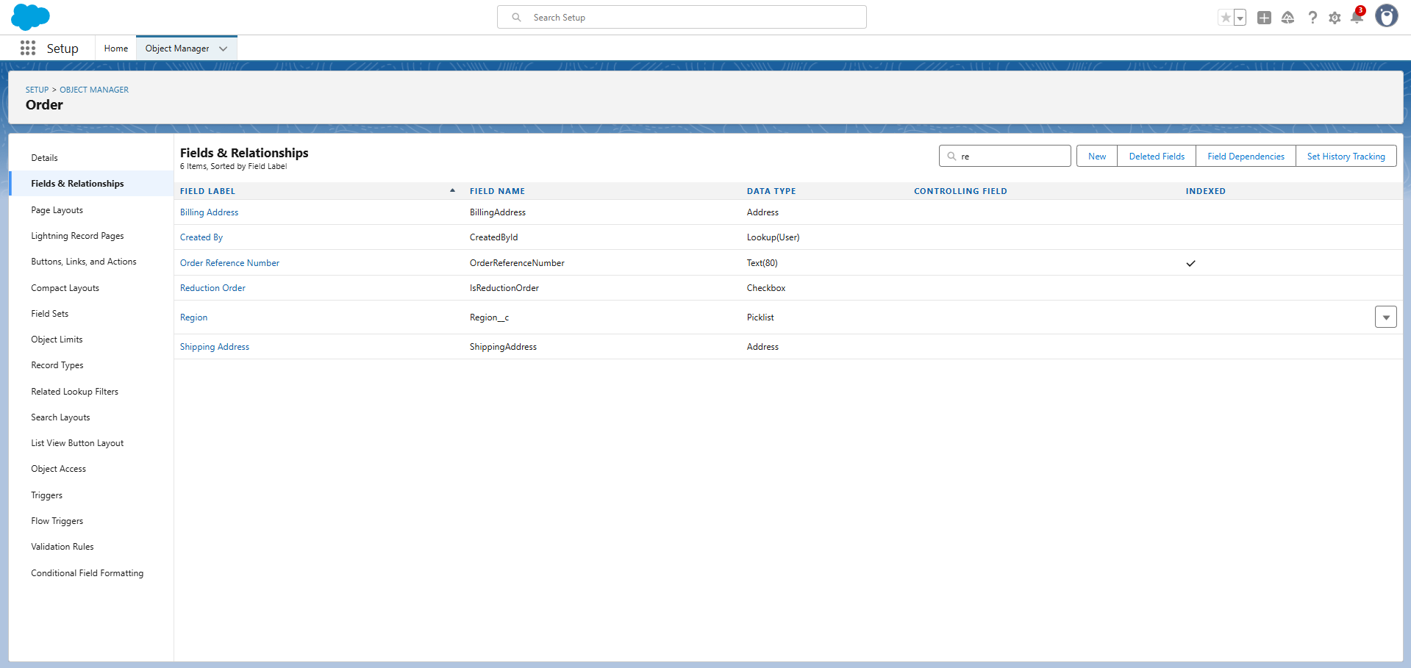

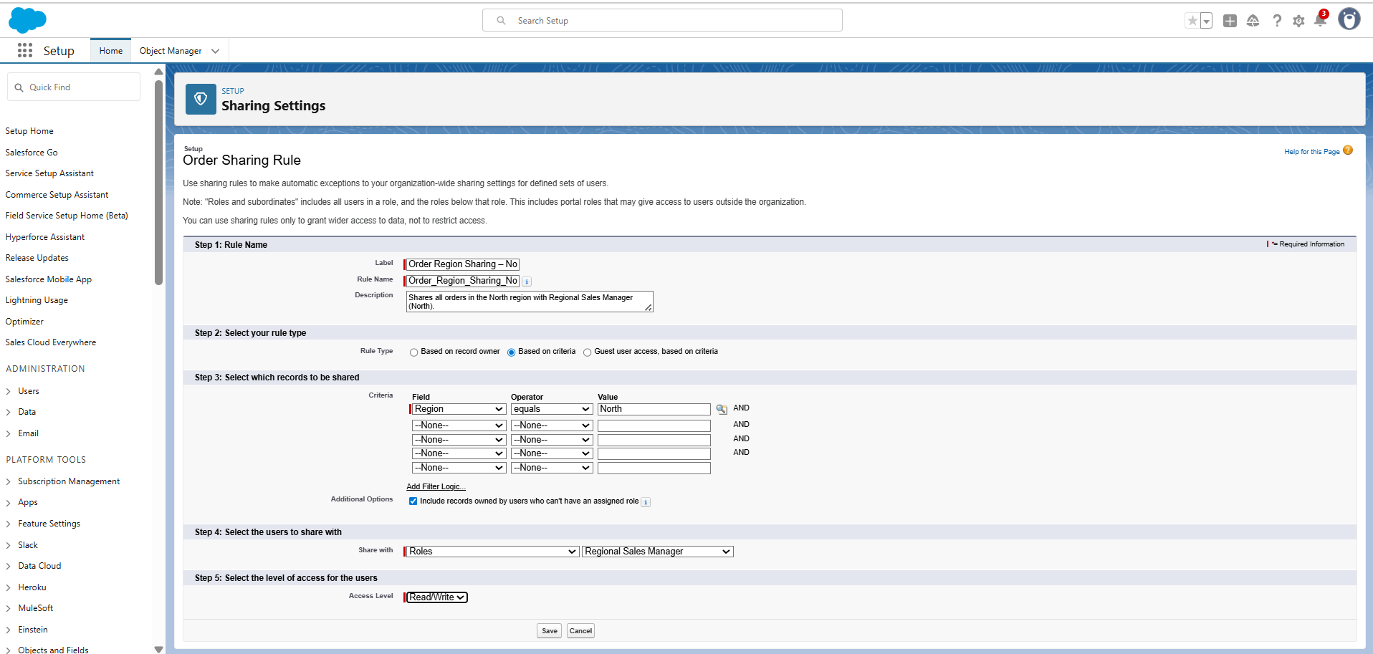

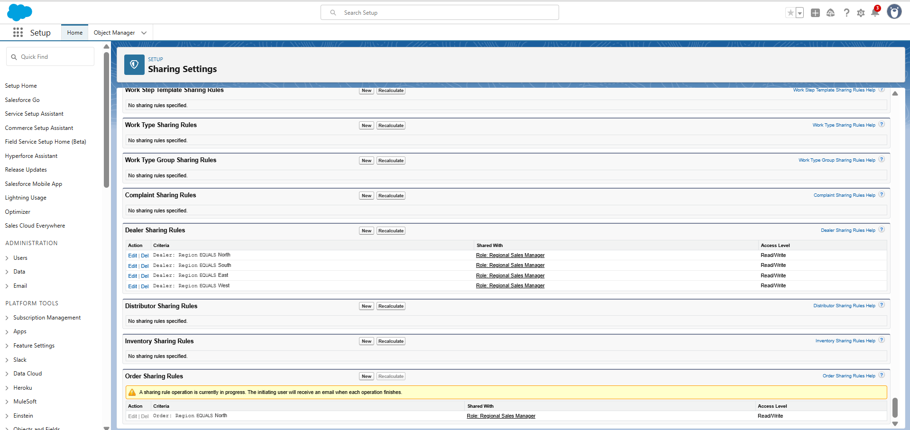

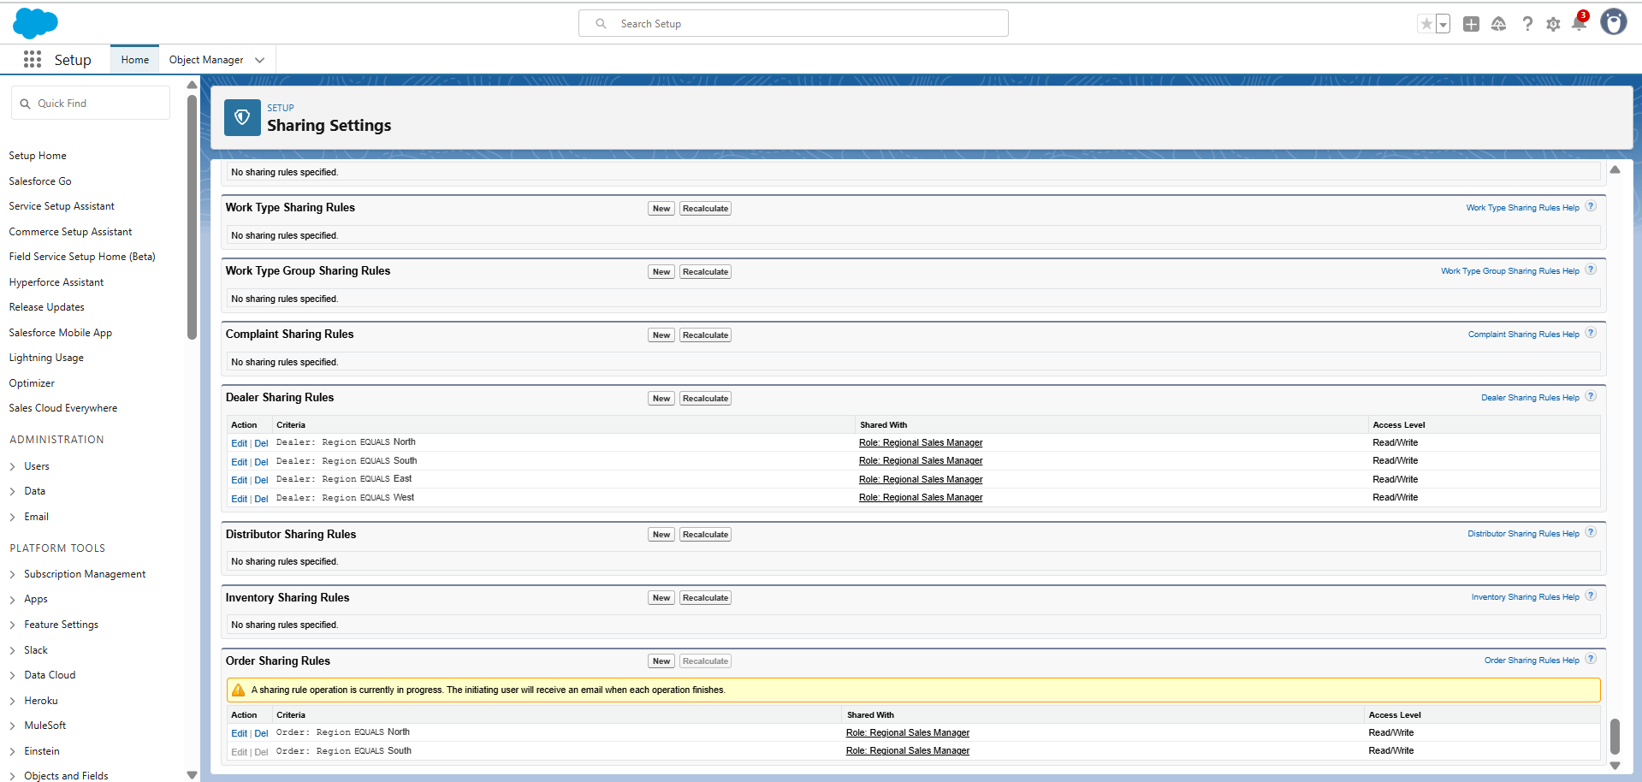

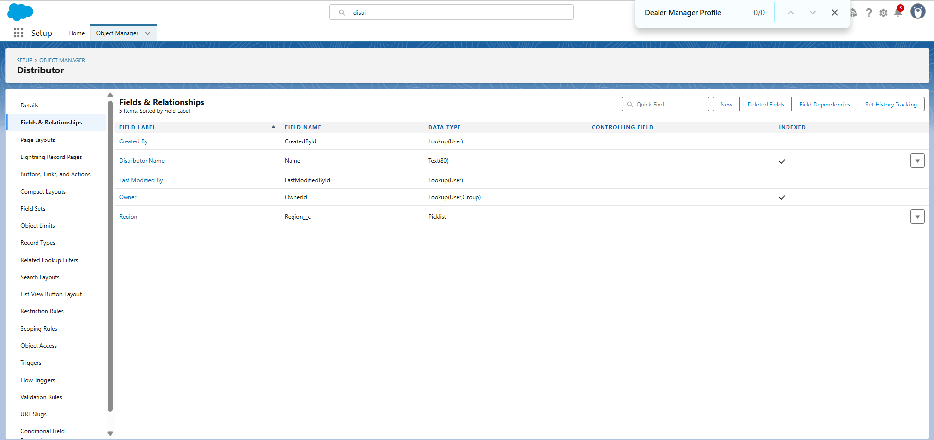

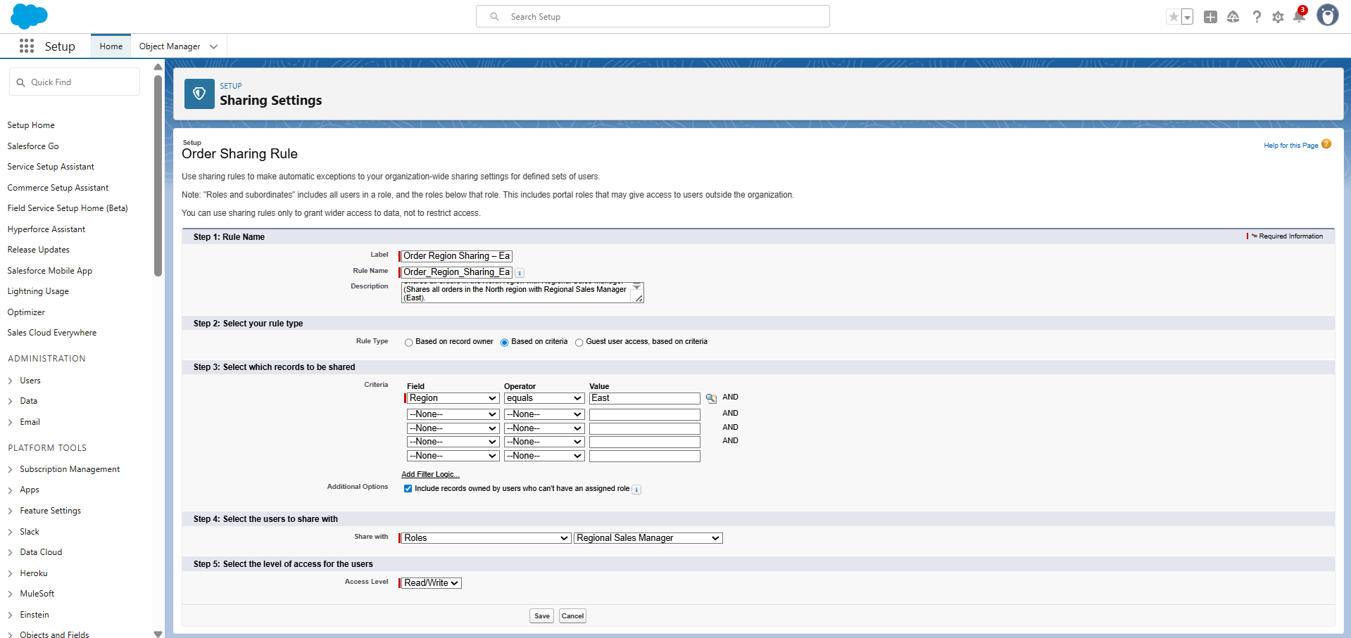 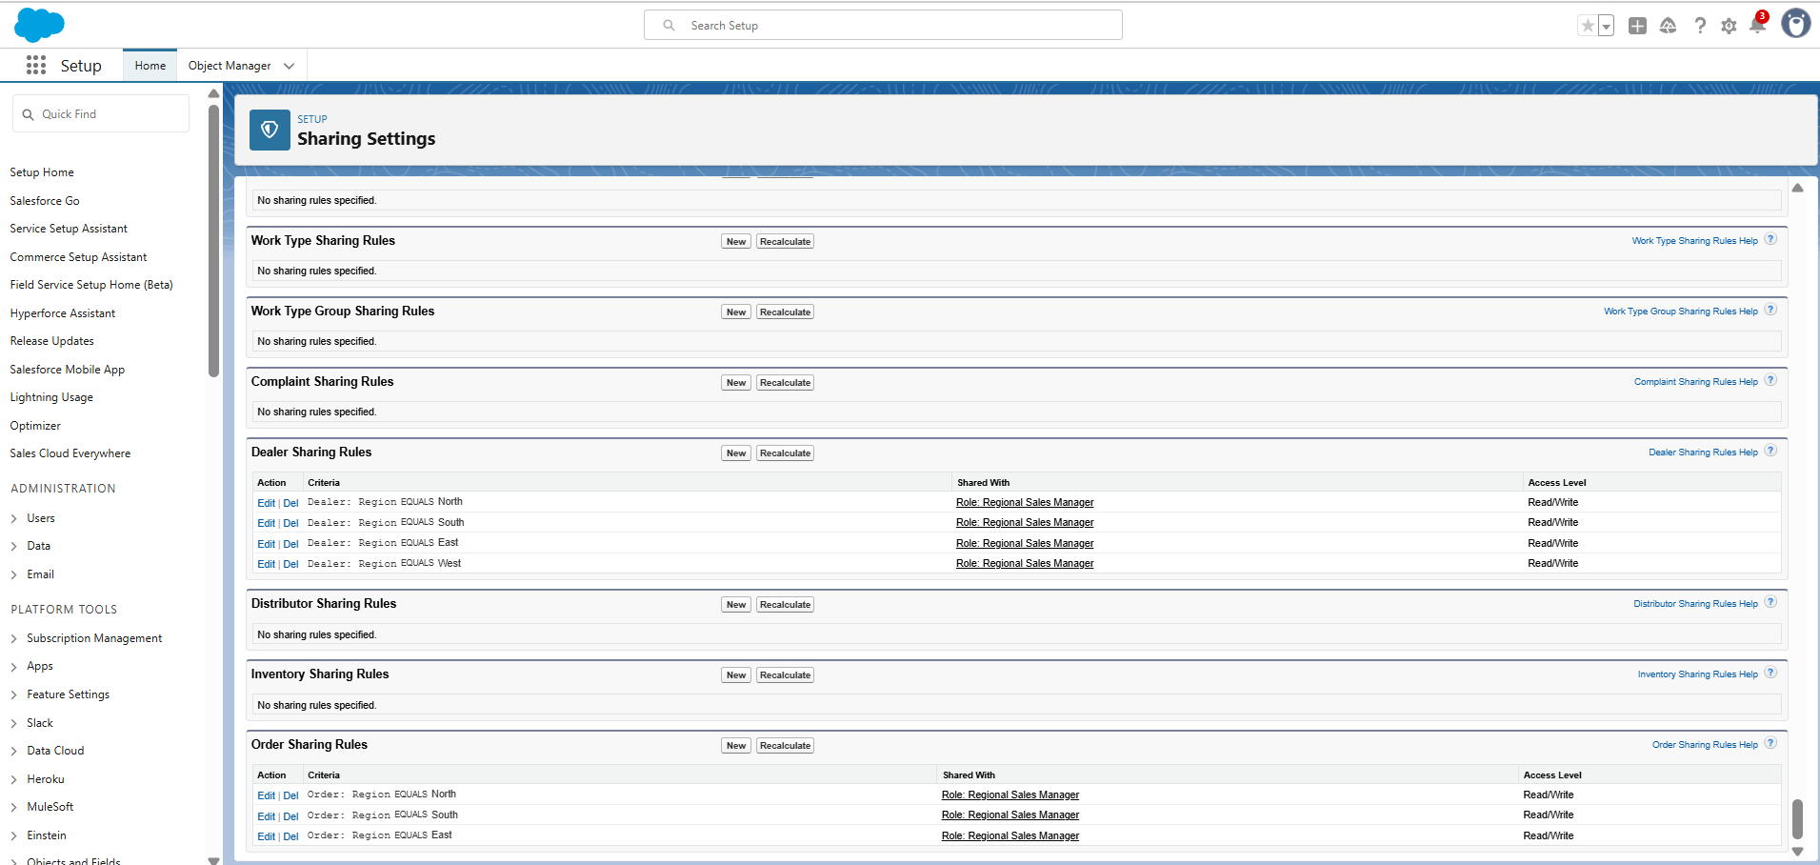

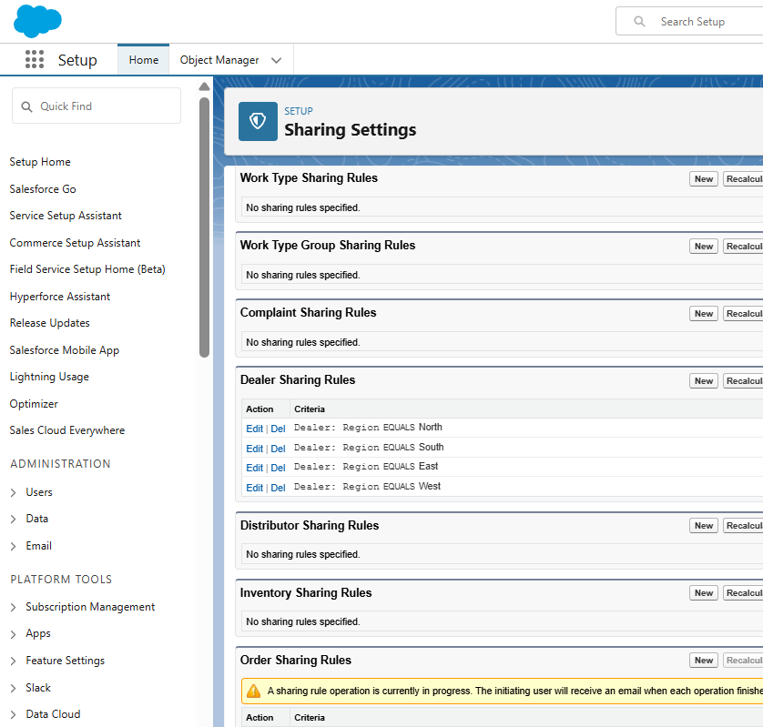 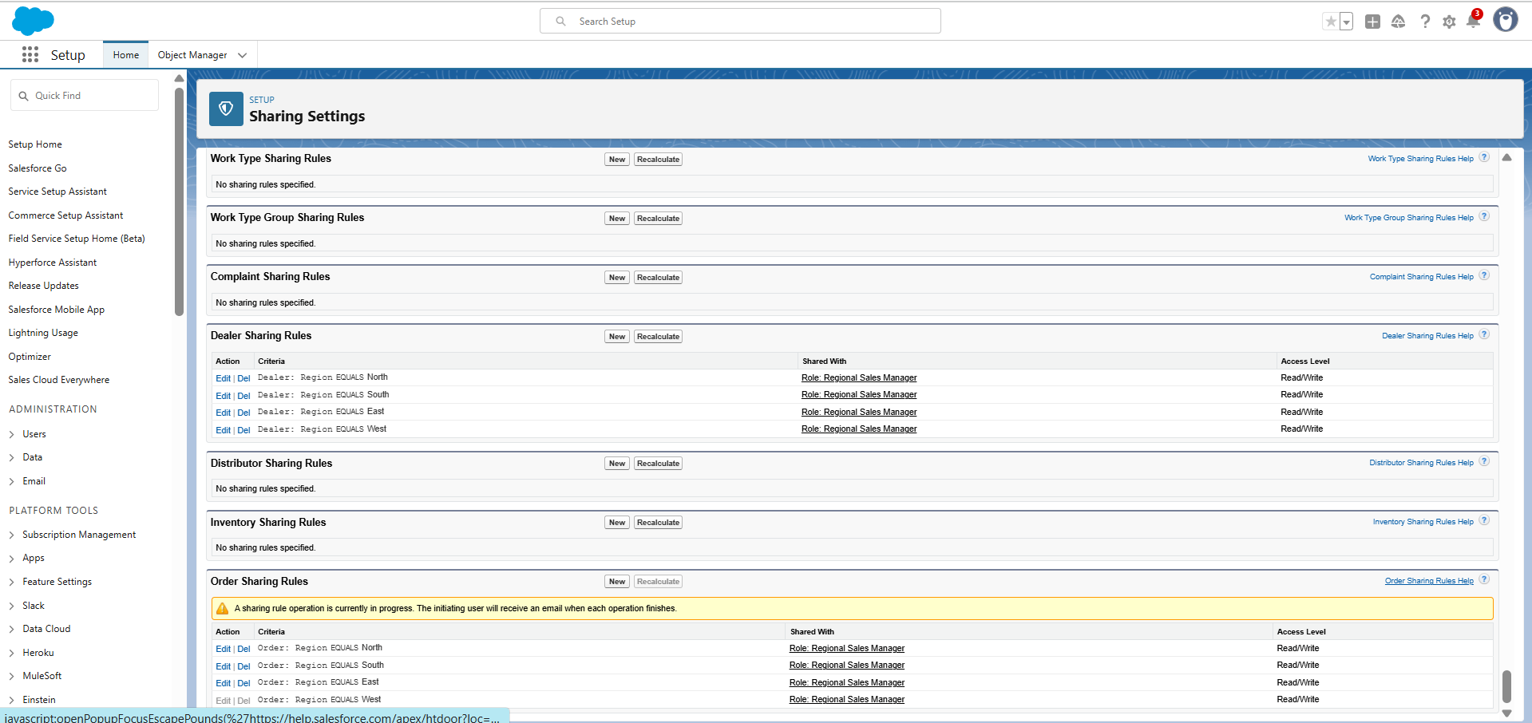 **Distributor Sharing Rule Setup**

**Step 1: Rule Name**

* **Label:** Distributor Region Sharing – North
* **Rule Name:** Distributor_Region_Sharing_North
* **Description:** Shares Distributor records in the North region with Regional Sales Manager (North).

**Step 2: Select Rule Type**

* **Rule Type:** Based on Criteria

**Step 3: Select Records to be Shared**

**Criteria:**

* + **Field:** Distributor.Region
  + **Operator:** Equals
  + **Value:** North

**Step 4: Select the Users to Share With**

* **Share With:** Role → Regional Sales Manager (North)

**Step 5: Select the Level of Access for the Users**

* **Access Level:** Read/Write

**Distributor Sharing Rules – Work Done**

* **Type:** Criteria-Based
* **Criteria:** Distributor.Region = Assigned Region
* **Shared With:** Role → Regional Sales Manager (corresponding region)
* **Access:** Read/Write
* **Purpose:** To ensure Regional Managers can access distributor records only within their territory.

**Result:**

* North Regional Manager → Access to North Distributor records.
* South Regional Manager → Access to South Distributor records.
* East Regional Manager → Access to East Distributor records.
* West Regional Manager → Access to West Distributor records.

**Territory-based visibility is enforced for distributor management.**

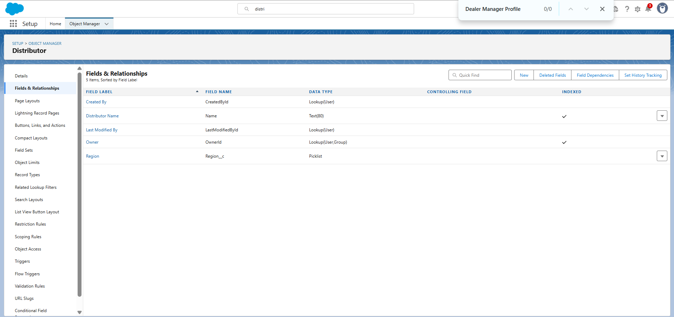

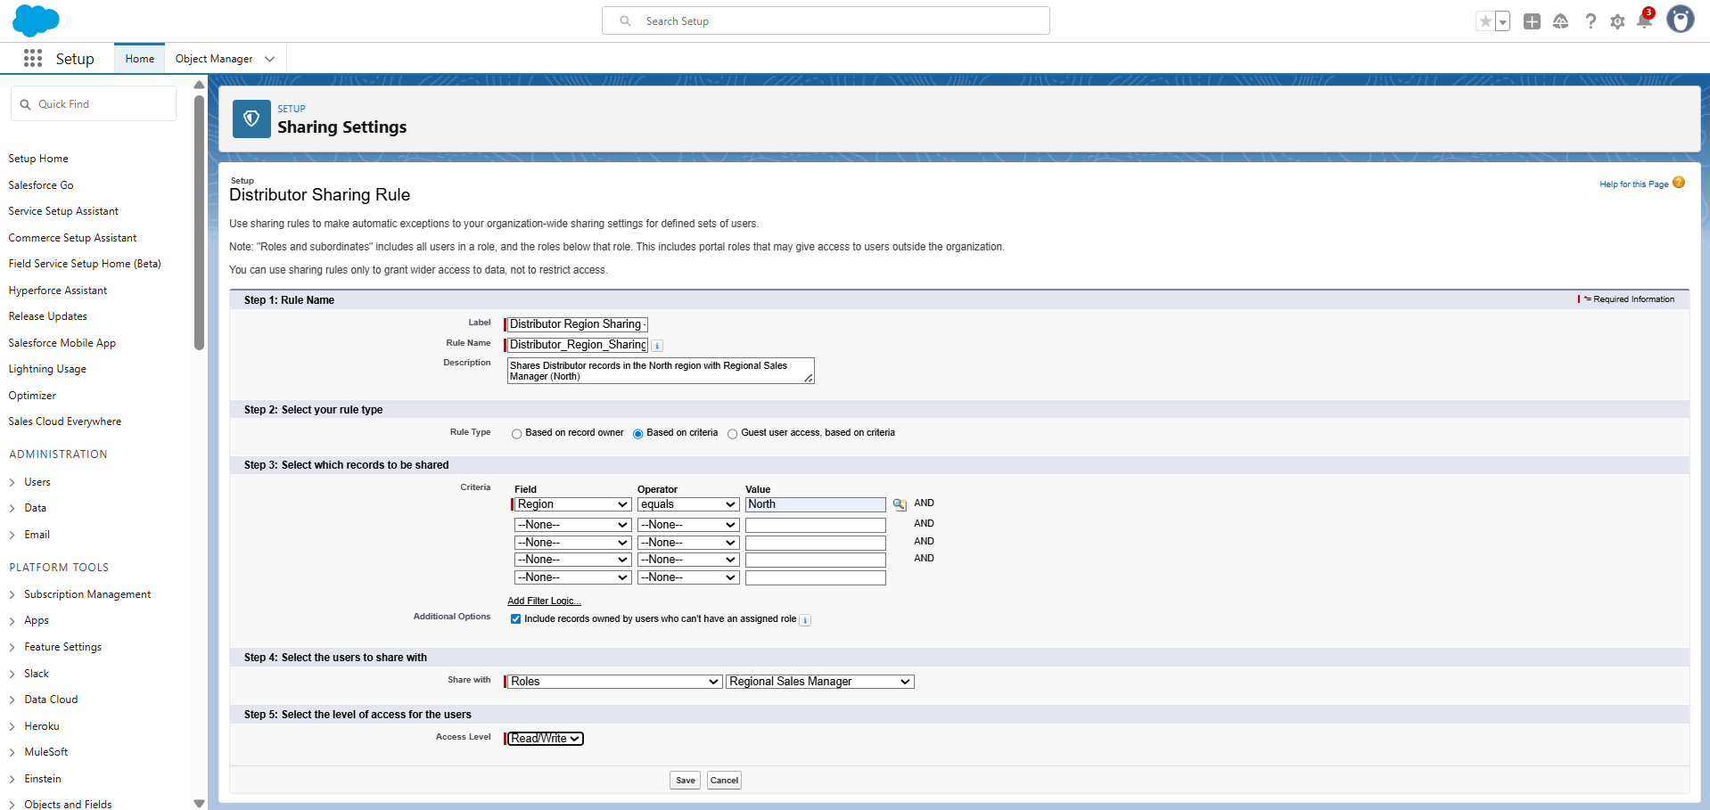

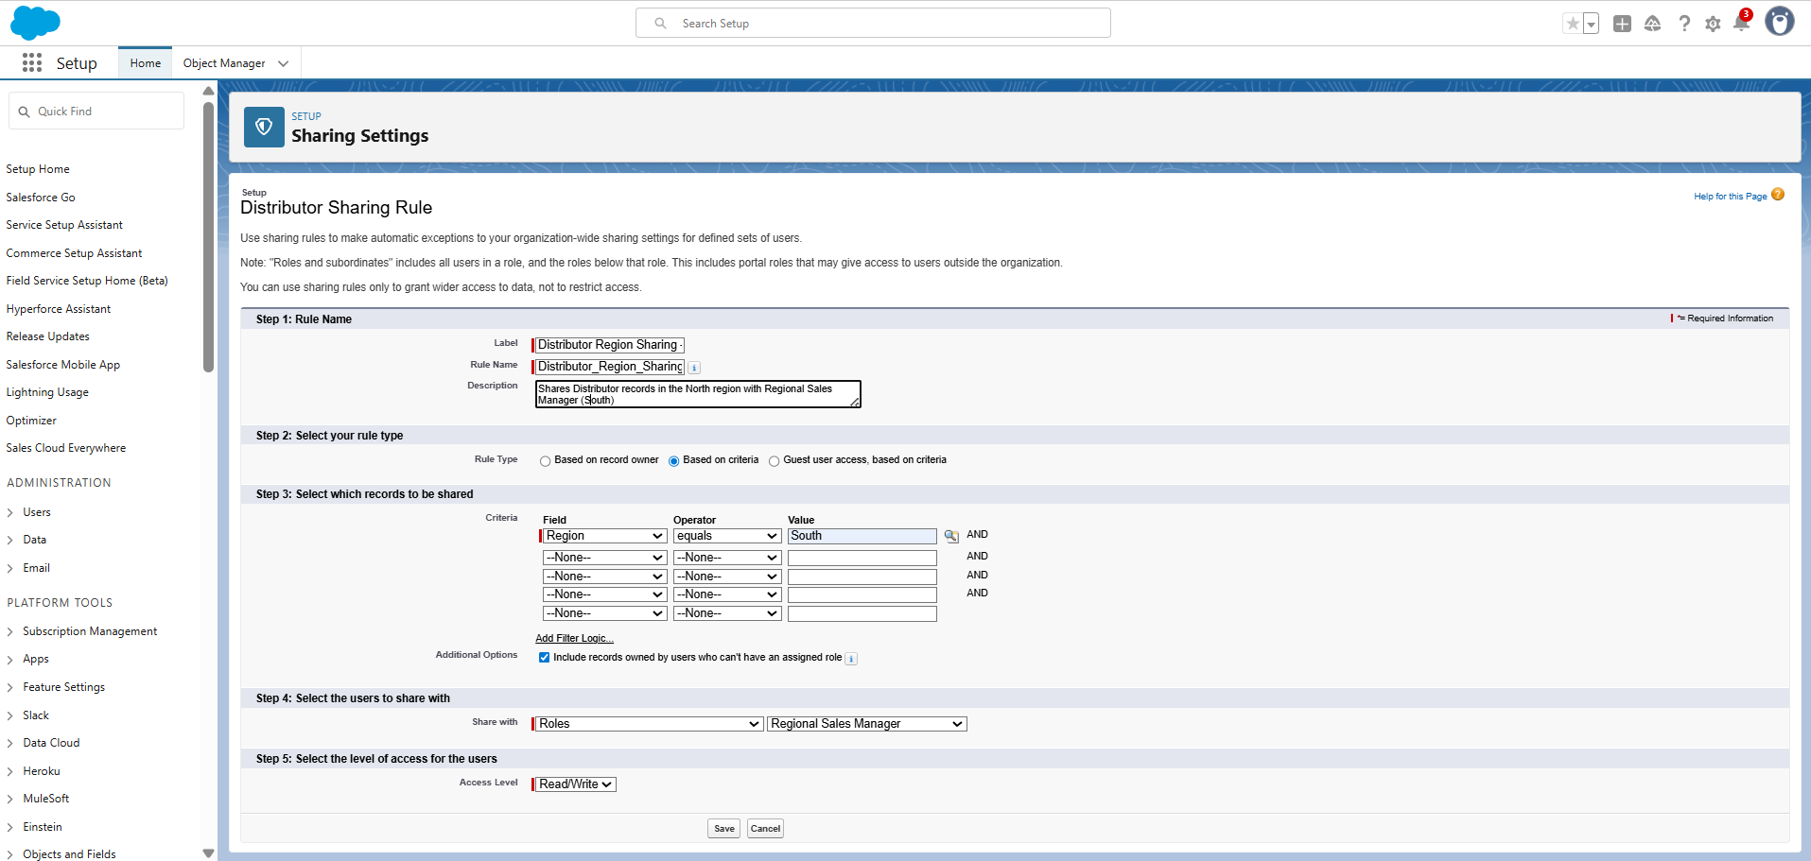

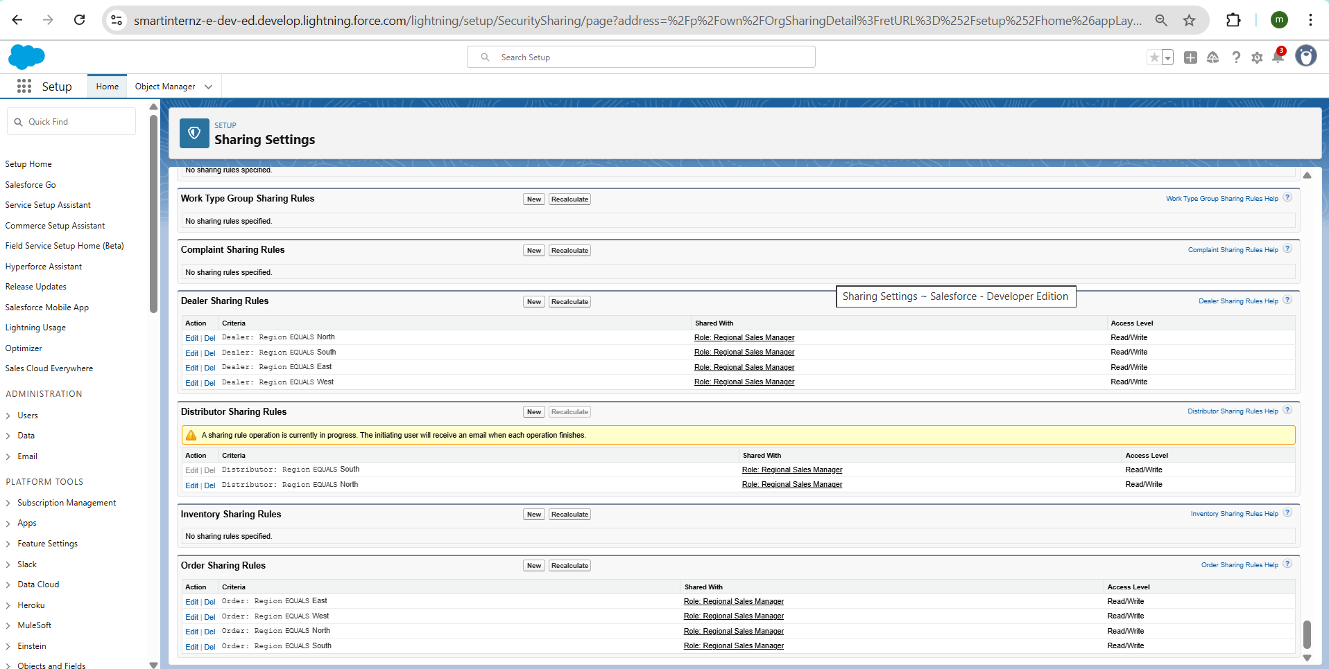

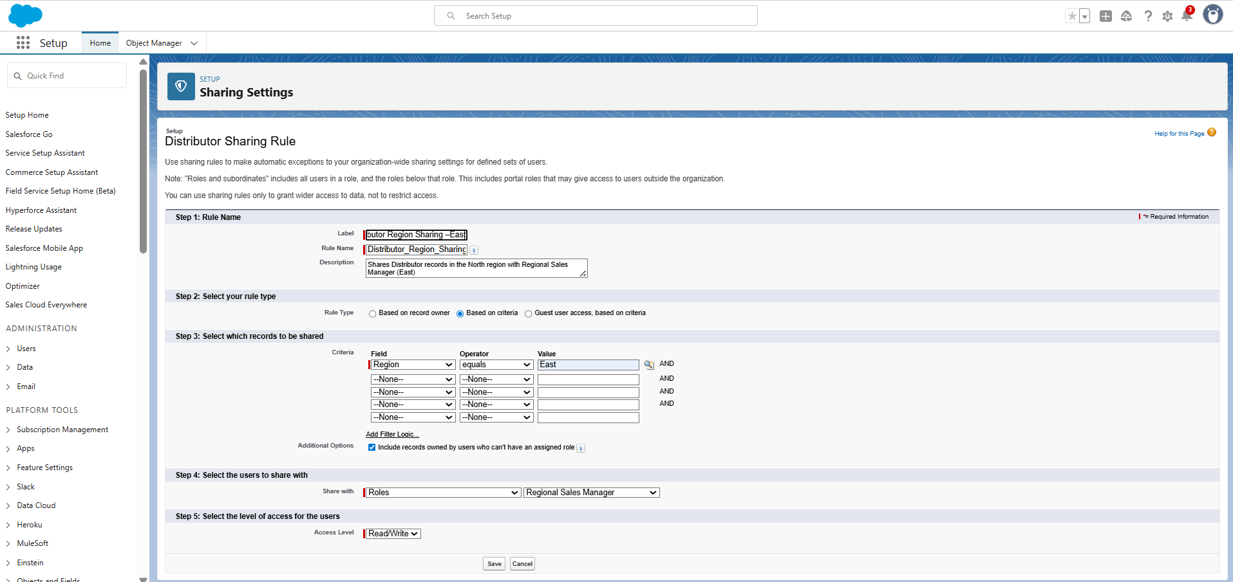

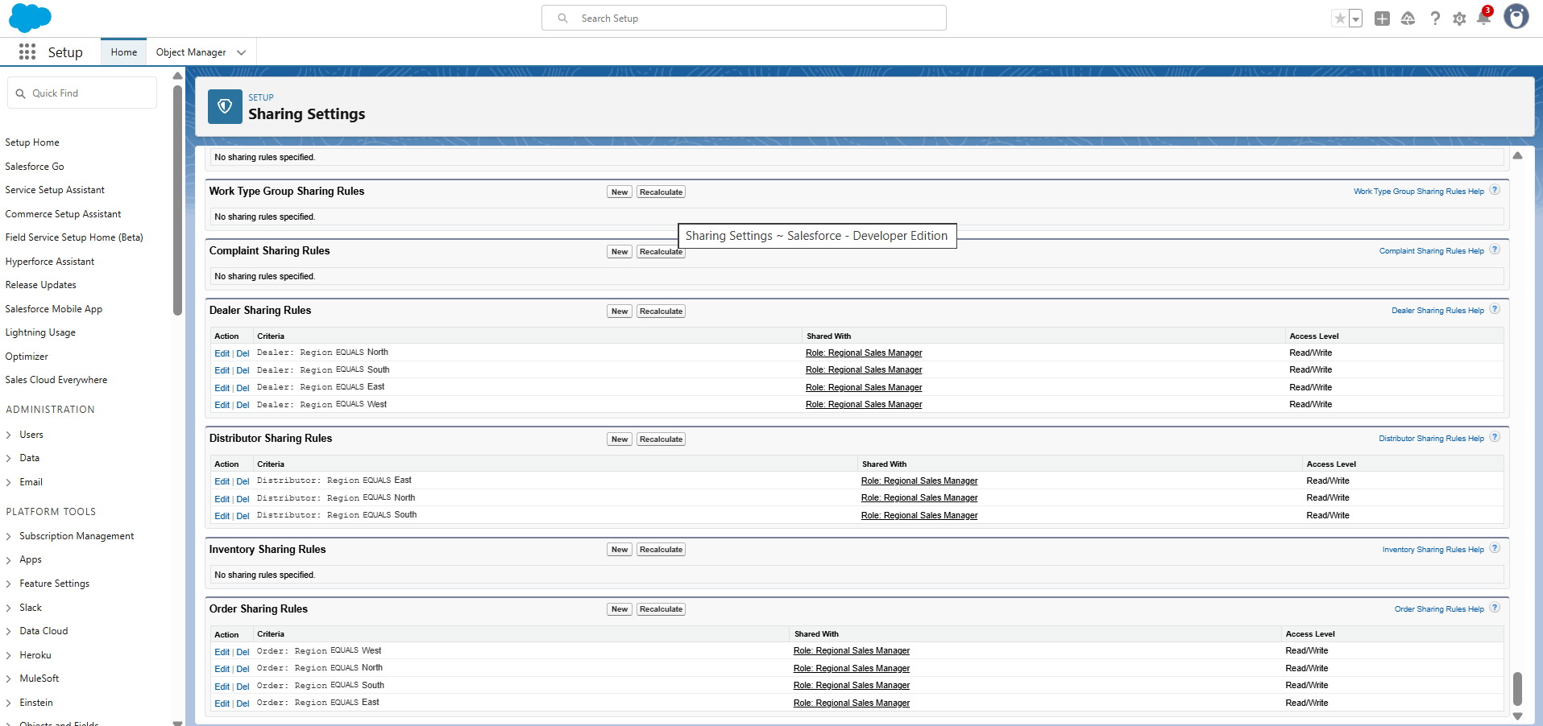

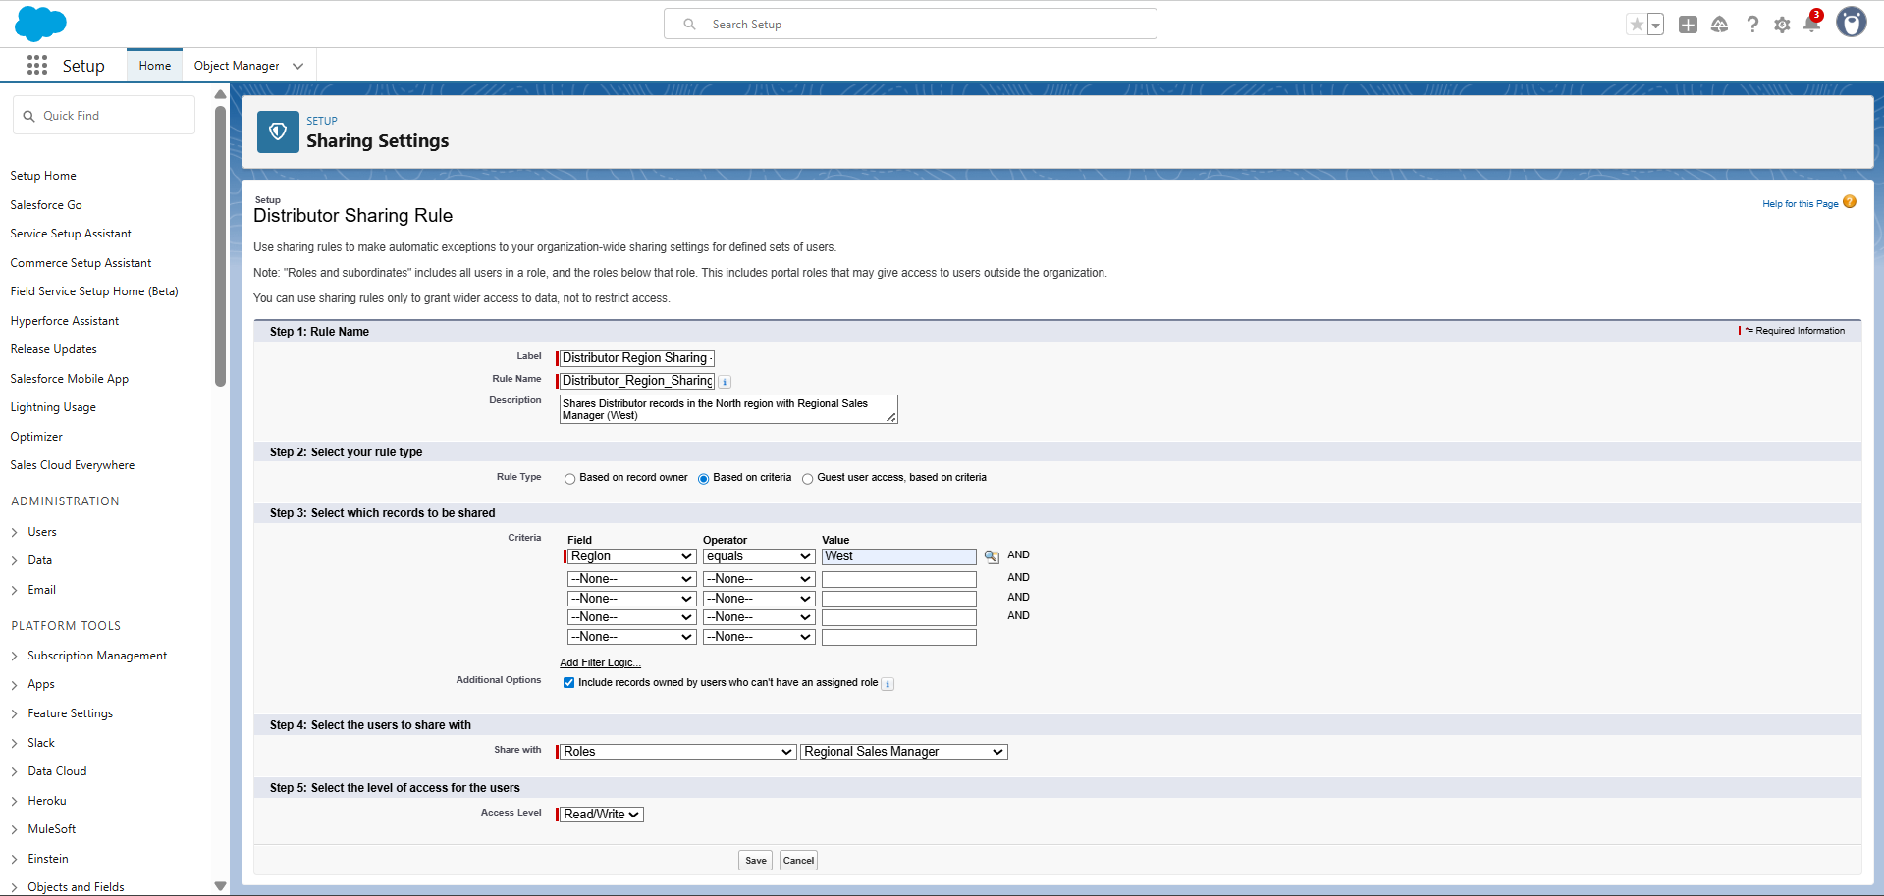

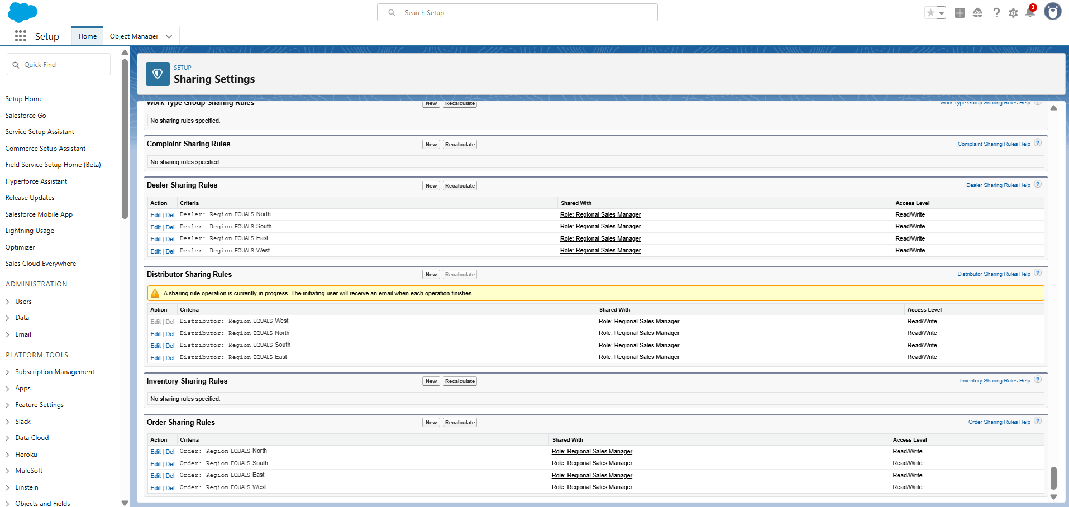

Complaint Sharing Rules

**Complaint – Status Field Setup**

**Step 1: Create Field**

* Object: **Complaint**
* Field Type: **Picklist**
* Field Label: **Status**
* Values:
  + New
  + In Progress
  + Resolved
  + Escalated

**Step 2: Field-Level Security**

* **Support Profile** → Visible (Editable)
* **Sales Profile** → Visible + Read-Only
* **Dealer Manager Profile** → Visible + Read-Only
* **Customer Community Login User (Dealer Portal User)** → Visible + Read-Only

**Step 3: Add to Page Layouts**

* Added **Status** field to the **Complaint Page Layout**, so it is visible to all relevant users.

**Description:**  
The **Status** field was created to track the lifecycle of complaints and enable escalation management. Dealers and Sales Managers can **view** the status of complaints, while Support Agents can **update** the status (e.g., New → In Progress → Resolved → Escalated). This field also supports the **Complaint Sharing Rule** configuration by allowing escalated complaints to be shared automatically with the **Support Managers Public Group**.

Now the **Complaint.Status** field is available for use in reports, dashboards, and **sharing rules**.

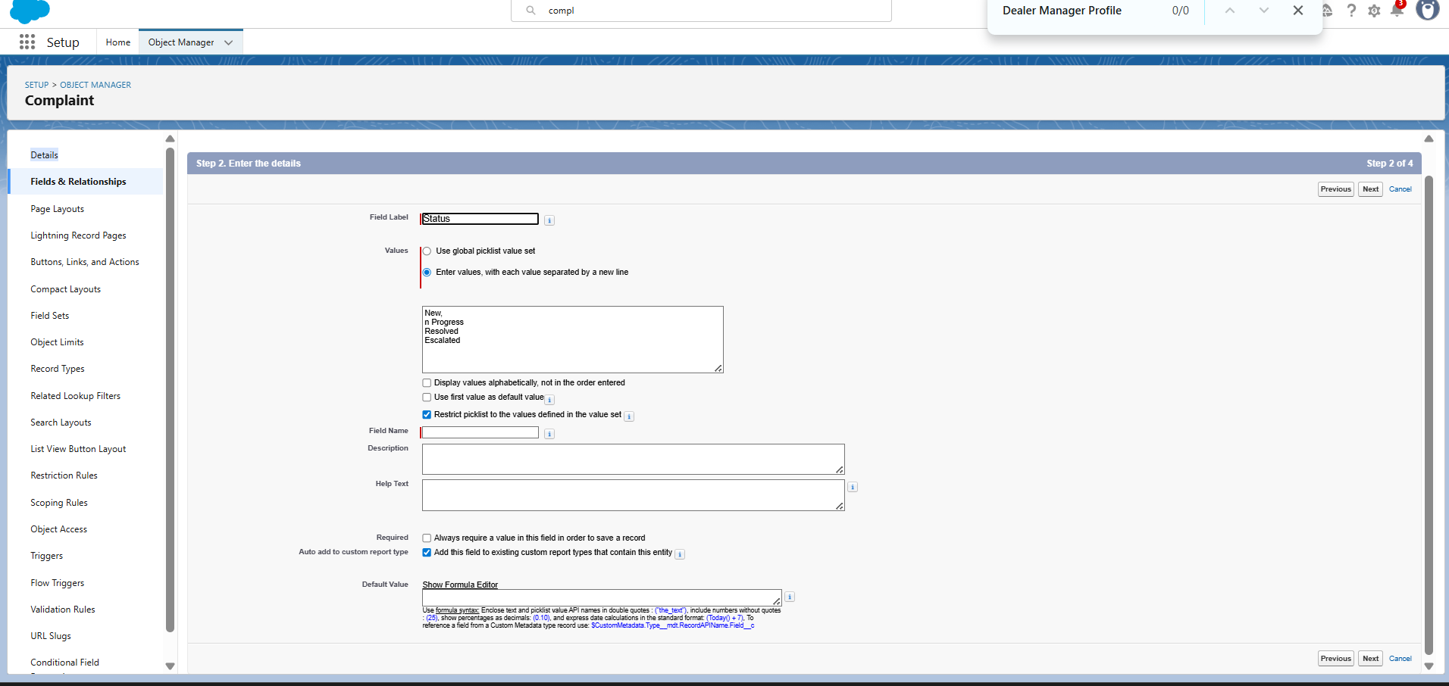

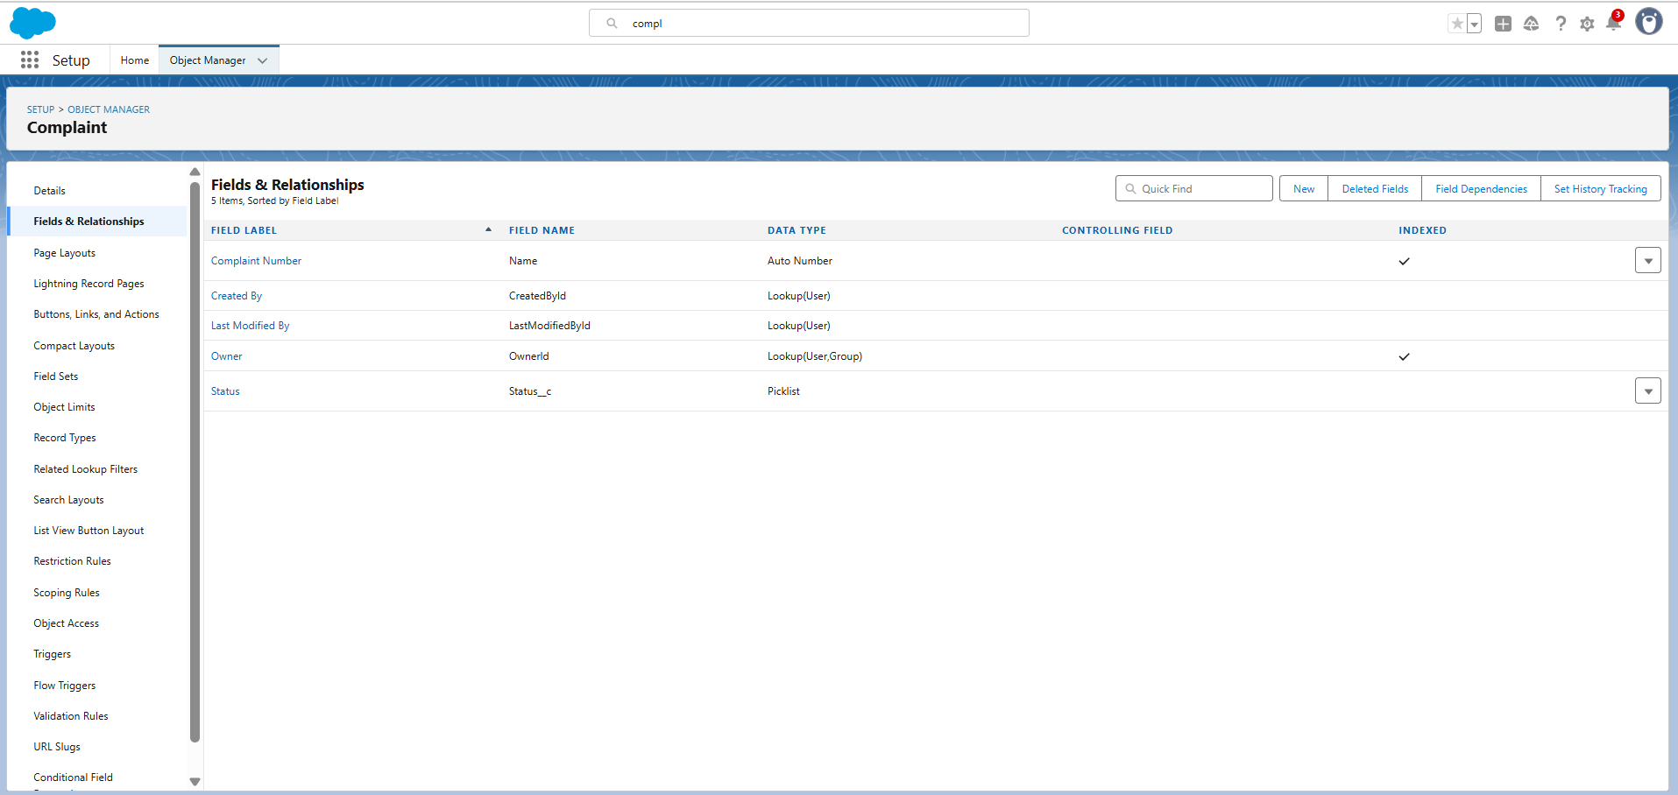

**Complaint – Status Field Setup**

**Step 1: Create Field**

* Object: **Complaint**
* Field Type: **Picklist**
* Field Label: **Status**
* Values:
  + New
  + In Progress
  + Resolved
  + Escalated

**Step 2: Field-Level Security**

* **Support Profile** → Visible (Editable)
* **Sales Profile** → Visible + Read-Only
* **Dealer Manager Profile** → Visible + Read-Only
* **Customer Community Login User (Dealer Portal User)** → Visible + Read-Only

**Step 3: Add to Page Layouts**

* Added **Status** field to the **Complaint Page Layout**, so it is visible to all relevant users.

**Description:**  
The **Status** field was created to track the lifecycle of complaints and enable escalation management. Dealers and Sales Managers can **view** the status of complaints, while Support Agents can **update** the status (e.g., New → In Progress → Resolved → Escalated). This field also supports the **Complaint Sharing Rule** configuration by allowing escalated complaints to be shared automatically with the **Support Managers Public Group**.

Now the **Complaint.Status** field is available for use in reports, dashboards, and **sharing rules**.

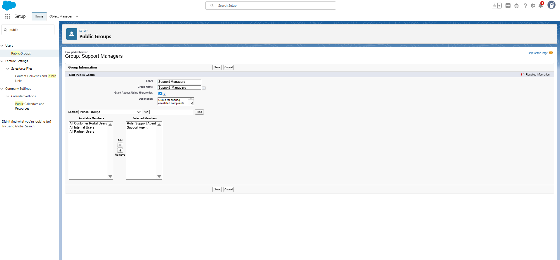

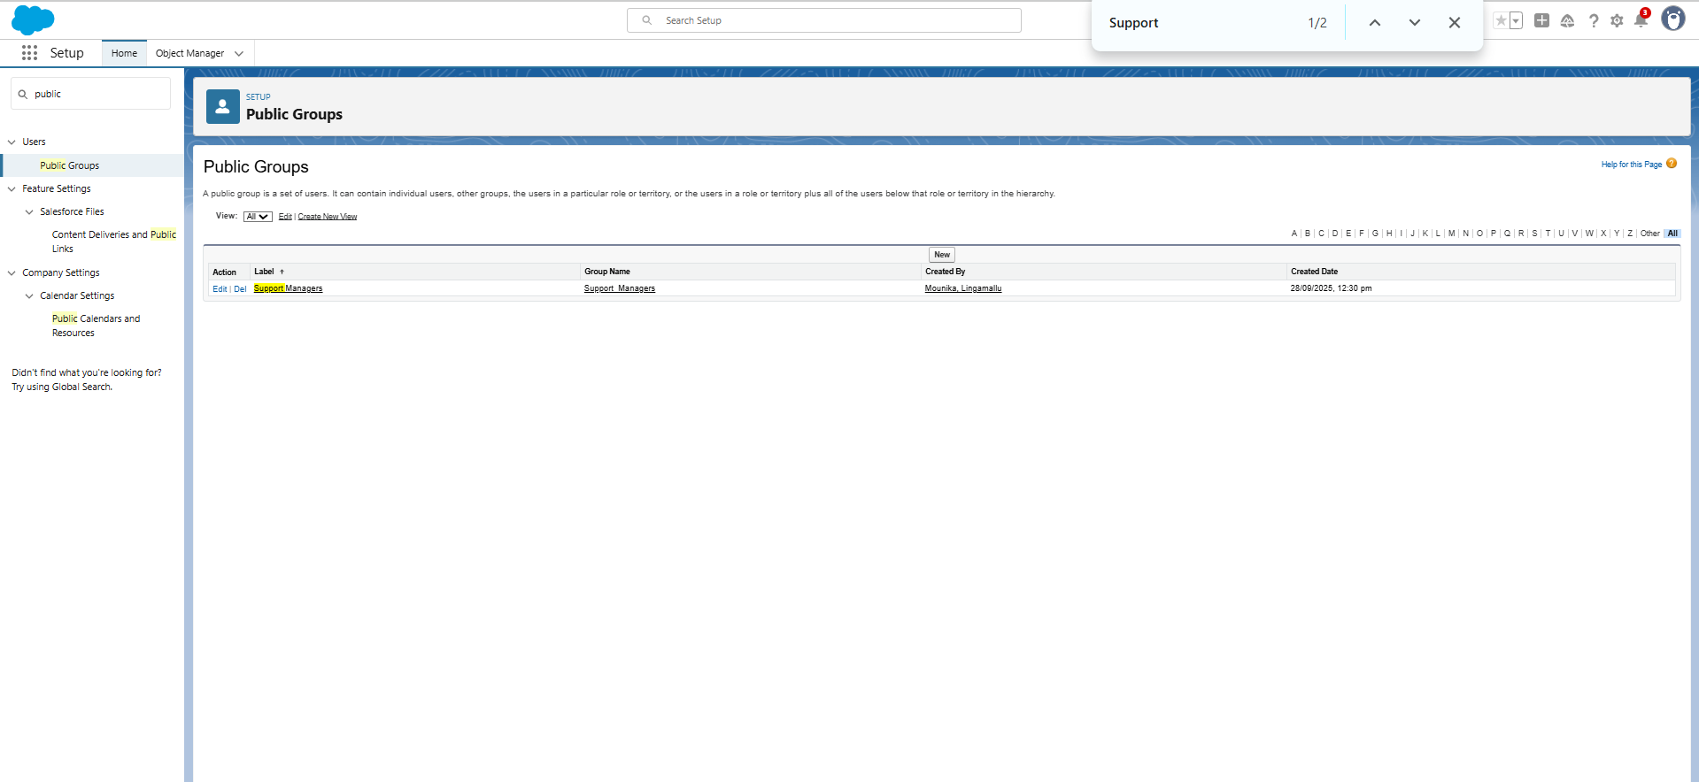

**Steps to Create Public Group → Support Managers**

1. **Go to Setup**
   * Click ⚙️ → Setup.
2. **Search for Public Groups**
   * In the Quick Find box → type *Public Groups*.
   * Click **Public Groups** under *Users*.
3. **Create a New Group**
   * Click **New**.
4. **Fill in Group Details**
   * **Label:** Support Managers
   * **Group Name:** auto-fills → Support_Managers
   * **Grant Access Using Hierarchies:** Keep checked (default).
   * **Description:** Group for sharing escalated complaints with Support Managers.
5. **Add Members**
   * In the Search drop-down, choose **Users**.
   * From Available Members, select the users with the **Support Profile** (e.g., *Support Agent, Support User*).
   * Click **Add** → they move to the **Selected Members** box.
6. **Save the Group**
   * Scroll down and click **Save**.

The **Support Managers Public Group** is now available to use when configuring the **Complaint Sharing Rule**. 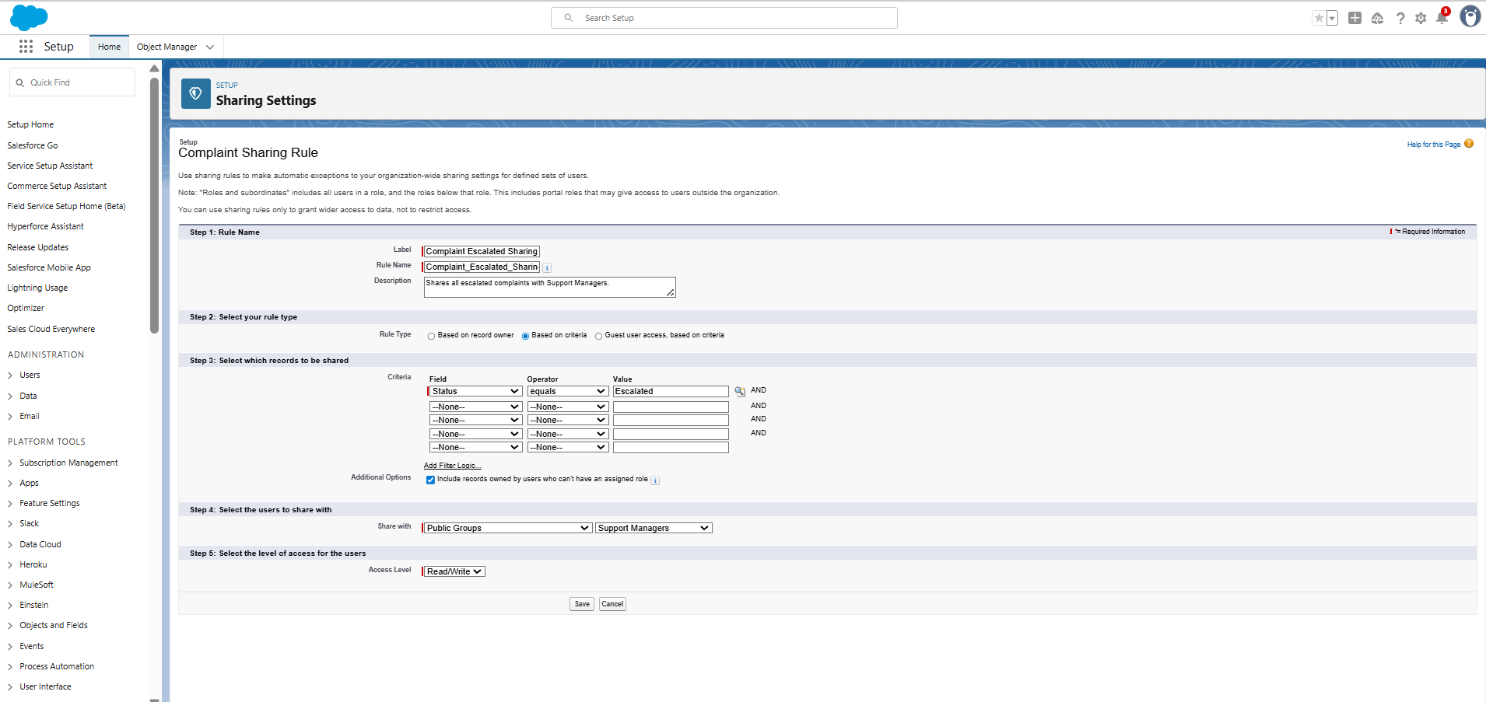

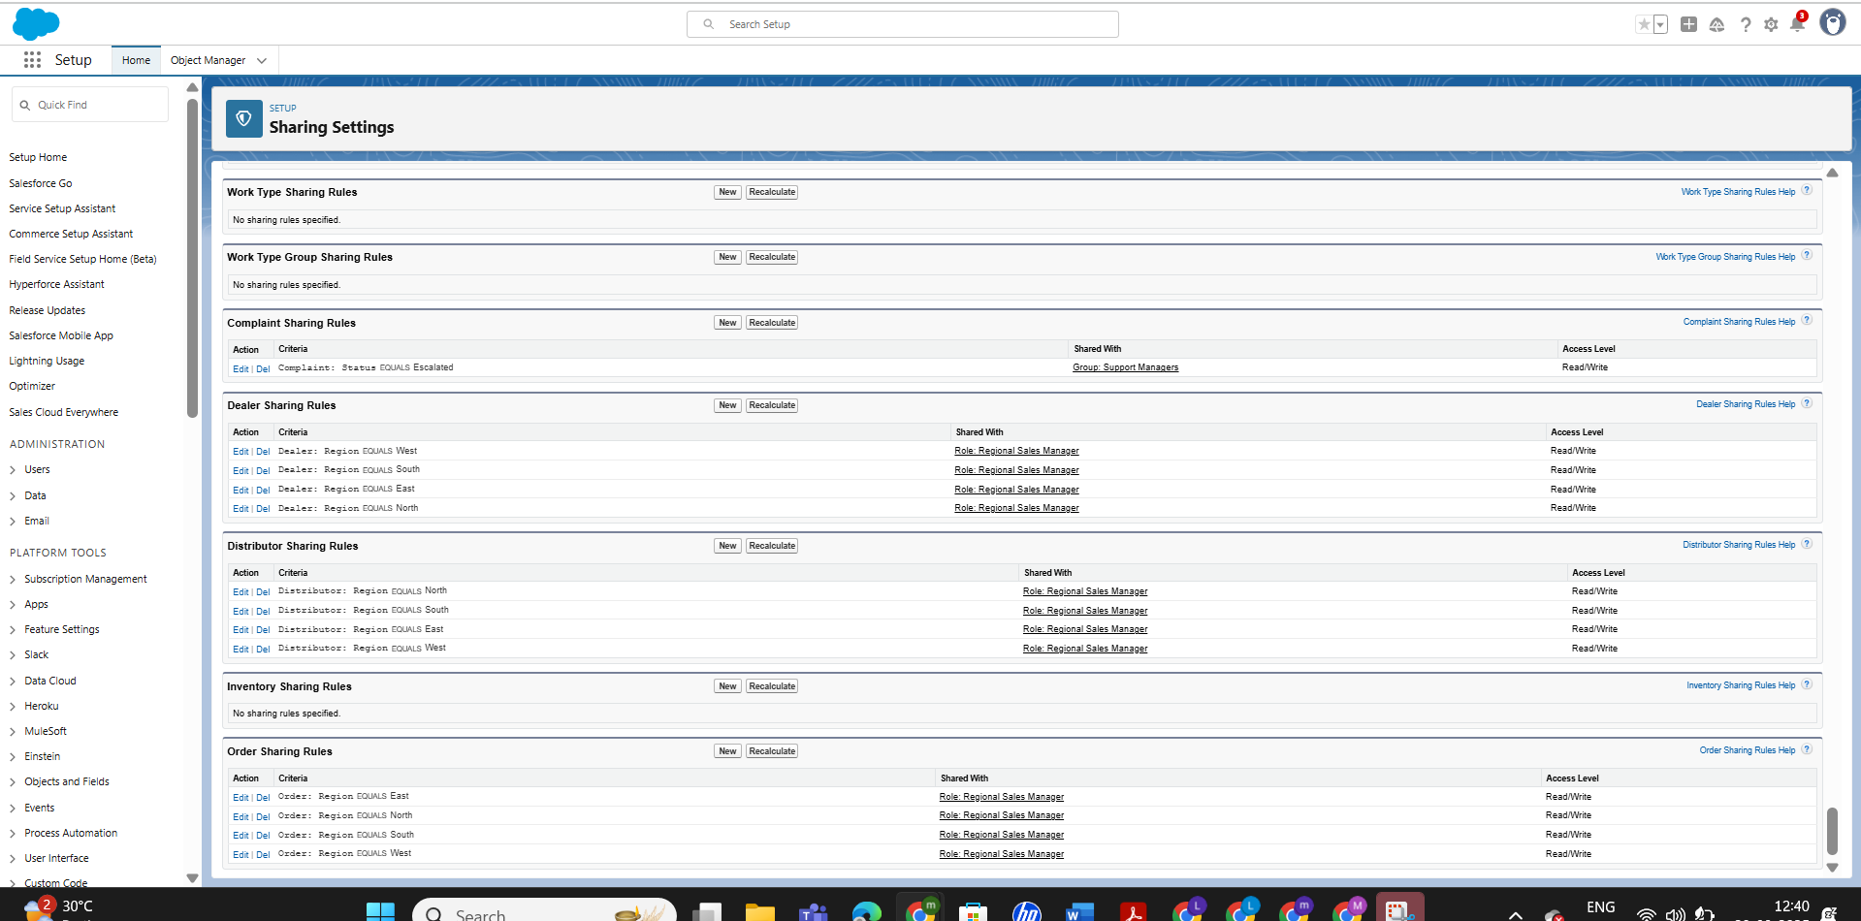  
**Complaint Sharing Rule Setup**

**Step 1: Rule Name**

* **Label:** Complaint Escalated Sharing
* **Rule Name:** Complaint_Escalated_Sharing
* **Description:** Shares all escalated complaints with Support Managers.

**Step 2: Select Rule Type**

* **Rule Type:** Based on Criteria

**Step 3: Select Records to be Shared**

**Criteria:**

* + **Field:** Status
  + **Operator:** Equals
  + **Value:** Escalated

**Step 4: Select the Users to Share With**

* **Share With:** **Public Group → Support Managers**

**Step 5: Select the Level of Access for the Users**

* **Access Level:** **Read/Write**

**Complaint Sharing Rules – Work Done**

* **Type:** Criteria-Based
* **Criteria:** Complaint.Status = Escalated
* **Shared With:** Public Group → Support Managers
* **Access:** Read/Write
* **Purpose:** To give Support Managers visibility into all escalated complaints across regions for faster resolution.

**Result:**

* Support Managers → Can view and update escalated complaints.
* Non-escalated complaints → Remain restricted to Support Agents only.

**Escalated cases now automatically route to Support Managers with full access.**

**Inventory Sharing Rules**

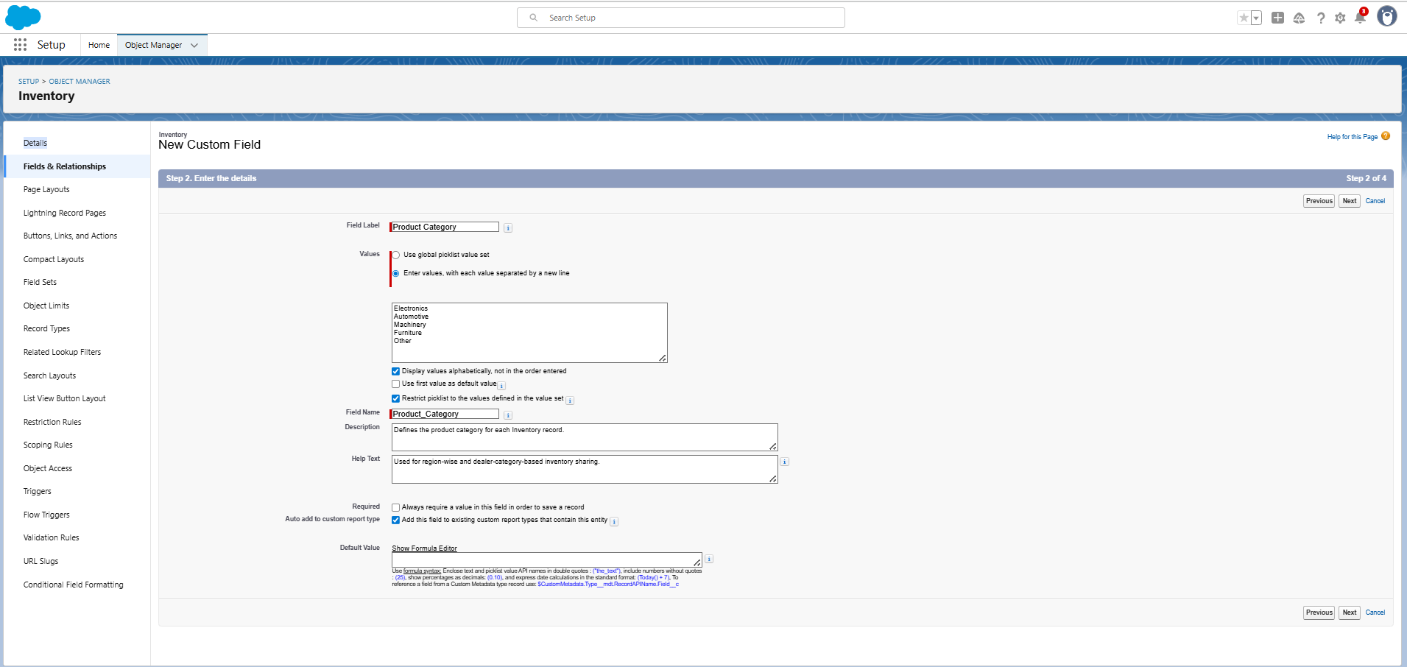

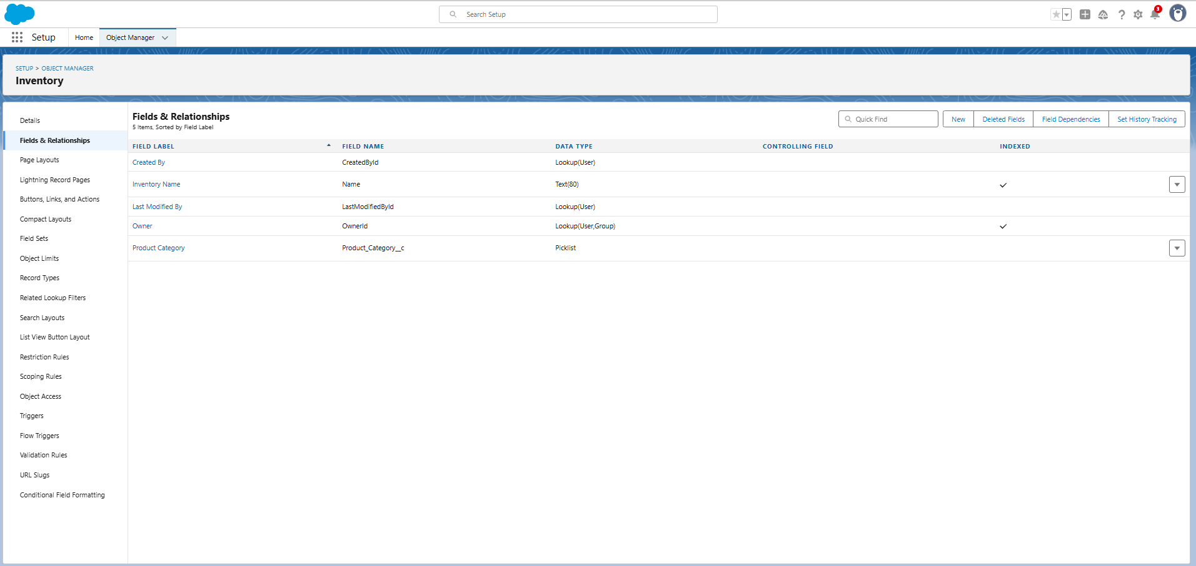

**1. Create Custom Field on Inventory**

* **Object**: Inventory
* **Field Type**: Picklist
* **Field Label**: Product Category
* **Field Name**: Product_Category

**Picklist Values:**

* Electronics
* Automotive
* Machinery
* Furniture
* Other

**Options Selected:**

* Restrict picklist to the values defined (to avoid invalid data).
* Display values alphabetically (optional).
* **Required** = Yes (every Inventory record must have a category).
* Auto add to custom report type = Yes.

**Description:** Defines the product category for each Inventory record.  
**Help Text:** Used for region-wise and dealer-category-based inventory sharing.

**2. Field-Level Security Setup (Partner Community Scenario)**

* System Administrator → Visible and Editable
* Sales Manager Profile → Visible and Editable
* Dealer Manager Profile → Visible and Editable
* Partner Community User (Dealers) → Visible but it shouldn’t Read-Only

**3. Add to Page Layout**

* Added **Product Category** field to the **Inventory Layout**.
* Marked as **Required**.

**4. Sharing Rule Setup**

Created **Criteria-Based Sharing Rules** to share inventory based on category:

* **Rule 1:**
  + Criteria: Inventory.Product Category = Electronics
  + Shared With: Public Group → Electronics Dealer Managers
  + Access: Read Only
* **Rule 2:**
  + Criteria: Inventory.Product Category = Automotive
  + Shared With: Public Group → Automotive Dealer Managers
  + Access: Read Only

This allows controlled, category-based visibility of inventory to specific dealer groups.

**Outcome:**  
With this setup, Inventory is categorized into **Electronics, Automotive, Machinery, Furniture, Other**, and sharing rules ensure dealers/managers only see relevant product categories.

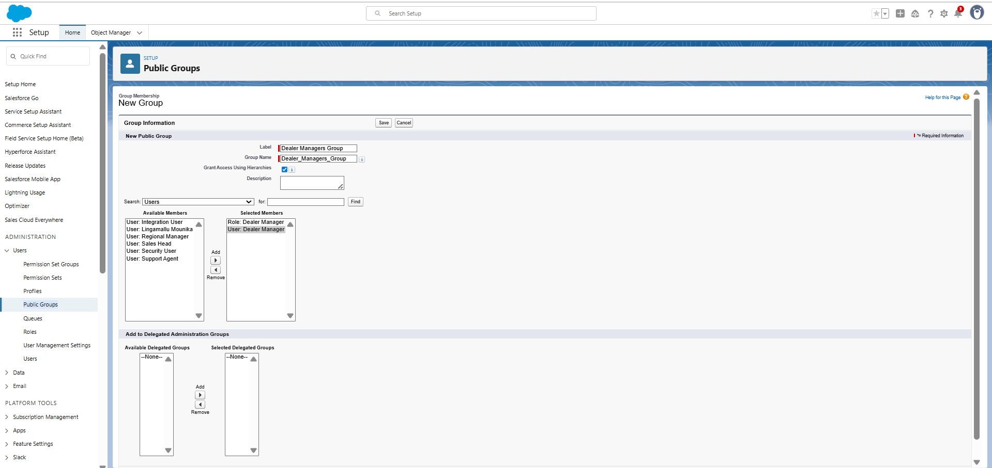 **Creating Public Group for Dealer Managers**

To simplify sharing rule management, a Public Group was created to include all Dealer Managers. This allows sharing rules to be applied to the group instead of configuring them for each user individually.

**Steps:**

1. Go to **Setup** ⚙️
2. In Quick Find, type **Public Groups**
3. Click **New**
4. Enter the following details:
   * **Label:** Dealer Managers Group
   * **Group Name:** Dealer_Managers_Group
   * **Members:** Add all **Dealer Manager Roles** or individual Dealer Manager users
5. Click **Save**

**Result:**  
The *Dealer Managers Group* can now be used in **Inventory Sharing Rules** and other rules, ensuring that all Dealer Managers get consistent access as per project requirements.

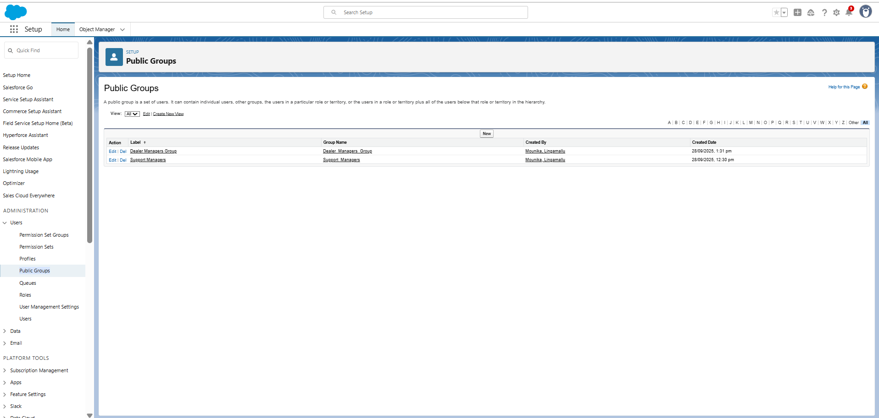

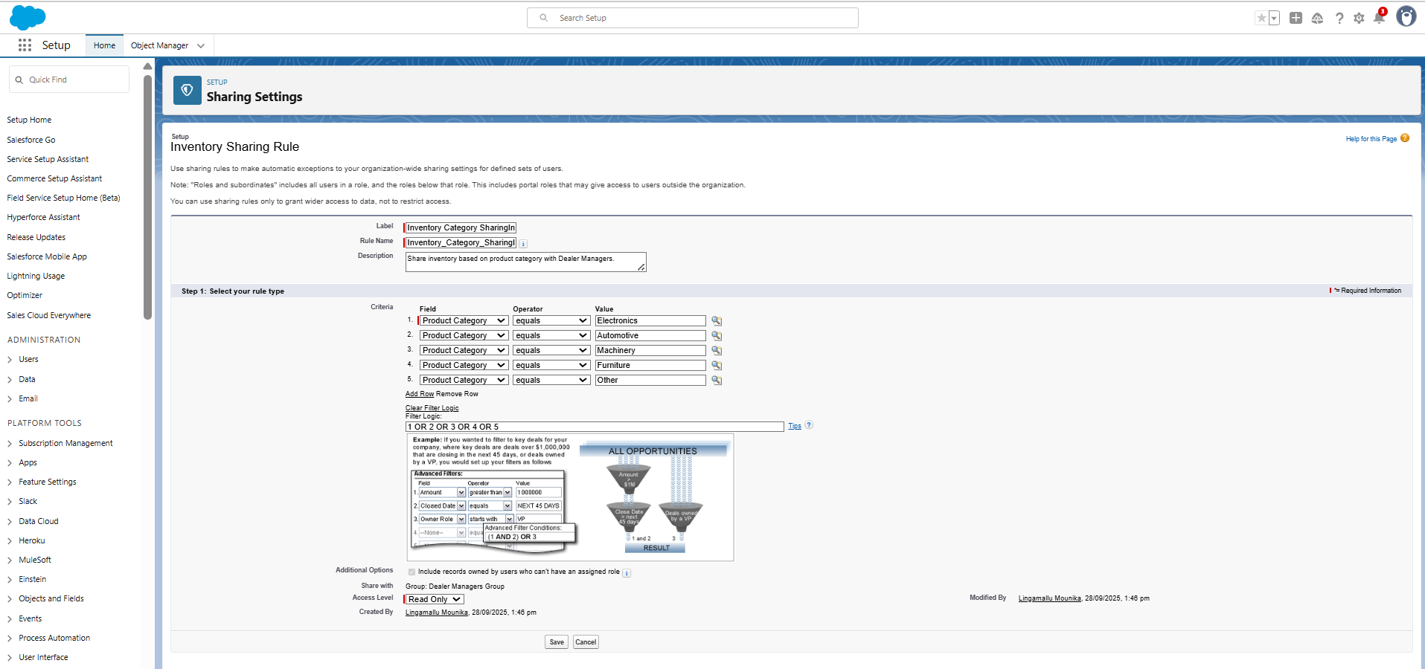  
**Salesforce Inventory Sharing Rule Setup**

This document provides step-by-step instructions to configure an Inventory Sharing Rule in Salesforce to share multiple product categories (Electronics, Automotive, Machinery, Furniture, and Other) with the Dealer Managers Group.

**Steps**

**Step 1: Open the Sharing Rule**

1. Go to Setup → Sharing Settings.  
2. Scroll down to Inventory Sharing Rules.  
3. Open the existing rule named 'Inventory Category Sharing'.

**Step 2: Add More Criteria**

1. In Step 3: Select which records to be shared, you already have:  
 - Field = Product Category  
 - Operator = equals  
 - Value = Electronics  
  
2. Add additional rows with the following values:  
 - Field = Product Category, Operator = equals, Value = Automotive  
 - Field = Product Category, Operator = equals, Value = Machinery  
 - Field = Product Category, Operator = equals, Value = Furniture  
 - Field = Product Category, Operator = equals, Value = Other

**Step 3: Update Filter Logic**

1. Click 'Add Filter Logic…' below the criteria rows.  
2. In the filter box, enter the following expression:  
  
 1 OR 2 OR 3 OR 4 OR 5  
  
This ensures records from any of the listed product categories will be shared.

**Step 4: Save the Rule**

1. In Step 4: Select the users to share with, keep:  
 - Share with = Public Groups → Dealer Managers Group  
  
2. In Step 5: Select the level of access:  
 - Access Level = Read Only (or change to Read/Write if editing is required).  
  
3. Click Save.

Now Dealer Managers will have access to Electronics, Automotive, Machinery, Furniture, and Other inventory records.

**2.11 Login Access Policies**

- Defined to control who can log in, from where, and when.

- Login IP Ranges were set for internal users (Sales Head, Regional Sales Manager, Support Agent) to restrict unauthorized access.

- Login Hours configured: 9:00 AM – 6:00 PM (business hours).

- Dealers (external users) log in via the Dealer Partner Portal, with access controlled by Profiles + Sharing Sets.

- Ensures security while still enabling dealers/distributors to self-serve.

**2.12 Dev Org Setup**

- Project development carried out in a Salesforce Developer Org (free edition).

- Company Information, Fiscal Year, Business Hours, and Holidays configured.

- Users, Profiles, Roles, and Permission Sets created as per requirements.

- Custom Objects built: Dealers, Distributors, Orders, Complaints, Inventory.

- Org serves as the primary build and testing environment before sandbox/deployment.

**2.13 Sandbox Usage**

- Sandboxes will be used for testing and training before production rollout.

- Types of Sandboxes to be used:

* + Developer Sandbox → For individual configuration and unit testing.
  + Partial Copy Sandbox → For testing with sample dealer/distributor data.

- Benefits:

* + Prevents risks to live data.
  + Enables UAT (User Acceptance Testing) by Sales Managers and Support Agents.
  + Allows safe experimentation with customizations.

Deployment Basics

- Deployment will be done in phases from Dev Org → Sandbox → Production.

- Tools used: Change Sets (for profiles, objects, workflows, sharing rules).

- Pre-deployment checklist:

* + Validate in Sandbox.
  + Assign correct licenses and profiles.
  + Verify data access rules (OWD, Sharing Rules, Permission Sets).
  + Post-deployment steps:
  + Publish Dealer Partner Portal.
  + Assign community users.
  + Test order placement, complaint logging, and reporting dashboards.

**Phase 3: Data Modeling & Relationships**

**2.1 Standard & Custom Objects**

* **Standard Objects** used: Accounts, Contacts, Opportunities, Cases.
* **Custom Objects** created for this project:

Dealers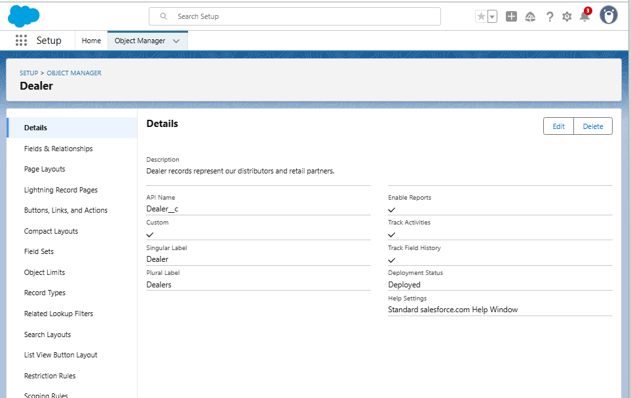

Distributors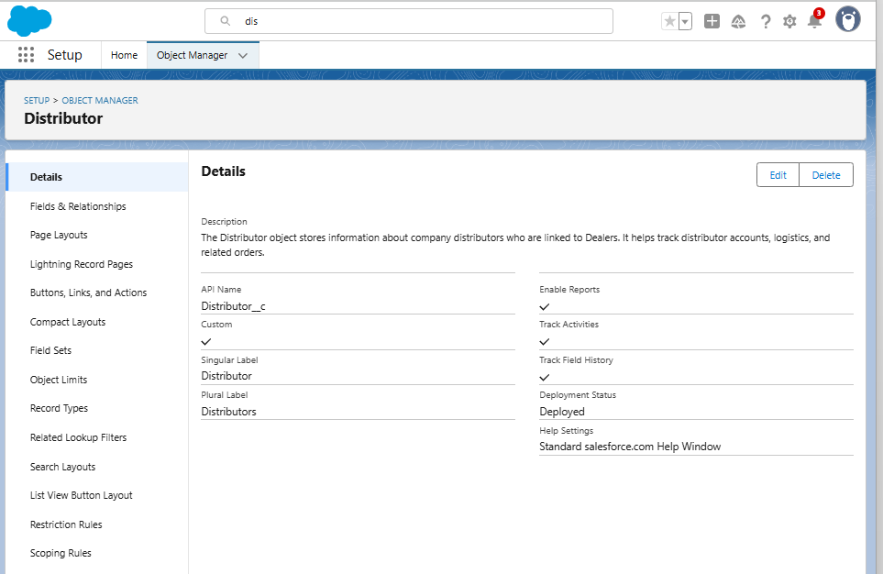

Order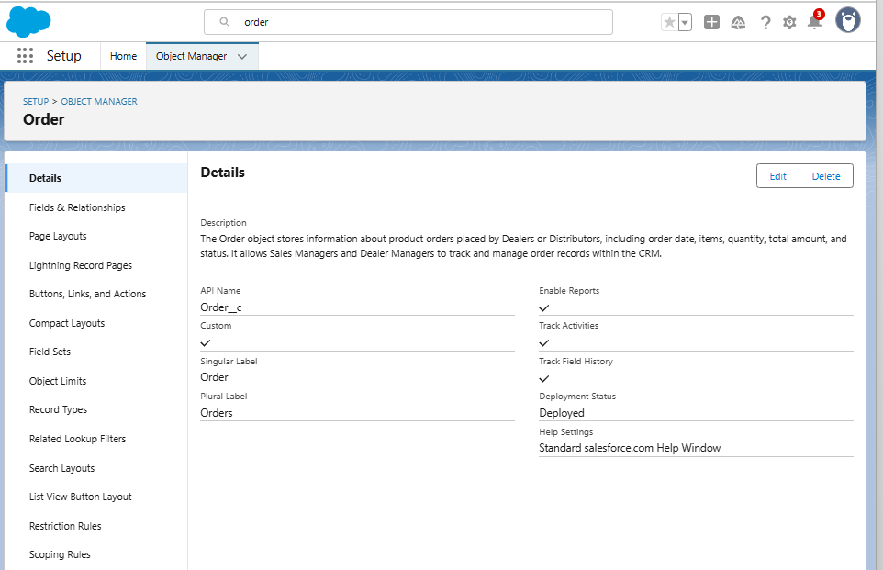

Complaints 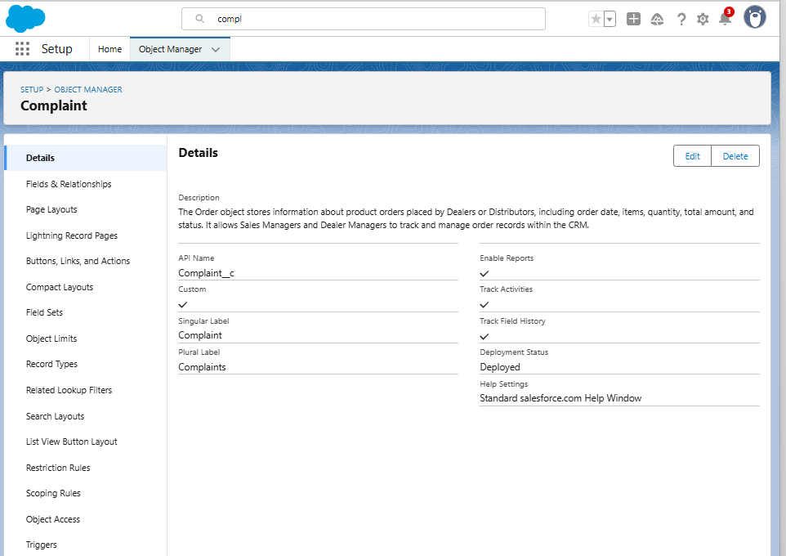

Inventory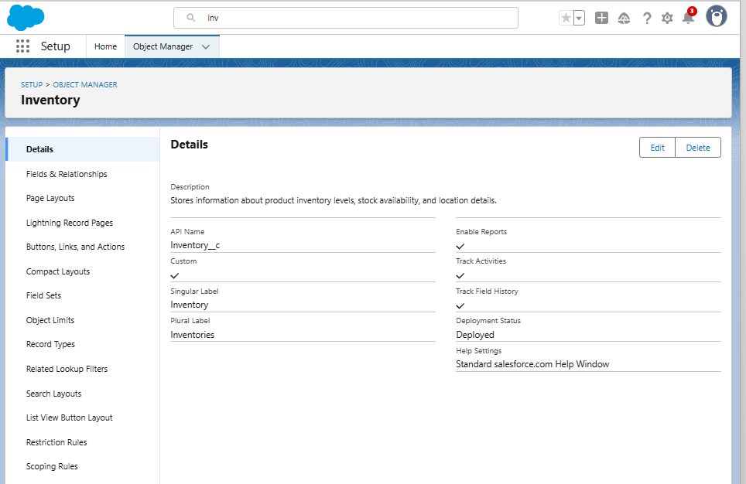  
These represent the business-specific entities in the CRM.

**2.2 Fields**

* **Custom Fields** added as per requirements:
  1. Dealers → Region (Picklist: North, South, East, West)
  2. Orders → Status (Pending, Approved, Dispatched, Delivered), Region
  3. Complaints → Status (New, In Progress, Resolved, Escalated)
  4. Inventory → Product Category (Electronics, Automotive, Machinery, Furniture, Other)

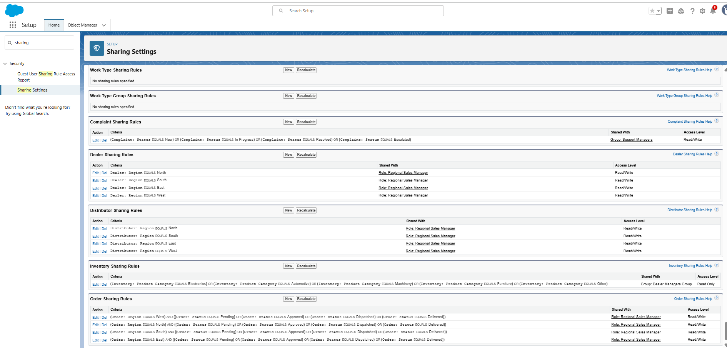

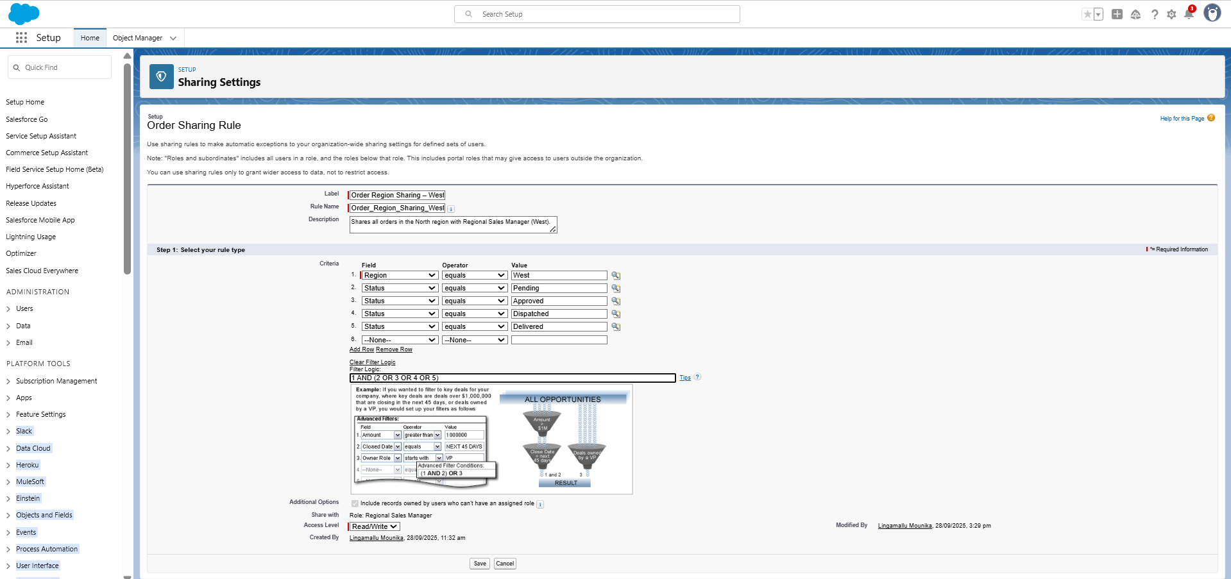

**Orders: Custom Field & Sharing Rules – Project Summary**

**1)Created Status Field**

* **Object:** Orders
* **Field Type:** Picklist
* **Field Label / Name:** Status
* **Picklist Values:** Pending, Approved, Dispatched, Delivered
* **Purpose:** Tracks the lifecycle of an order.
* **Field-Level Security:**

**Field-Level Security Setup (Order Status Example)**

* **Sales Manager Profile** → Visible, Editable → Can edit order status
* **Dealer Manager Profile** → Visible, Read-Only → View-only in portal
* **Partner / Community User** → Visible, Read-Only → Can only view assigned orders
* **System Administrator** → Visible, Editable → Full access

**2) Existing Region-Based Sharing Rules**

* You had **owner-based sharing rules** for each region: West, North, South, East.
* Shared with **Regional Sales Managers** with **Read/Write** access.

**3) Updated Sharing Rules to Include Status**

* Since existing rules cannot be edited to add Status, you created **criteria-based sharing rules** for each region:

| **Region** | **Criteria** | **Filter Logic** | **Shared With** | **Access Level** |
| --- | --- | --- | --- | --- |
| West | Region = West; Status = Pending, Approved, Dispatched, Delivered | 1 AND (2 OR 3 OR 4 OR 5) | Role: Regional Sales Manager West | Read/Write |
| North | Region = North; Status = Pending, Approved, Dispatched, Delivered | 1 AND (2 OR 3 OR 4 OR 5) | Role: Regional Sales Manager North | Read/Write |
| South | Region = South; Status = Pending, Approved, Dispatched, Delivered | 1 AND (2 OR 3 OR 4 OR 5) | Role: Regional Sales Manager South | Read/Write |
| East | Region = East; Status = Pending, Approved, Dispatched, Delivered | 1 AND (2 OR 3 OR 4 OR 5) | Role: Regional Sales Manager East | Read/Write |

* **Filter Logic Explanation:**
  + 1 = Region
  + 2–5 = Status values
  + Ensures **orders are shared only if they match the region AND one of the listed statuses**.

**Outcome**

* Orders object now tracks **order lifecycle** with Status.
* Sharing is **both region-wise and status-based**, giving Sales Managers access to relevant orders.
* Dealers and community users can **view orders assigned to them** but cannot edit Status.

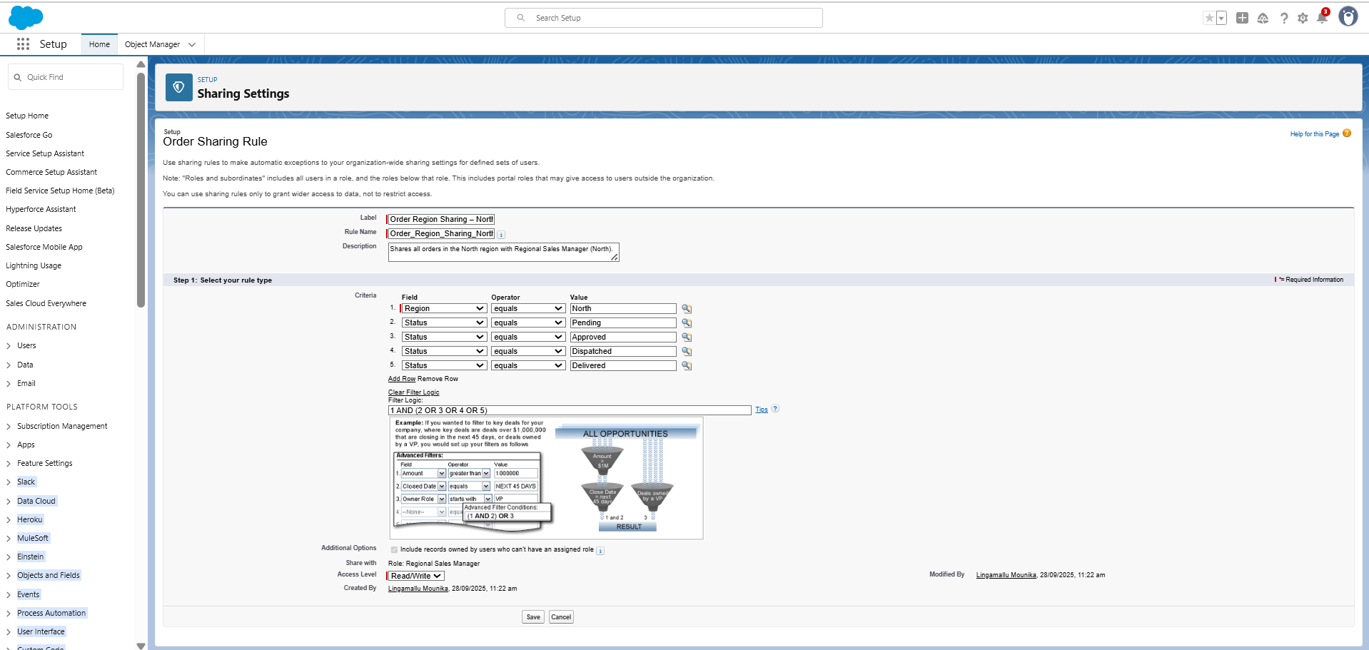

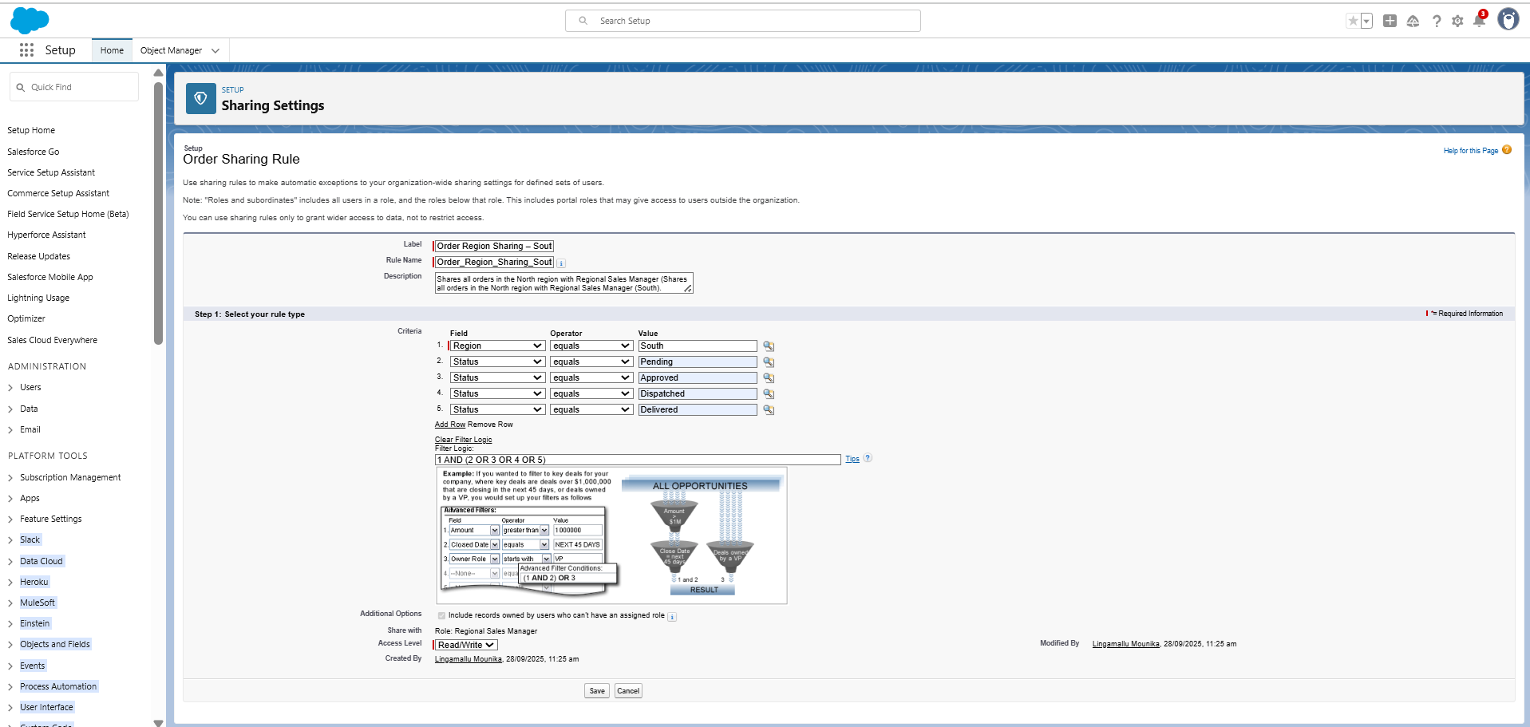

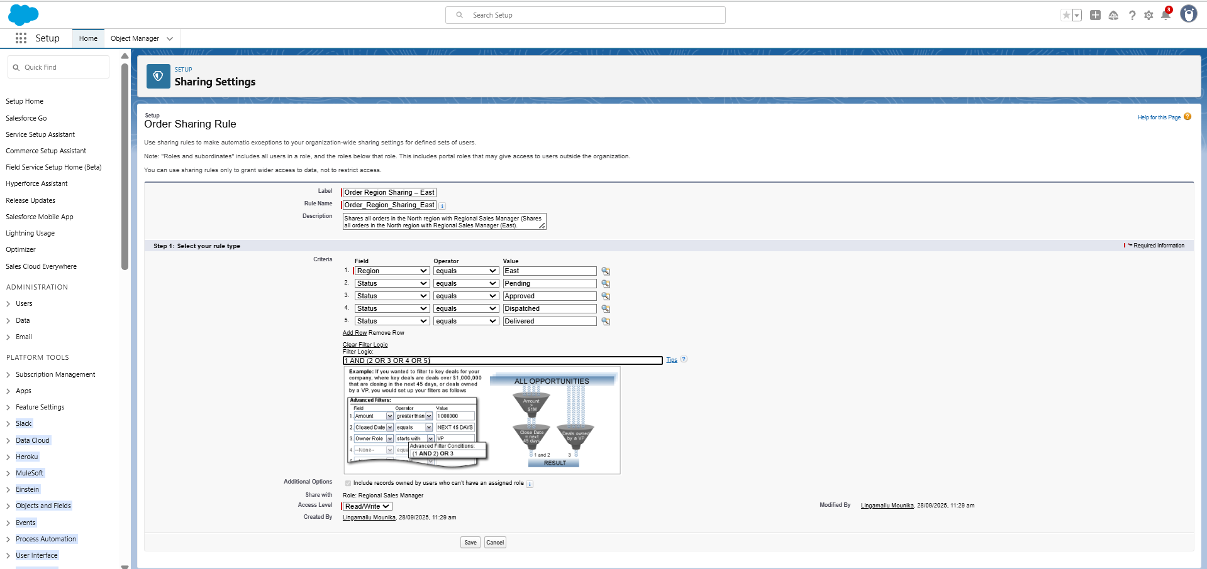

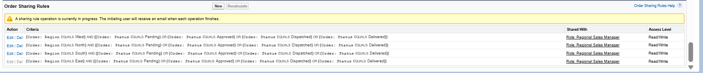

**1)Dealer Code (for Dealer Layout)**

**Purpose:** Unique identifier for each dealer.

**Steps to Create:**

1. Go to **Setup → Object Manager → Account → Fields & Relationships → New**
2. Choose **Text** as Data Type → Click **Next**
3. Enter **Field Label:** Dealer Code
   * Field Name auto-fills → leave as is
   * Length: 50
4. Click **Next**
5. **Field-Level Security:** make visible to **System Administrator**
6. Click **Next**
7. **Add to Page Layout:** select **Dealer Layout**
8. Click **Save**

**2)Region (for Dealer & Distributor Layouts)**

**Purpose:** Specifies geographical area of Dealer/Distributor.

**Steps to Create:**

1. **New Field** → Choose **Text** → Click **Next**
2. Field Label: Region
   * Length: 50
3. Click **Next**
4. Field-Level Security → make visible for your profile
5. Click **Next**
6. Add to **Dealer Layout** and/or **Distributor Layout**
7. Click **Save**

**3)Status (for Dealer Layout)**

**Purpose:** Shows the current state of Dealer (Active, Inactive, Pending).

**Steps to Create:**

1. **New Field** → Choose **Picklist** → Click **Next**
2. Field Label: Status
3. **Enter Picklist Values** (one per line):
4. Active
5. Inactive
6. Pending
7. Click **Next**
8. Field-Level Security → visible for your profile
9. Click **Next**
10. Add to **Dealer Layout**
11. Click **Save**

**4) Distributor Code (for Distributor Layout)**

**Purpose:** Unique identifier for each distributor.

**Steps to Create:**

1. **New Field** → Choose **Text** → Click **Next**
2. Field Label: Distributor Code
   * Length: 50
3. Click **Next**
4. Field-Level Security → visible for your profile
5. Click **Next**
6. Add to **Distributor Layout**
7. Click **Save**

**2.3 Record Types**  
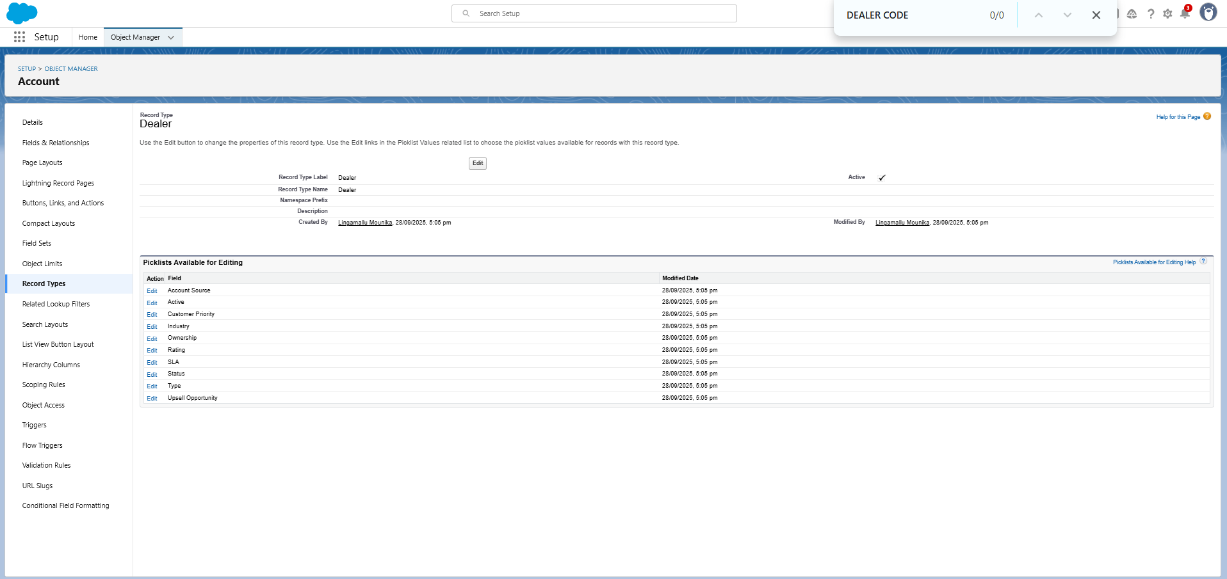  
**Creating Record Types & Page Layouts in Salesforce**

**1. Navigate to Record Types**

* Go to **Setup ⚙️ → Object Manager → Account → Record Types**.
* Click **New** to create a record type.

**2. Create a New Record Type**

1. **Clone an Existing Record Type:** Select Master to inherit picklist values.
2. **Enter Record Type Details:**
   * Example: Label = Dealer, Name = Dealer
   * Example: Label = Distributor, Name = Distributor
3. **Profile Access:** Choose which user profiles can access this record type.

**3. Create Page Layouts**

* Go to **Setup → Object Manager → Account → Page Layouts → New**.
* Name the layouts: Dealer Layout and Distributor Layout.
* Customize fields, sections, and related lists as needed.
* Click **Save**.  
  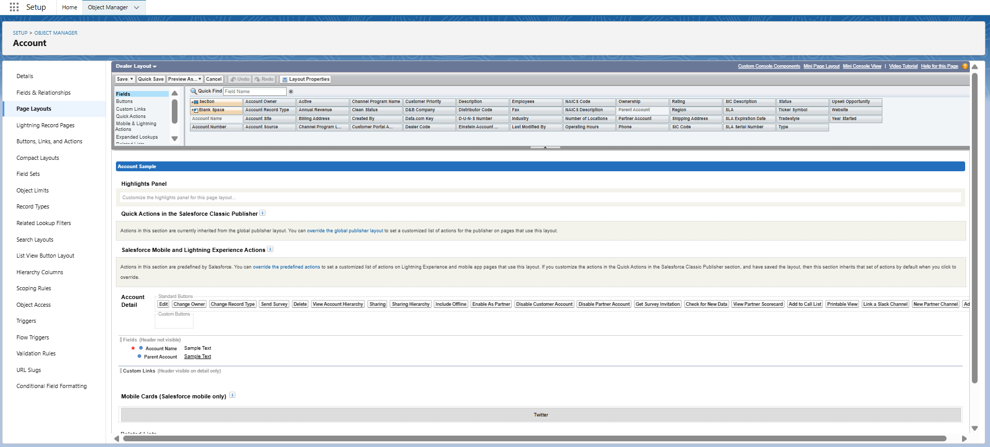

**4. Assign Layouts to Record Types**

1. Open the Record Type → **Page Layout Assignment → Edit Assignment**.
2. Assign layouts:
   * Dealer Record Type → Dealer Layout
   * Distributor Record Type → Distributor Layout
3. Click **Save**.  
   

**Record Types Created**

* **Dealer Record Type** – for dealer accounts.
* **Distributor Record Type** – for distributor accounts.
* **Assigned Profiles** – selected which user profiles can access each record type.
* **Page Layouts Assigned:**
  + Dealer Record Type → **Dealer Layout**
  + Distributor Record Type → **Distributor Layout**

**2.4 Page Layouts Created**

* **Dealer Layout** – customized for dealer accounts.
* **Distributor Layout** – customized for distributor accounts.

**Fields added to respective layouts:**

* **Dealer Layout:** Account Name, Parent Account, Dealer Code, Status, Region
* **Distributor Layout:** Account Name, Parent Account, Distributor Code, Region

**Custom Fields Created**

* **Dealer Code** – Text(50), added to Dealer Layout.
* **Distributor Code** – Text(50), added to Distributor Layout.
* **Status** – Picklist (Active, Inactive, Pending), added to Dealer Layout.
* **Region** – Text(50), added to both Dealer and Distributor Layouts.
* **Field-Level Security:** Set visible/editable for appropriate profiles.

**Dealer Layout Field Order:**

1. Account Name
2. Parent Account
3. Dealer Code
4. Status
5. Region 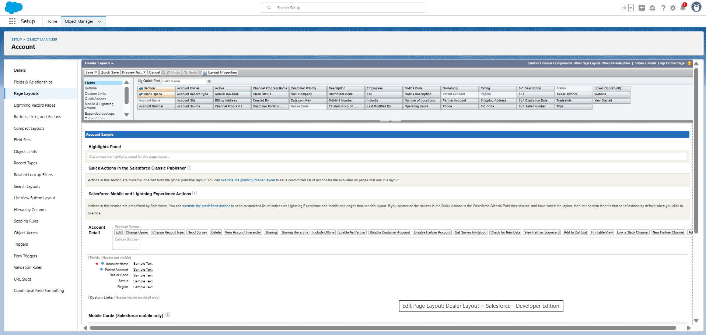

**Related Lists Added:**

* Orders
* Inventory
* Complaints 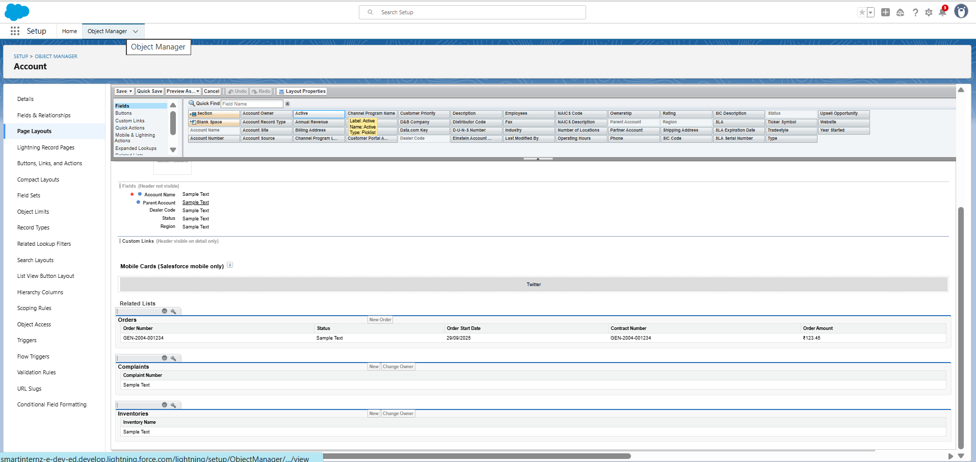

**Distributor Layout Field Order:**

1. Account Name
2. Parent Account
3. Distributor Code
4. Region

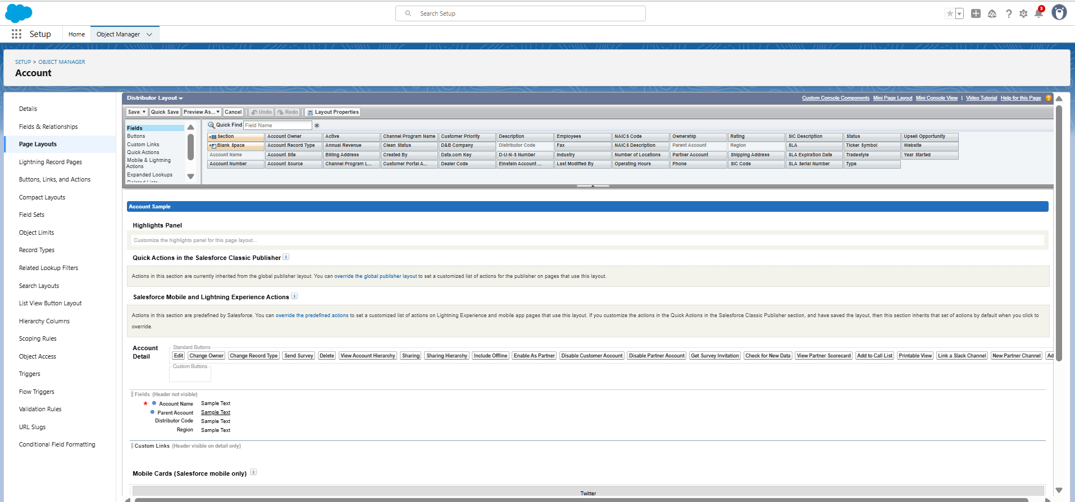

**Related Lists Added:**

* Orders
* Inventory
* Complaints

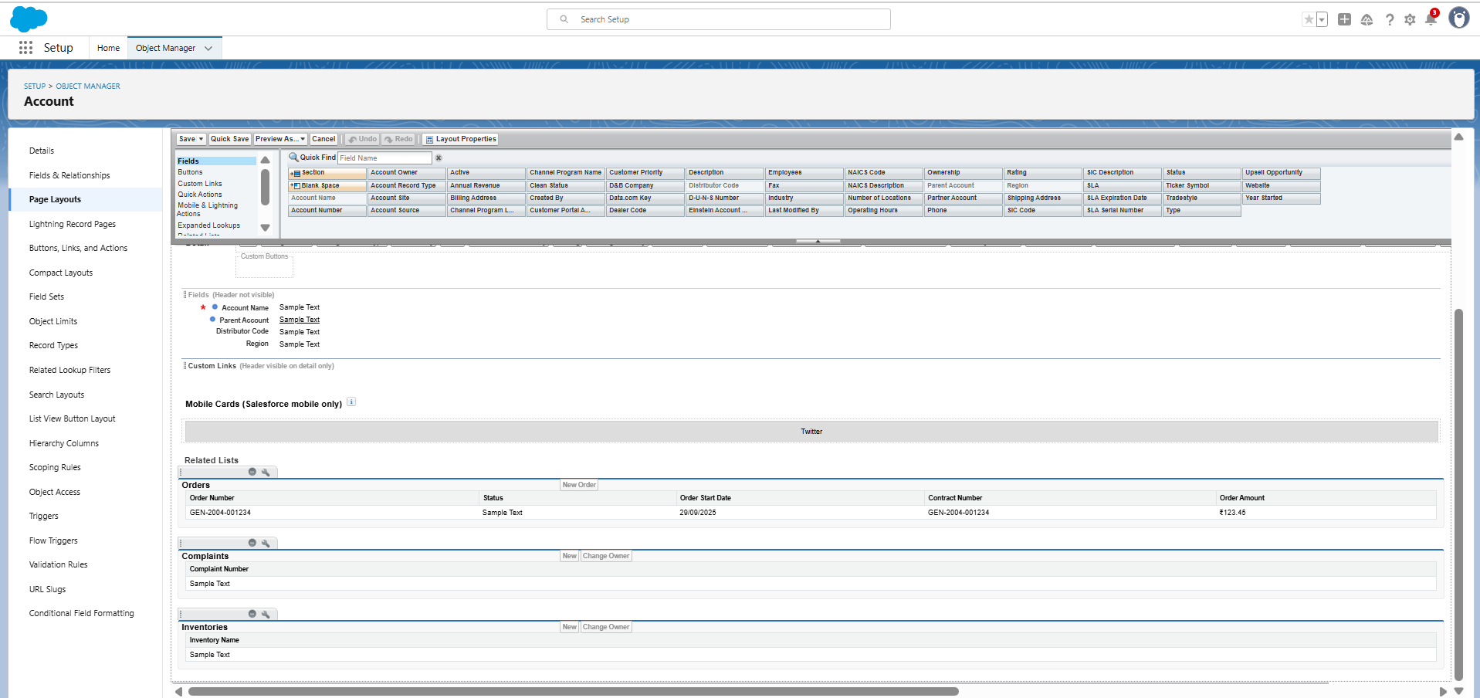

**2.5 Compact Layouts**

**Purpose:**

* Compact Layouts control **which fields appear at the top of a record page** in Salesforce (like highlights on mobile and Lightning Experience).
* Useful for **quickly showing key information** without scrolling.

1. Go to **Setup → Object Manager → Account → Compact Layouts**.
2. Click **New** (or edit the existing one).
3. Add the **key fields** for quick view, e.g.:
   * **Dealer Layout:** Account Name, Dealer Code, Status, Region
   * **Distributor Layout:** Account Name, Distributor Code, Region
4. Save the layout.
5. Make it **primary** so Salesforce uses it on record pages automatically.

**Result:** Users see important details at the top of the Account record in Lightning and mobile apps.

**Related Lists Added**

* Orders
* Inventory
* Complaints

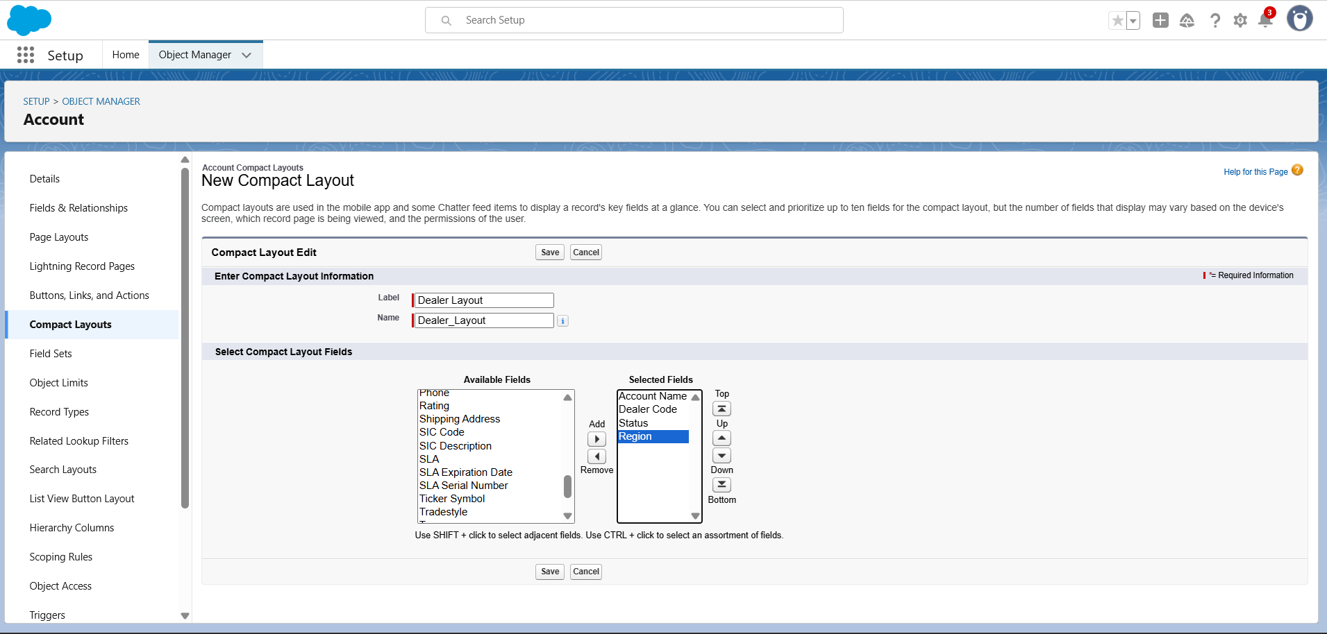

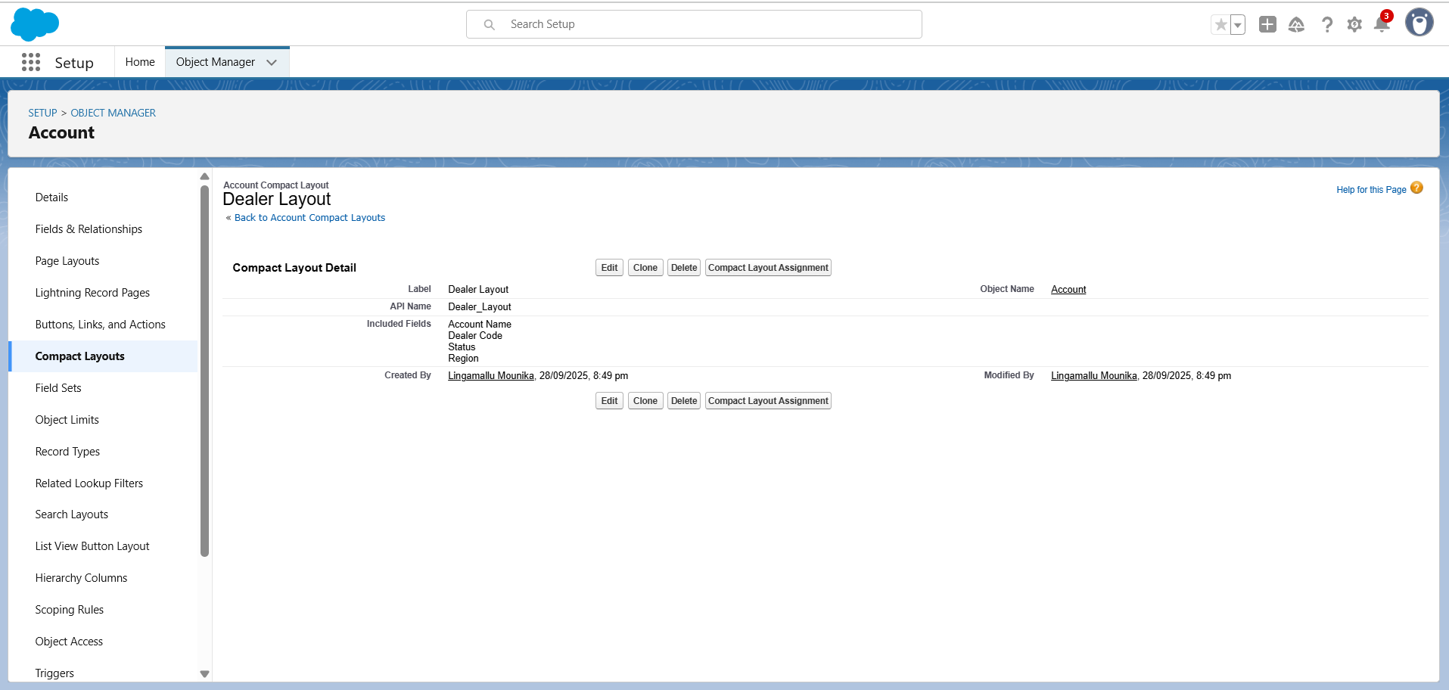

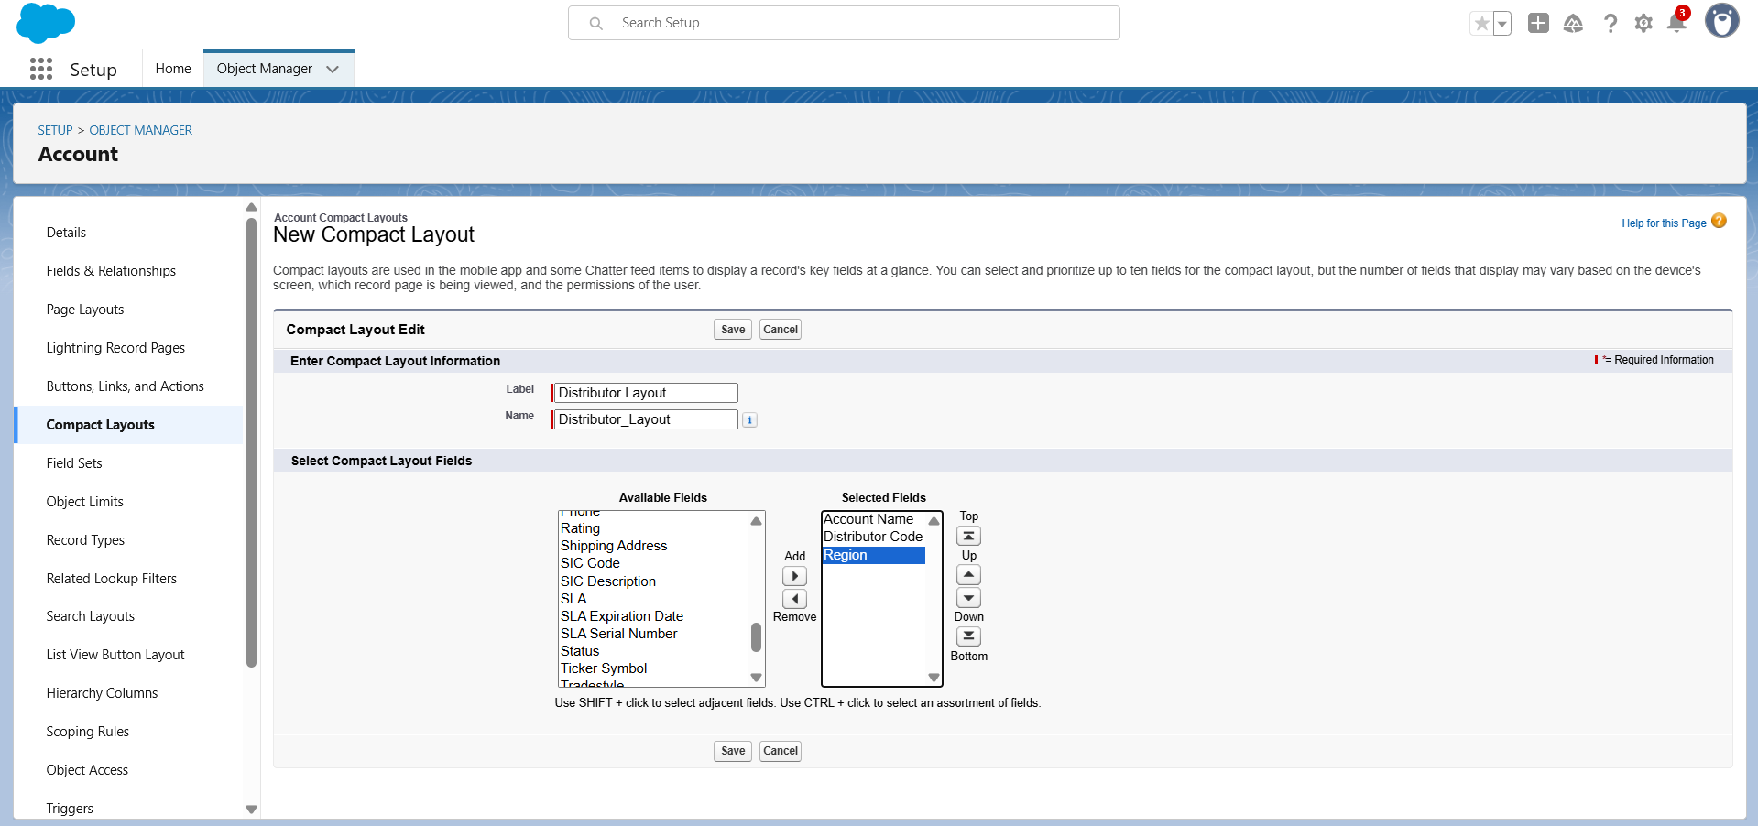 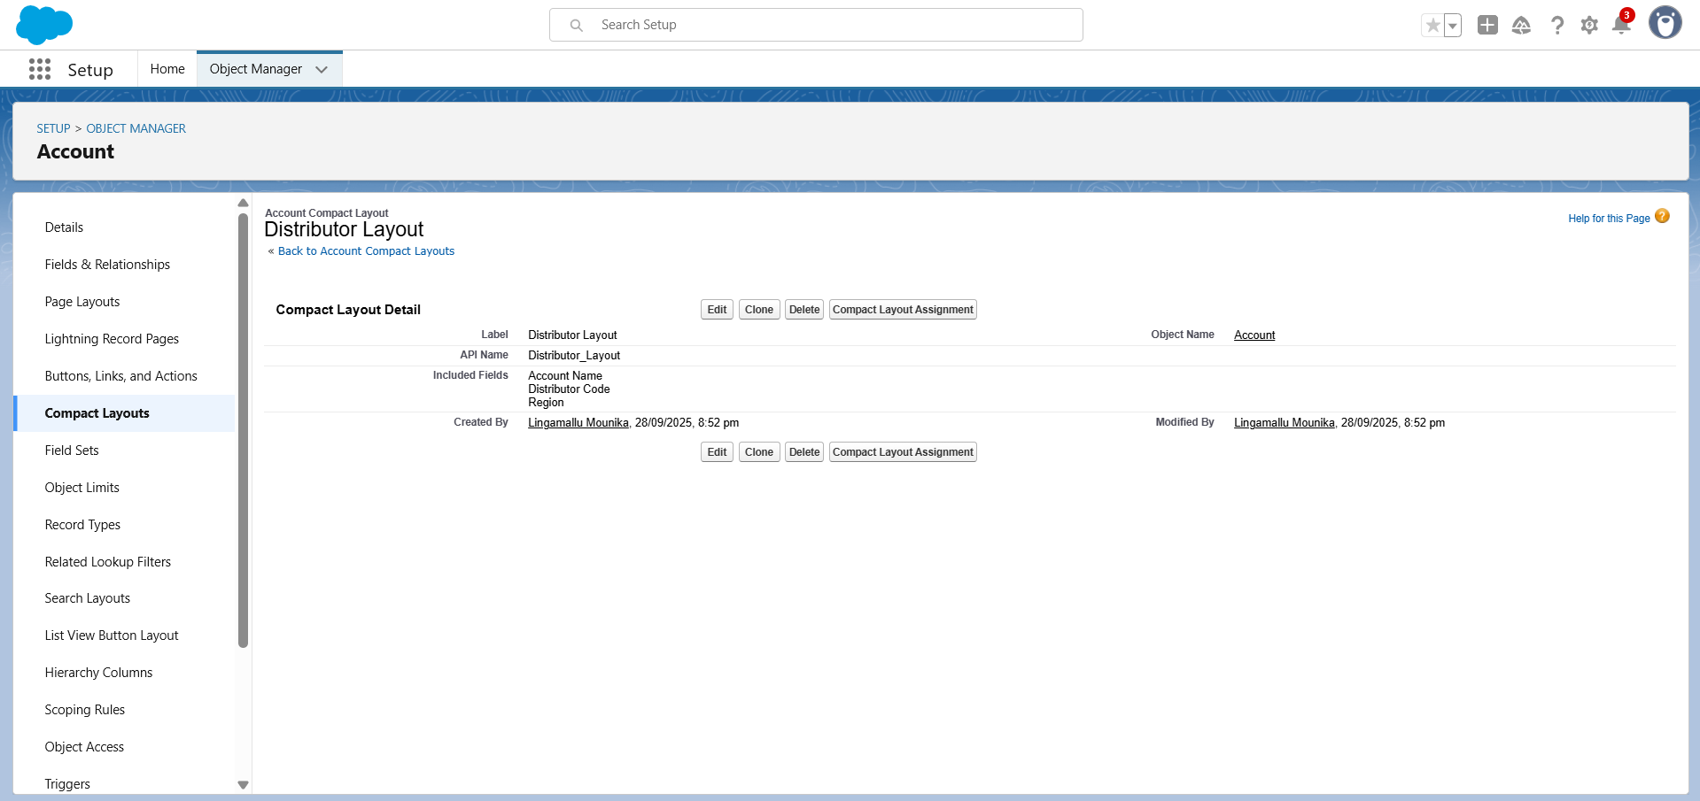

**2.5 Compact Layouts**

**Purpose:**

* Compact Layouts control **which fields appear at the top of a record page** in Salesforce (like highlights on mobile and Lightning Experience).

1. Go to **Setup → Object Manager → Account → Compact Layouts**.
2. Click **New** (or edit the existing one).
3. Add the **key fields** for quick view, e.g.:
   * **Dealer Layout:** Account Name, Dealer Code, Status, Region
   * **Distributor Layout:** Account Name, Distributor Code, Region
4. Save the layout.
5. Make it **primary** so Salesforce uses it on record pages automatically.

**Result:** Users see important details at the top of the Account record in Lightning and mobile apps.

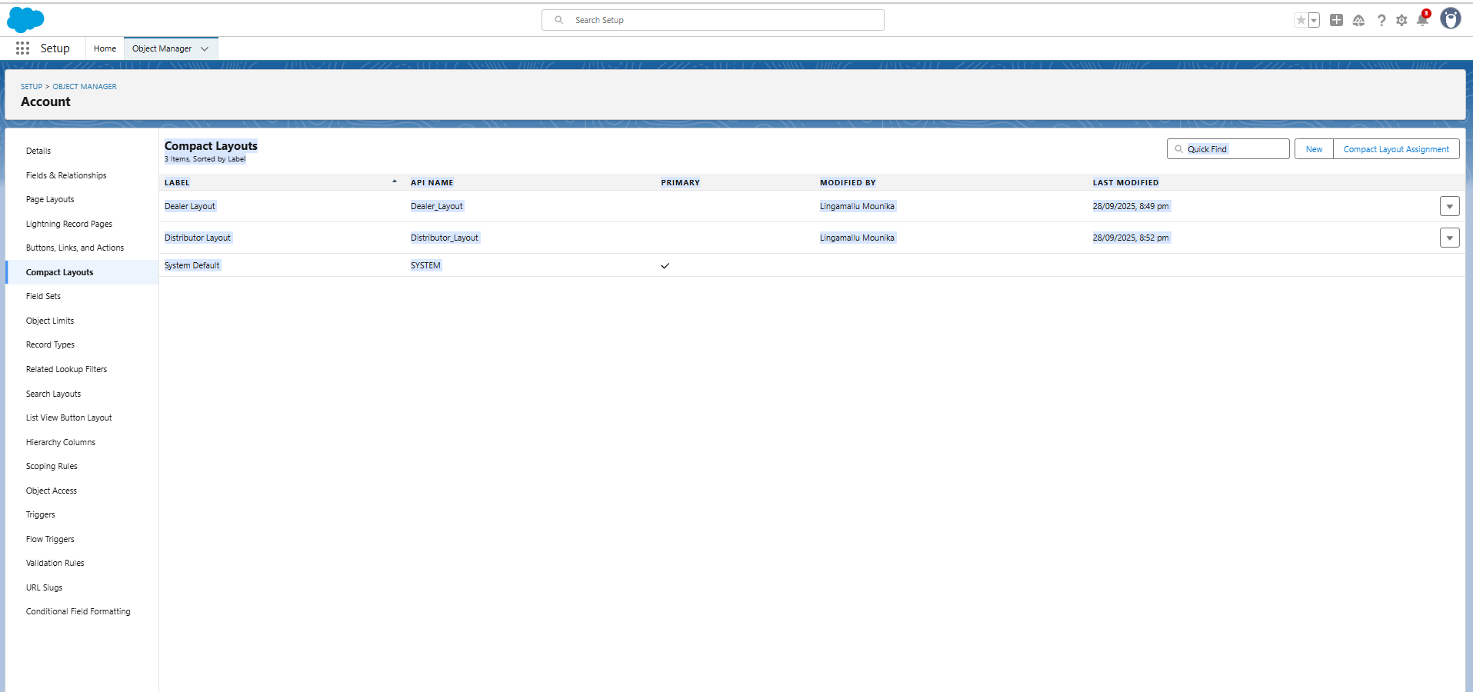

**2.6 Schema Builder**

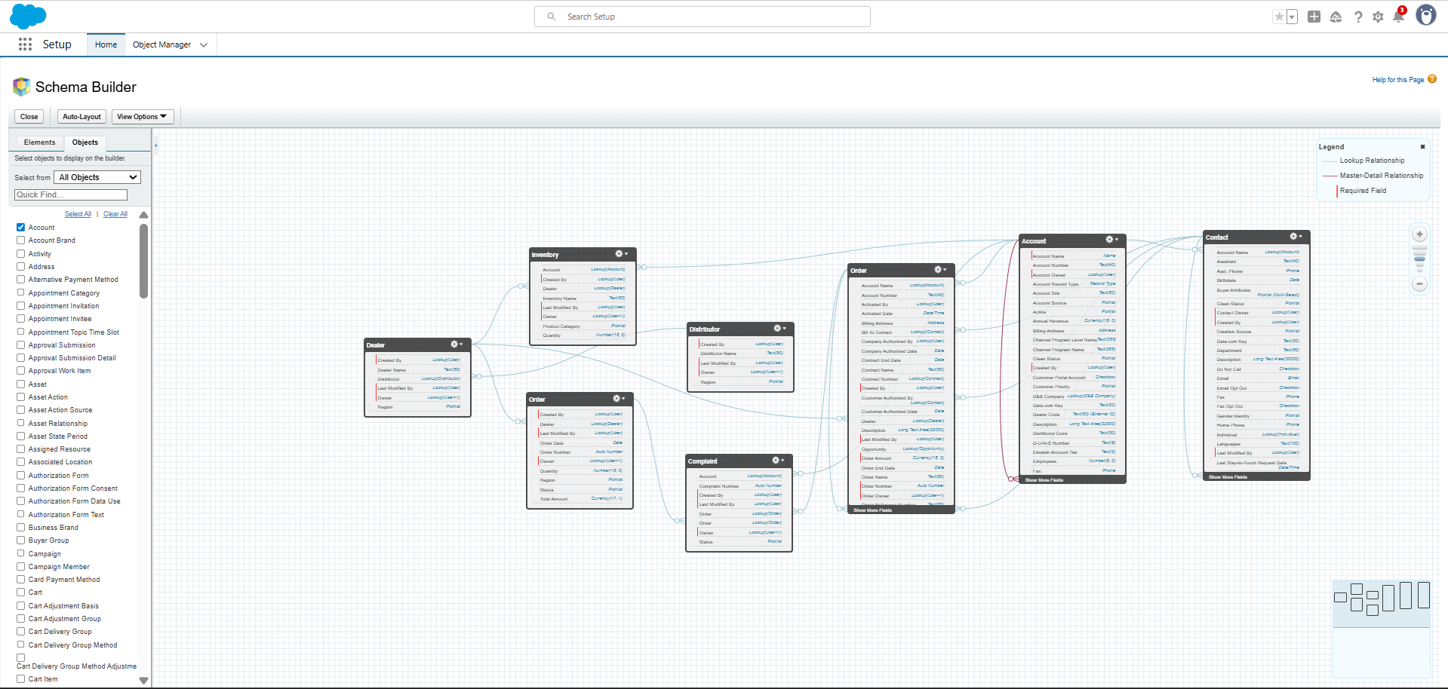

1. **Inventory__c → Dealer__c**
   * **Type: Lookup**
   * **Purpose: Inventory records belong to a Dealer; ensures inventory is tied to a dealer and is deleted if the dealer is deleted.**
2. **Orders__c → Dealer__c**
   * **Type: Lookup**
   * **Purpose: Links orders to the dealer who placed them; essential for tracking dealer-specific sales.**
3. **Orders__c → Inventory__c**
   * **Type: Lookup**
   * **Purpose: Associates orders with the products being ordered; needed for stock tracking and order management.**
4. **Distributor__c → Dealer__c**
   * **Type: Lookup**
   * **Purpose: Connects distributors to dealers; builds the distribution network hierarchy.**

**2.7 Lookup vs Master-Detail vs Hierarchical Relationships**

**Relationships Implemented (Using Lookup):**

**Order → Dealer (Lookup): Each order is linked to a dealer.**

**Complaints → Order (Lookup): Each complaint is linked to an order.**

**Inventory → Dealer (Lookup): Inventory items are linked to dealers.**

**Dealer → Distributor (Lookup): Dealers can be associated with a distributor.**